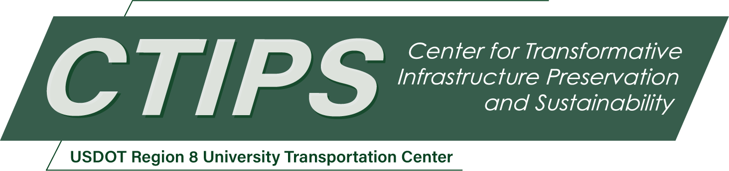

# Project Title Goes Here

*CTIPS-### – UTC Project Information*

|  |  |
| --- | --- |
| **Recipient/Grant Number:** | North Dakota State University  Grant No. 69A3552348308 |
| **Center Name:** | Center for Transformative Infrastructure Preservation and Sustainability |
| **Research Priority:** | Preserving the Existing Transportation System |
| **Principal Investigator(s):** |  |
| **Project Partners:** | USDOT, Office of the Assistant Secretary for Research and Technology – $  List additional fund source(s) here… |
| **Total Project Cost:** | $ |
| **Project Start and End Date:** |  |

## Project Description

Project abstract goes here…

## USDOT Priorities

Describe how the project supports USDOT priorities and the RD&T strategic goals. Also describe how the project engages in breakthrough, advanced, or transformative research.

## Outputs

The results of the work performed. Describe what new research, technology, or process this research project is expected to produce or has produced. The outputs could include processes and methods; data, hardware, software and databases; invention disclosures, patent filings, inventions, etc. Also describe any new partnerships outside of the UTC consortium that may be established or have been established through the project.

## Outcomes/Impacts

Describe the application of the output and any changes this output has or will make to the transportation system, or its regulatory, legislative, or policy framework, including a description of products or patents, or a change in practice, or instances of research results informing policy decisions. Discuss how this research output will positively impact the transportation system in terms of safety, reliability, durability, costs, etc.

## Final Report

Upon completion, the final report link will be added to the [project page on the CTIPS website](https://www.ctips.org/projects/).