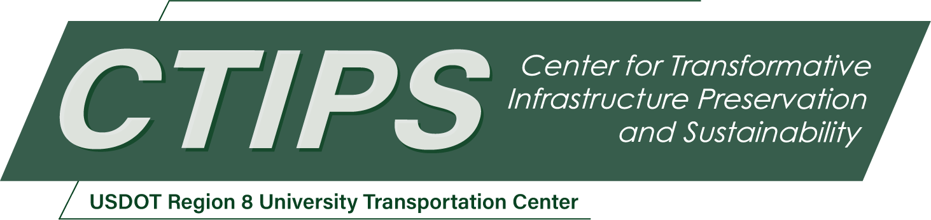

**A Durable Composite Bridge Deck System for Accelerated Bridge Construction Comprising FRP Stay in Place Form and UHPC Overlay**

*CTIPS-043*

*Approved 3/24/2025*

## University

South Dakota State University

## Principal Investigators

Akram Jawdhari, Ph.D., P.E.

Assistant Professor

Dept. of Civil and Environmental Engineering

South Dakota State University

Phone: (605) 688-5226

Email: akram.jawdhari@sdstate.edu

ORCID: 0000-0001-9540-5040

## Research Needs

Bridge decks deteriorate at much faster rates than other super- or sub-structure elements due to their direct contact with the traffic loads and their intense exposure to environmental conditions such as moisture and chlorides (Hartanto Wibowo 2018). Several deterioration mechanisms have been reported for concrete decks, including cracking, delamination, spalling, and corrosion of steel reinforcement (Bouguerra et al. 2011; Dieter et al. 2002). Typically, deck deterioration starts with surface cracking, followed by ingress of moisture and chloride, ultimately resulting in concrete spalling and reinforcement corrosion (Sritharan et al. 2018). Other factors such as freeze-thaw cycles, temperature variations, use of de-icing salts in winter operations, presence of cyclical vehicular traffic loads, and exposure to seawater salts in coastal regions, accelerate the deterioration problem (Hartanto Wibowo 2018). Typically, maintenance of conventional concrete decks subjected to normal traffic and environmental conditions is required after 4 to 8 years of service (Balakumaran et al. 2017). Deck maintenance and repair operations can cost 50 to 80% of all bridge related expenditures (Gucunski 2011).

Recognizing the dire situation, many solutions and techniques have been proposed to increase the durability and longevity of concrete bridge decks and reduce construction costs, user discomfort, and service disruptions. Some of the solutions include increasing the concrete cover; using epoxy-coated or fiber reinforced polymer (FRP) reinforcements to mitigate corrosion problems; adding overlays made of low-slump dense concrete, latex modified concrete, or polymer concrete (Hartanto Wibowo 2018). Some of these systems have limitations including high material costs, unavailability of some ingredients, and environmental concerns (Russell 2004). Overlaying is a viable option in decks experiencing moderate deterioration and are not in immediate of replacement (Johan Silfwerbrand 2017). The overlay acts as a new wearing surface and protects the deck from further cracking, and intrusion of harmful chemicals (Liu and Charron 2024). Recent research and field applications have identified ultra-high-performance concrete (UHPC) as a new, effective deck overlaying system. This is facilitated by UHPC’s superior mechanical properties including compressive strength exceeding 150 MPa (21.7 ksi), tensile strength greater than 5 MPa (0.7 ksi) with sustained post-cracking tensile ductility due to bridging effects of fibers, high durability, low permeability (Ben Graybeal 2019). The excellent bond with other concrete materials and with reinforcement reduces the development and transfer lengths for embedded reinforcement and eliminates the need for mechanical anchorage at the UHPC-deck interface (Sriram Aaleti 2014). A 2023 report from the Federal Highway Administration (FHWA) provides design and construction guidance and outlines the use of UHPC in bridge preservation and repair practices, including as a deck overlay (Zachary B. Haber 2022a). Typically, UHPC overlays are classified into two categories based on function, (a) for protection only, and (b) for protection and strength which features thicker sections and include rebar or wire mesh reinforcement (Sritharan et al. 2018).

Prefabricated deck panels (PDPs) have also been implemented in new constructions and in redecking of existing bridges as part of the Accelerated Bridge Construction (ABC) technique which offers numerous advantages such as use of high quality and durability materials, rapid construction, enhanced safety, and reductions in traffic disruptions (Zachary B. Haber 2022b). In a project sponsored by the FHWA Bridges for life program, (Sriram Aaleti 2013)developed a PDP system made of UHPC waffle slab, reinforced with non-prestressed mild steel bars running orthogonally within the waffle ribs. To comply with the American Association of State Highway and Transportation Officials (AASHTO) Load and Resistance Factor Design (LRFD) specification, the total slab thickness was chosen to be 200 mm (8 in). Field-cast UHPC was used as a grout material for the panel-panel and panel-girder connections (FHWA 2013). Constructability challenges including the need to demold the panels immediately after final set to reduce autogenous shrinkage cracking, utilization of expensive and highly customized void forms, inflexibility of changing the deck geometry (requires new forms), resulted in disfavor compared to other conventional PDP systems. Nonetheless, the UHPC waffle deck was successfully used as a deck replacement for a single-span, two-lane bridge in Wapello County, Iowa.

Concrete decks incorporating Stay-in-Place (SIP) FRP forms have also been extensively researched and successfully implemented in number of bridge decking projects (Nelson et al. 2014b). These forms serve dual purposes as permanent formwork and structural reinforcement, offering several advantages, including reduced construction costs, shorter timelines, and enhanced safety by eliminating the need for temporary formwork (Boules et al. 2023). Typically, these forms function as bottom reinforcement and are paired with an orthogonal mat of FRP bars as top reinforcement (Nelson et al. 2014b). Various configurations of SIP forms have been employed in bridge decks, including T-rib stiffened plates, tubular sections on plates, FRP grids bonded to plates, and corrugated FRP plate formwork (Zuo et al. 2018). The deck systems have been rigorously studied under diverse conditions, such as service, ultimate, and fatigue limit states, as well as under freeze-thaw cycles, surface treatment techniques, bond enhancements at the form-concrete interface, and different boundary conditions (Boles et al. 2015; Nelson et al. 2014a; Nelson and Fam 2014; Richardson et al. 2014). Field applications include installations on steel girders, precast/prestressed concrete I-girders, and precast concrete bulb-tee girders (Nelson et al. 2014b).

However, the concrete-FRP SIP deck system has only been explored and implemented in jointless field-cast applications. Its feasibility for prefabricated decking and ABC systems, as well as the design, construction, and performance of panel-to-panel and panel-to-girder connections, remains unexplored, presenting opportunities for further research. Additionally, while the use of FRP bars effectively addresses corrosion concerns, the deck system's reliance on conventional concrete throughout its depth presents potential challenges related to concrete cracking and degradation. These issues are particularly pronounced in the top layer, which is exposed to traffic-induced stresses and environmental loads.

The proposed research seeks to evaluate the strength, serviceability, and constructability of a durable composite deck system designed for versatile applications. This innovative deck system integrates FRP SIP forms as bottom reinforcement, conventional or lightweight concrete as an inner core, mild steel bars as top reinforcement, and an UHPC overlay as the top layer. The system is envisioned to be suitable for both prefabricated jointed and jointless field-cast applications, and applicable for new bridge constructions as well as redecking projects. The proposed system integrates the advantages of UHPC overlays and FRP SIP forms, which have been previously studied individually, to enhance the durability and longevity of bridge decks. Given the high environmental protection expected, the top reinforcement mat is designed to be of mild steel bars instead of FRP ones, reducing costs compared to earlier generations of concrete decks with FRP SIP forms that employed FRP top mats. The thickness and reinforcement ratio of the UHPC overlay can be customized to meet specific requirements for strength, protection, or a combination of both. Similarly, the inner concrete core can be tailored to accommodate diverse strength, weight, and sustainability objectives by incorporating materials such as normal-strength concrete (NSC), high-strength concrete (HSC), lightweight concrete (LWC), and recycled aggregate concrete (RAC). Figure 1 illustrates the proposed system for prefabricated applications, including a cross-section schematic of the composite deck, the proposed panel-to-panel and panel-to-girder connections, and a schematic of a bridge segment highlighting the superstructure elements and their joints.

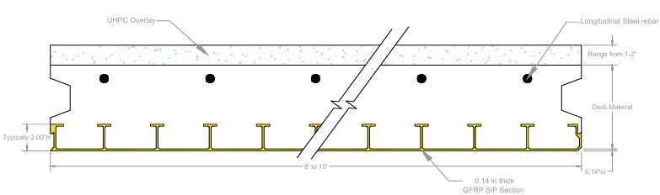

(a) Cross-section of proposed composite deck panel.

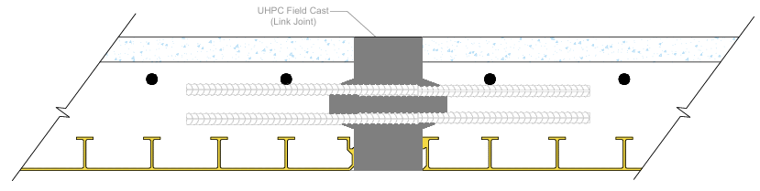

(b) Transverse panel-to-panel connection to be filled with field cast UHPC.

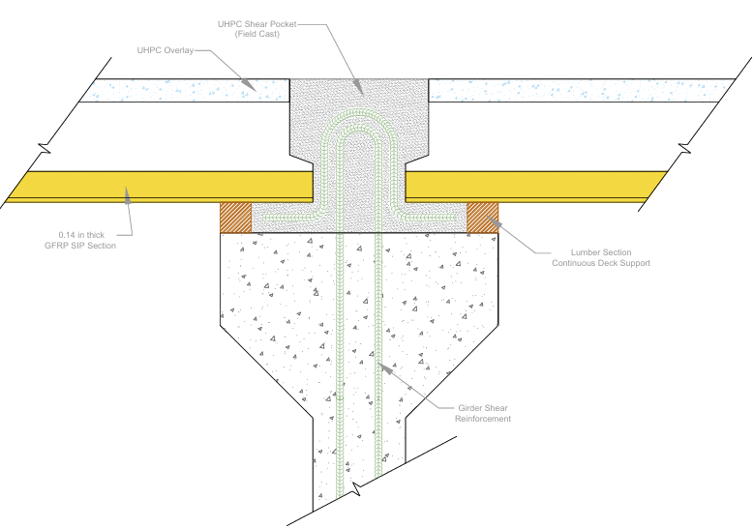

(c) Panel-to girder longitudinal joint to be filled with field cast UHPC.

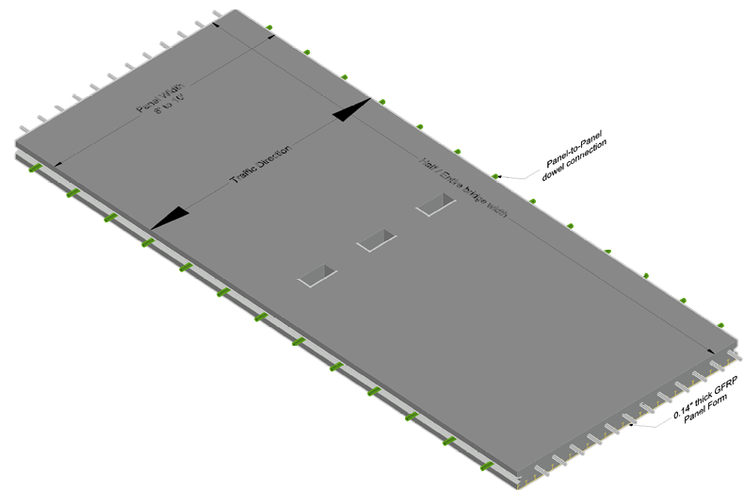

(d) Three-dimensional view of the proposed prefabricated deck panel.

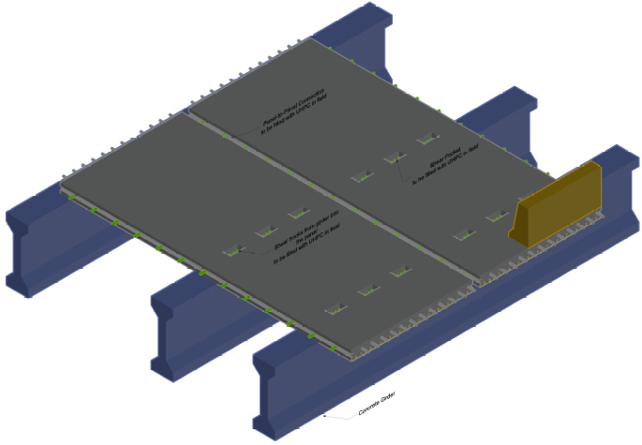

Concrete barrier

Concrete girder

(e) Three-dimensional view of a PC girder bridge superstructure, showing the proposed composite deck panel and connections.

**Figure 1:** Conceptual design of composite bridge deck with FRP SIP form, UHPC overlay.

## Research Objectives

The primary objective of this research is to evaluate the design, construction, and performance of the proposed deck system to ensure compliance with the strength and serviceability requirements outlined in the AASHTO LRFD Bridge Design Specifications (AASHTO 2020), herein after referred to as BDS standard. Specific objectives are:

* Develop final geometric configurations, material specifications, and connection designs, including detailed drawings, for the proposed deck system.
* Conduct experimental studies to assess key aspects of the proposed system, including the bond and interaction between deck components, panel-to-panel connections, and performance under service and ultimate loads.
* Perform analytical and numerical studies to accurately replicate experimental results, providing insights for broader evaluation and optimization of the deck design.
* Develop comprehensive design and construction guidelines to assist bridge designers, owners, and contractors in implementing the proposed system effectively.

Feedback and interactions with design professionals, researchers, and an advisory committee will serve as invaluable resources for assessing the quality and impact of the proposed project. Regular dissemination of project outcomes through presentations at professional events and publications in peer-reviewed journals will not only promote the proposed system but also provide essential insights and constructive feedback for its refinement and improvement.

## Research Methods

Given the potential versatility of the proposed deck system, a phased and focused research approach is essential. This project will primarily focus on the application of the system for prefabricated deck panels. The construction, design, and performance aspects of the field-cast variant differ significantly and will be explored in future research efforts. A comprehensive literature review will be conducted to summarize relevant studies and inform the development of initial geometric and material plans for the proposed deck panels and the entire deck system, including connections. This review will encompass technical work on other prefabricated deck panels, such as UHPC waffle slabs and full-depth precast HSC panels, and their connections. The deck design will adhere to current BDS standards, including design checks for strength, serviceability, and fatigue under various design loads, such as components, wearing surfaces, and live loads (HL-93 truck and lane, including dynamic effects). A robust experimental program will evaluate the deck's performance under service and ultimate load conditions. Simply supported one-way panel tests will be conducted in two configurations: single panels and two panels connected by a field-cast joint. Single-panel tests will investigate deck parameters such as FRP SIP form configuration (e.g., T-rib spacing, thickness) and bond treatment, UHPC overlay thickness and bar reinforcement ratio, inner core concrete type (e.g., NSC, HSC, lightweight), and section resistance to positive and negative moments by flipping panel orientation relative to the load. Tests involving two connected panels will evaluate panel-to-panel connections under service and ultimate loads, varying joint shapes, dowel reinforcement details (e.g., contact vs. non-contact, straight vs. looped), and load location relative to the joint. Full-scale tests, planned for future phases, will examine a bridge section incorporating major superstructure components, including girders, prefabricated panels, shear pocket connections, and longitudinal and transverse panel-to-panel connections. A variety of experimental data, such as load-displacement and load-strain curves, slippage at SIP form-concrete and concrete-UHPC interfaces, and failure modes, will be collected and analyzed. The program will utilize traditional instrumentation like load cells, strain gauges, and LVDTs alongside state-of-the-art digital image correlation techniques to monitor deck performance under applied loads. Computational and analytical simulations, including three-dimensional finite element analysis, will complement the experiments by providing theoretical predictions, design expressions, and a cost-effective platform for parametric investigations.

## Relevance to Strategic Goals

The proposed research aligns closely with two strategic goals of the United States Department of Transportation (USDOT), namely: Climate and Sustainability, and Transformation and Innovation. The proposed decking system which includes high strength, durability, and lightweight components is expected to be highly resilient to climate change effects. Reductions in the deck’s thickness and self-weight translate into reductions in greenhouse gas emissions related to transportation and installation operations. Future versions of the deck can include recycled aggregate concrete as inner core, contribute further to sustainability. In relation to transformation and Innovation, the deck deploys non-traditional advanced materials and is designed for implementation within the Accelerated Bridge Construction program, an innovative solution promoted by USDOT to modernize the nation’s transportation infrastructure. ABC technology aligns with USDOT's strategic goals of improving safety, fostering innovation, and enhancing infrastructure resilience.

## Educational Benefits

The research team will comprise graduate and undergraduate students actively participating in the design, construction, testing, and analysis of the proposed structure. These activities will provide students with invaluable opportunities to develop technical expertise, teamwork capabilities, and leadership skills, all of which are essential for a successful engineering career. Additionally, the technical content of CEE 769 “Bridge Design,” taught by Dr. Jawdhari, will be revised to incorporate the design of prefabricated deck elements and connections. Graduate students involved in the project will also be invited to deliver presentations to the class on the proposed deck system, further improving their presentation and public speaking skills.

## Outputs through Technology Transfer

The project findings will be disseminated and transferred to researchers, professionals, and practitioners through a variety of methods, including peer-reviewed articles that detail experimental and analytical results alongside practical recommendations. Workshops and live webinars hosted by CTIPS and professional events, such as research-in-progress sessions during the American Concrete Institute (ACI) bi-annual conventions and the Transportation Research Board (TRB) meetings, will further extend outreach. The research outputs will also be shared via university and CTIPS web pages, as well as professional platforms like LinkedIn. Engagement with design professionals, bridge authorities such as State DOTs and FHWA engineers, and industry leaders, including committee chairs and chapter directors from the Precast Concrete Institute (PCI), will be prioritized to support the transformation of research findings into practice.

## Expected Outcomes and Impacts

The innovative bridge deck system proposed in this project offers numerous advantages, including enhanced durability, sustainability, safety, and faster construction. Once implemented, the deck is expected to significantly reduce bridge maintenance and repair operations, leading to lower construction costs, reduced disruptions to users, and minimized service interruptions. The design and construction guidelines developed as part of this project will be written in a code-like format to facilitate adoption in regional and national bridge design specifications. Furthermore, a patent will be filed for the conceptual design of the deck system. The successful implementation of this project, which primarily focuses on concept design and proof of the system's capabilities, will set the stage for future research into key areas, including the investigation of the bridge superstructure system, field implementation and testing.

## Work Plan

The following is a summary of planned tasks:

*Task 1: Literature review* (1 month) – A comprehensive survey of the relevant literature will be conducted to gather insights into the current state of the art and identify research gaps in the field. Technical documents and lessons learned from existing full-depth panels, such as UHPC waffle decks and decks with SIP forms, will be carefully reviewed and incorporated into the development of the geometric, reinforcement, connection details, and constructability considerations for the proposed decking system.

*Task 2: Panel and connection design* (1 month) – The final design of the geometric and reinforcement details for the panels and panel-to-panel connections will adhere to the AASHTO LRFD Bridge Design Specifications, best practice recommendations from industry and literature, and input from design engineers and precast concrete professionals. Alongside meeting code requirements for strength and serviceability, practical considerations such as ease of fabrication, transportation, erection, and assembly will also be prioritized.

*Task 3: Single panel tests* (7 month) – Tasks involved in the testing campaign of single panels include designing of test matrix, specimen dimensions, and test setup; fabrication of specimens; instrumentation with contact (e.g., strain gages and string pots) and non-contact (i.e., DIC technique) tools; testing; data analysis, and results presentation. The test matrix parameters, as previously discussed in the proposal, may be further refined through additional literature review and insights from researchers and design professionals.

*Task 4: Two panel-connection tests* (7 month) – Similar to Task 3, this task involves a testing campaign to evaluate two-panel systems with connecting joints. Activities include designing the test specimen geometry and test matrix, fabricating and instrumenting the panels, conducting tests, and processing raw data into presentable formats. The primary objective is to develop a suitable joint connection between panels. A comprehensive review of joint shapes, dowel reinforcement details, and numerical analyses will be conducted to recommend an optimal joint design.

*Task 5: Technology transfer* (1 month) – The research outcomes will be disseminated to the engineering community, including bridge designers, builders, and owners, through various channels such as oral presentations at professional events, conference and journal publications, and webinars hosted by CTIPS and organizations like the Precast Concrete Institute.

*Task 6: Final written report* (1 month) – Findings from project tasks 1 to 4, best practice recommendations for design and construction, and suggestions for future work on the proposed deck system will be compiled into a final report. The report's content will undergo peer review and be revised accordingly.

## Project Cost

Total Project Costs: $ 150,724

CTIPS Funds Requested: $ 59,999

Matching Funds: $ 90,725

Source of Matching Funds: South Dakota State University – $74,725

QuakeWrap Inc. – $16,000

## References

AASHTO. 2020. *Highway Subcommittee on Bridges and Structures. 2020. AASHTO LRFD Bridge Design Specifications, 9th ed*. Washington, DC.

Balakumaran, S. S. G., R. E. Weyers, and M. C. Brown. 2017. “Influence of Cracks on Corrosion Initiation in Bridge Decks.” *ACI Mater J*, 114 (1). https://doi.org/10.14359/51689489.

Boles, R., M. Nelson, and A. Fam. 2015. “Durability of Bridge Deck with FRP Stay-in-Place Structural Forms under Freeze-Thaw Cycles.” *Journal of Composites for Construction*, 19 (4). https://doi.org/10.1061/(ASCE)CC.1943-5614.0000531.

Bouguerra, K., E. A. Ahmed, S. El-Gamal, and B. Benmokrane. 2011. “Testing of full-scale concrete bridge deck slabs reinforced with fiber-reinforced polymer (FRP) bars.” *Constr Build Mater*, 25 (10): 3956–3965. https://doi.org/10.1016/j.conbuildmat.2011.04.028.

Boules, P., A. S. Genikomsou, A. Jawdhari, and A. Fam. 2023. “Modeling of a concrete floor incorporating GFRP Stay-in-Place structural form.” *Eng Struct*, 278: 115513. https://doi.org/10.1016/j.engstruct.2022.115513.

Dieter, D. A., J. S. Dietsche, L. C. Bank, M. G. Oliva, and J. S. Russell. 2002. “Concrete Bridge Decks Constructed with Fiber-Reinforced Polymer Stay-in-Place Forms and Grid Reinforcing.” *Transportation Research Record: Journal of the Transportation Research Board*, 1814 (1): 219–226. https://doi.org/10.3141/1814-26.

FHWA. 2013. *“The Implementation of Full-Depth UHPC Waffle Bridge Deck Panels”, Publication No. FHWA-HIF-13-031, Highway for Life Program*. Washington, DC.

Ben Graybeal. 2019. *Design and Construction of Field-Cast UHPC Connections, FHWA Publication No: FHWA-HRT-14-084*. McLean, VA.

Gucunski, N. , F. R. S. K. R. F. and H. P. 2011. *Comprehensive Bridge Deck Deterioration Mapping of Nine Bridges by Nondestructive Evaluation Technologies. Final Report. Project no. SPR-NDEB(90)–8H-00, Iowa Highway Research Board*. Ames, Iowa.

Hartanto Wibowo, S. S. 2018. *Use of Ultra-High-Performance Concrete for Bridge Deck Overlays*. Ames, IA.

Johan Silfwerbrand. 2017. “Johan Silfwerbrand.” *Concrete International*, 39 (5): 31–36.

Liu, T., and J.-P. Charron. 2024. “Analytical Model for Calculating Shear Capacity of NSC Beams Strengthened by UHPC Lateral Layers.” *Journal of Structural Engineering*, 150 (6). https://doi.org/10.1061/JSENDH.STENG-12866.

Nelson, M., E. Beriker, and A. Fam. 2014a. “Splices of FRP Stay-in-Place Structural Forms in Concrete Bridge Decks.” *Journal of Composites for Construction*, 18 (4). https://doi.org/10.1061/(ASCE)CC.1943-5614.0000455.

Nelson, M., and A. Fam. 2014. “Full bridge testing at scale constructed with novel FRP stay-in-place structural forms for concrete deck.” *Constr Build Mater*, 50: 368–376. https://doi.org/10.1016/j.conbuildmat.2013.09.056.

Nelson, M. S., A. Z. Fam, J. P. Busel, C. E. Bakis, A. Nanni, L. C. Bank, M. Henderson, and J. Hanus. 2014b. “FRP Stay-in-Place Structural Forms for Concrete Bridge Decks: A State-of-the-Art Review.” *ACI Struct J*, 111 (5). https://doi.org/10.14359/51686810.

Richardson, P., M. Nelson, and A. Fam. 2014. “Fatigue Behavior of Concrete Bridge Decks Cast on GFRP Stay-in-Place Structural Forms.” *Journal of Composites for Construction*, 18 (3). https://doi.org/10.1061/(ASCE)CC.1943-5614.0000432.

Russell, H. G. 2004. *NCHRP Synthesis of Highway Practice 333: Concrete Bridge Deck Performance. National Cooperative Highway Research Program*. Washington, DC.

Sriram Aaleti, B. P. and S. S. 2013. *Design Guide for Precast UHPC Waffle Deck Panel System, including Connections*. Ames, IA.

Sriram Aaleti, E. H. S. S. M. R. and T. W. 2014. *Structural Characterization of UHPC Waffle Bridge Deck and Connections, nTrans Project 09-362* . Ames, IA.

Sritharan, S., G. Doiron, D. Bierwagen, B. Keierleber, and A. Abu-Hawash. 2018. “First Application of UHPC Bridge Deck Overlay in North America.” *Transportation Research Record: Journal of the Transportation Research Board*, 2672 (26): 40–47. https://doi.org/10.1177/0361198118755665.

Zachary B. Haber, A. F. M. M. J. O. K. Z. B. G. 2022a. *Design and Construction of UHPC-Based Bridge Preservation and Repair Solutions, FHWA-HRT-22-065* . McLean, VA.

Zachary B. Haber, A. F. M. M. J. O. K. Z. B. G. 2022b. *Design and Construction of UHPC‑Based Bridge Preservation and Repair Solutions*. McLean, VA.

Zuo, Y., A. Mosallam, H. Xin, Y. Liu, and J. He. 2018. “Flexural performance of a hybrid GFRP-concrete bridge deck with composite T-shaped perforated rib connectors.” *Compos Struct*, 194: 263–278. https://doi.org/10.1016/j.compstruct.2018.03.105.