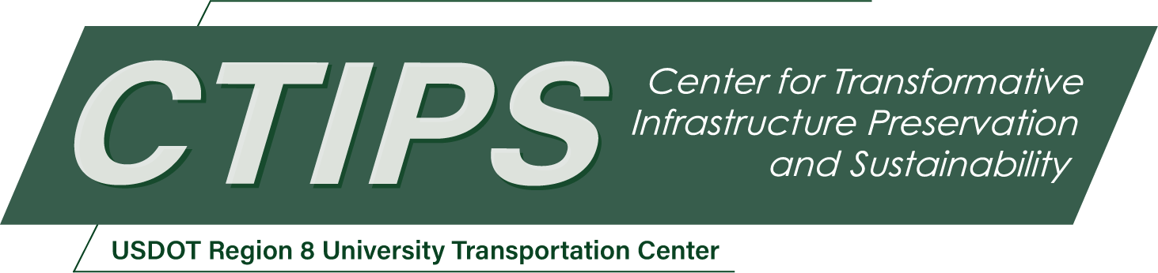

# A Durable Composite Bridge Deck System for Accelerated Bridge Construction Comprising FRP Stay in Place Form and UHPC Overlay

*CTIPS-043 – UTC Project Information*

|  |  |
| --- | --- |
| **Recipient/Grant Number:** | North Dakota State University, South Dakota State University  Grant No. 69A3552348308 |
| **Center Name:** | Center for Transformative Infrastructure Preservation and Sustainability |
| **Research Priority:** | Preserving the Existing Transportation System |
| **Principal Investigator(s):** | Akram Jawdhari, Ph.D., P.E. |
| **Project Partners:** | USDOT, Office of the Assistant Secretary for Research and Technology – $59,999  South Dakota State University – $74,725  QuakeWrap Inc. – $16,000 |
| **Total Project Cost:** | $150,724 |
| **Project Start and End Date:** | 3/24/2025 to 3/23/2027 |

## Project Description

Prefabricated deck panels have also been implemented in new constructions and redecking of existing bridges as part of the Accelerated Bridge Construction technique which offers numerous advantages such as rapid construction, enhanced safety, and reductions in traffic disruptions. A composite deck is proposed in this project comprising fiber-reinforced polymer (FRP) stay-in-place (SIP) forms as bottom reinforcement, the inner concrete core which could be made from a variety of materials to meet different strength and sustainability requirements and is to be reinforced with conventional steel bars, and ultra-high-performance concrete (UHPC) as a top overlay. The system is envisioned to be suitable for both prefabricated jointed and jointless field-cast applications, and applicable for new bridge constructions as well as redecking projects. The FRP SIP forms integrate the advantages of both SIP forms such as reduced construction costs, shorter timelines, enhanced safety; and FRP reinforcement including high strength, lightweight, and immunity to corrosion. The exceptional mechanical and durability characteristics of UHPC enable protection of the inner core and its steel reinforcement against environmental stressors and contribute to structural performance. The primary objective of this research is to evaluate the design, construction, and performance of the proposed deck system under service and ultimate conditions. Specific objectives include: (a) developing final designs including geometric, material, and reinforcement details of the deck and deck connections for prefabricated systems; (b) conducting experimental and analytical investigations to evaluate the deck and deck joint performance under mechanical loading and assess conformance to the design requirements in bridge design specifications; and (c) developing design, construction, and implementation guidelines for the proposed technology.

## USDOT Priorities

The proposed research aligns closely with two strategic goals of the United States Department of Transportation (USDOT), namely: Climate and Sustainability, and Transformation and Innovation. The proposed decking system which includes high strength, durability, and lightweight components is expected to be highly resilient to climate change effects. Reductions in the deck’s thickness and self-weight translate into reductions in greenhouse gas emissions related to transportation and installation operations. Future versions of the deck can include recycled aggregate concrete as inner core, contribute further to sustainability. In relation to transformation and Innovation, the deck deploys non-traditional advanced materials and is designed for implementation within the Accelerated Bridge Construction program, an innovative solution promoted by USDOT to modernize the nation’s transportation infrastructure. ABC technology aligns with USDOT's strategic goals of improving safety, fostering innovation, and enhancing infrastructure resilience.

## Outputs

The project findings will be disseminated and transferred to researchers, professionals, and practitioners through a variety of methods, including peer-reviewed articles that detail experimental and analytical results alongside practical recommendations. Workshops and live webinars hosted by CTIPS and professional events, such as research-in-progress sessions during the American Concrete Institute (ACI) bi-annual conventions and the Transportation Research Board (TRB) meetings, will further extend outreach. The research outputs will also be shared via university and CTIPS web pages, as well as professional platforms like LinkedIn. Engagement with design professionals, bridge authorities such as State DOTs and FHWA engineers, and industry leaders, including committee chairs and chapter directors from the Precast Concrete Institute (PCI), will be prioritized to support the transformation of research findings into practice.

## Outcomes/Impacts

The innovative bridge deck system proposed in this project offers numerous advantages, including enhanced durability, sustainability, safety, and faster construction. Once implemented, the deck is expected to significantly reduce bridge maintenance and repair operations, leading to lower construction costs, reduced disruptions to users, and minimized service interruptions. The design and construction guidelines developed as part of this project will be written in a code-like format to facilitate adoption in regional and national bridge design specifications. Furthermore, a patent will be filed for the conceptual design of the deck system. The successful implementation of this project, which primarily focuses on concept design and proof of the system's capabilities, will set the stage for future research into key areas, including the investigation of the bridge superstructure system, field implementation and testing.

## Final Report

Upon completion, the final report link will be added to the [project page on the CTIPS website](https://www.ctips.org/projects/details.php?id=641).