

# Effectiveness of Warm Mix Asphalt Additives as Compaction Aid in Cold Regions Through Application of Wireless Sensors and Performance Tests

*CTIPS-042*

*Approved 3/23/2025*

## University

South Dakota State University

## Principal Investigators

Rouzbeh Ghabchi, Ph.D., P.E., M. ASCE

Associate Professor

Department of Civil and Environmental Engineering

South Dakota State University

Phone: (605) 688-6333

Email: Rouzbeh.Ghabchi@sdstate.edu

ORCID: 0000-0002-3827-6315

## Research Needs

The importance of adequate compaction of asphalt layers during construction cannot be overstated. Field density is known to directly impact the durability, longevity, and overall performance of the hot-mix asphalt (HMA) pavement. High air voids can result in accelerated oxidation, premature cracking, and raveling [1-3]. In addition, water infiltration into asphalt pavement voids can cause loss of binder-aggregate adhesion, leading to moisture-induced damage, cracks, and potholes. Asphalt pavement compaction consists of consolidating the mix, reducing voids’ volume, and raising field density. Other than the equipment and construction strategies, achieving an acceptable asphalt pavement density in construction depends on the binder’s viscosity and its interaction with aggregates, aggregate gradation, angularity, and texture. Asphalt binder’s viscosity, in turn, is controlled by the mix temperature, which is affected by the plant production temperature, hauling distance, ambient and substrate temperature, wind speed, and solar radiation during construction. To achieve an adequate field density, depending on the asphalt binder type, asphalt mixes are laid down while the mix temperature exceeds 120°C. Therefore, in the cold regions, the foregoing mix temperature requirements can significantly limit the seasonal construction window to a great extent, negatively affecting the pavement construction and preservation operations. Incorporating warm mix asphalt (WMA) additives in the asphalt mixes provides the workability necessary for the compaction of the mixes at temperatures lower than those required for the HMA while achieving the desired field density. Therefore, in cold regions, when the ambient temperature does not allow construction with the traditional HMA mixes, WMA additives are used to continue paving operations and still achieve acceptable compaction. In such projects, the WMA additives are added as a compaction aid to the mixes at the asphalt plant at temperatures used to produce the HMA mixes (163°C). In this process, different types of WMA additives with different amounts are used depending on the project location, product availability, and the experience of the agencies or contractors. However, the effectiveness of the WMA additives in improving the compaction practices based on the local aggregates, asphalt binders, and temperature ranges occurring in the Upper Midwest is unclear. More specifically, laboratory or field data based on which the allowable minimum ambient construction temperature for each type of WMA additive can be determined is missing. This study is proposed to evaluate the compaction efficacy of different WMA additives when used as a compaction aid or temperature reduction agent in producing the HMA and WMA mixes through a laboratory study. The collected data will be applied to determine the minimum allowable mix temperature for compaction in the cold regions based on the type of mix and additive used. In addition, the minimum allowable ambient temperatures for compaction will be determined based on the available methods of estimating the effect of solar energy, wind, and mat thickness on the cooling rate of the pavement. For this purpose, models developed for the thermal diffusivity and conductivity accounting for paving site parameters [4] will be applied. Furthermore, the effect of WMA additives on the resistance of the mixes to rutting, stripping, cracking at intermediate temperatures, and thermal cracking will be determined in this study. The findings of this study are expected to facilitate the data-driven selection of the WMA additives and minimum allowable compaction temperatures in cold regions to maximize the performance, economic, and environmental benefits of the WMA technology and extend the lifespan of the pavements.

## Research Objectives

The specific objectives of the proposed study are as follows:

1. Conduct a literature review on the use of different types of WMA additives and their effectiveness in improving the compaction and reduction of construction temperature, as well as their effect on the performance characteristics of asphalt mixes.
2. Benchmark the temperature-sensitivity of compaction for a surface course asphalt mix design widely used for the construction of South Dakota’s paving projects and develop iso-density curves.
3. Determine the two most effective WMA additives in improving the compaction of the mixes prepared at temperatures used for preparing and compacting HMA mixes (compaction aid). These three additives used at the manufacturer-recommended dosage will be used in the rest of the study.
4. Implement a recently developed technology for assessing the workability of asphalt mixes using wireless particle-size sensors (WPS) as per ASTM 8541 [5].
5. Benchmark the temperature-sensitivity of compaction for a surface course asphalt mix containing the selected two WMA additives and develop iso-density curves.
6. Determine the minimum mix and ambient temperatures for compaction of HMA mix containing WMA additives and those without any additives to achieve adequate density.
7. Based on the design widely used for the construction of South Dakota’s paving projects and developing iso-density curves.
8. Determine the resistance of the control HMA mix, HMA mix containing WMA additives (used as a compaction aid), and the WMA mixes (used to reduce mixing and compaction temperatures) to rutting, stripping, cracking at intermediate temperature, and thermal cracking.

## Research Methods

The proposed study will evaluate two major groups of WMA additives (organic and chemical) and their effectiveness in improving the field density of asphalt mixes when used as a compaction aid in cold regions. In addition, the findings of this study will be utilized to recommend the minimum allowable mix and ambient temperatures for achieving adequate compaction of the HMA mixes containing different WMA additives in the cold regions to expand the seasonal construction window while ensuring adequate density and compaction consistency. A laboratory study is proposed to assess the compaction performance and workability of the mixes at different temperatures. For this purpose, a surface course mix design widely used for the construction of highway projects in South Dakota will be selected, and laboratory mixes will be produced as per the job-mix formula (JMF) at temperatures indicated in the mix design for preparing the hot mix. The compaction temperature of the hot mix (T °C) will be determined following the methodology proposed in NCHRP Report No. 648 [6]. The important volumetric properties of the loose mix will be determined, and approximately 2800 g of the prepared HMA will be densified in a Superpave gyratory compactor (SGC) to the design number of gyrations (Ndes) at different temperatures, namely T, T-15, T-30, T-45, and T-60 °C. Replica samples will be compacted at each temperature to ensure the repeatability of the compaction. The bulk-specific gravities of the compacted samples will be measured, and their %density will be determined based on the maximum theoretical specific gravity of the loose mix. Variations of the sample heights with the number of gyrations will be collected for each group of samples and compaction temperatures and will be used to develop iso-density curves for the mix (Figure 1). Iso-density curves will be further utilized to determine the compaction sensitivity with respect to temperature. In addition, a recently developed technology for assessing the workability of asphalt mixes using wireless particle-size sensors (WPS) as per ASTM 8541 [5] will be used in the process. This test method applies an aggregate-sized wireless electronic device that can be placed in the SGC mold along with the asphalt mix and transmit the rotation, orientation, and temperature data to a received and a data logger (Figure 2). The collected data can provide insight into the capability of the asphalt mix for handling the compaction efforts and compaction effectiveness and, therefore, the workability of the mix. Table 1 summarizes the methods used to benchmark the control HMA (HMA-CTRL) compaction sensitivity to temperature variation.

*Figure 1. Proposed Iso-Density Curves*

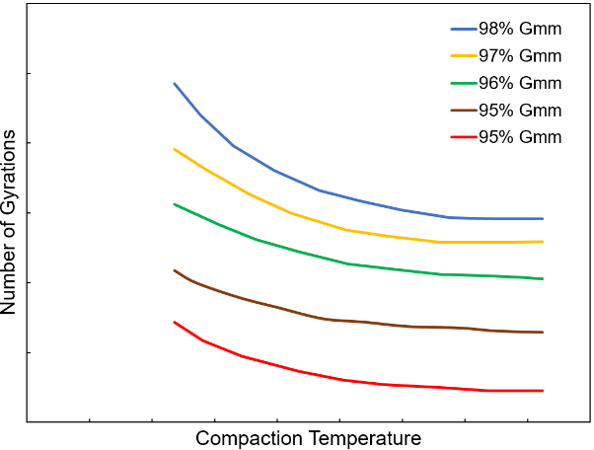

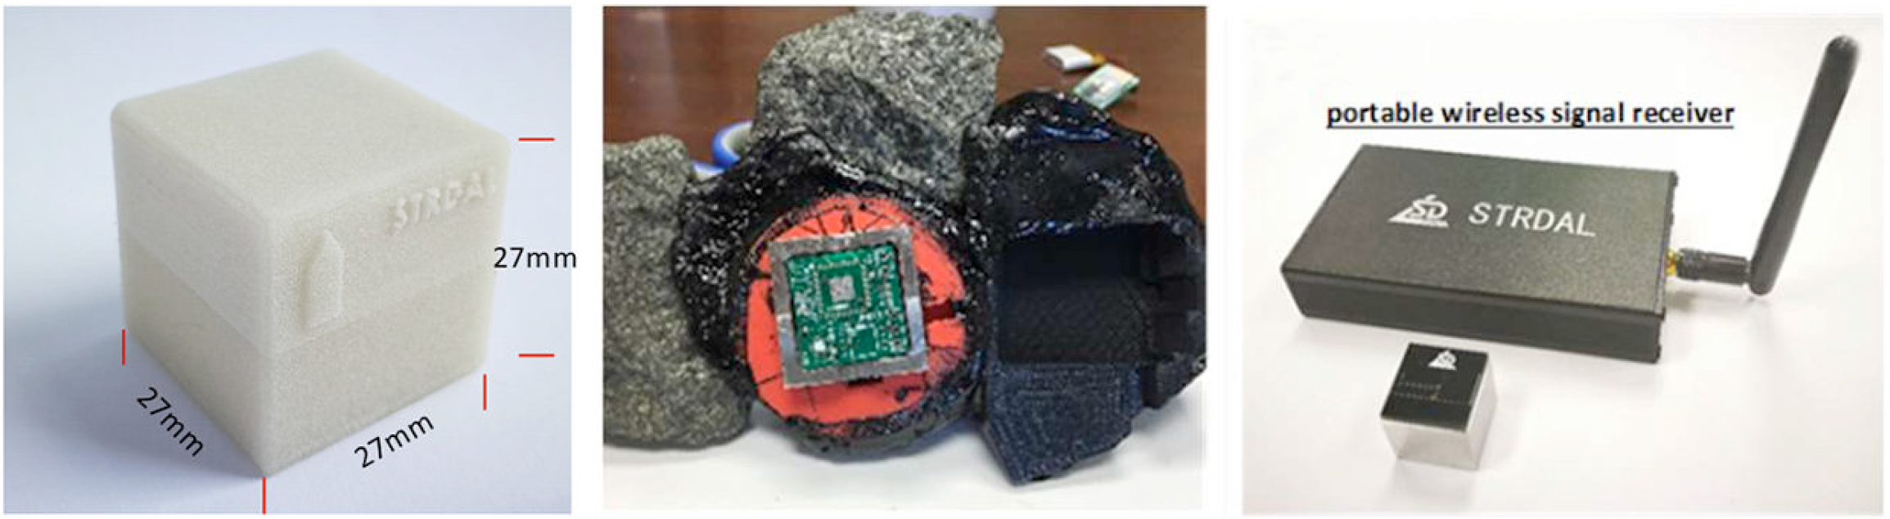

*Figure 2. Aggregate-size compaction sensor, inside sensors, and portable receiver (Image source: ASTM D8541, 2023)*

*Table 1. The proposed method for benchmarking the compaction sensitivity of the HMA to temperature*

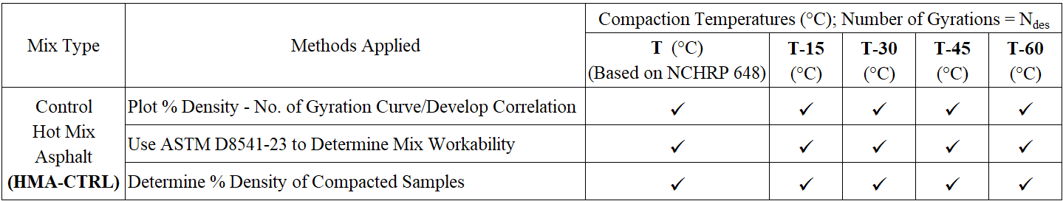

Six different WMA additives will be selected for this study based on their use in construction projects and the technology types (organic and chemical) in close collaboration with the local state DOT and pavement industry. The collected additives will be used to prepare HMA mixes (additives used as a compaction aid) as per the collected JMF and following their manufacturers’ recommendations for the application rate. The prepared mixes will be compacted in an SGC similar to the method used for the control HMA mix at the same temperature (T °C). Similar to the control HMA mix, variations in the %density with the number of gyrations and the ASTM D8541 method will be applied to determine the two most effective additives for enhancing the workability of the HMA mixes as compaction aid. Table 2 summarizes the methods used for screening WMA additives as compaction aids and the selection of the two most effective compaction aids.

*Table 2. The proposed method for screening the WMA additives for their effectiveness in improving the compaction at a constant temperature*

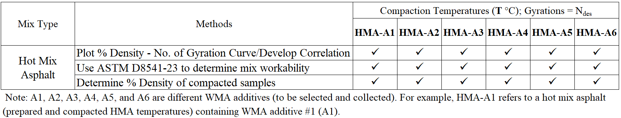

After determining the two most effective WMA additives (EA1 and EA2), the sensitivity of the workability of the HMA mixes containing manufacturer-prescribed dosages of the EA1 and EA2 additives to the compaction temperature will be studied. For this purpose, the methodology pursued for the control mix (HMA-CTRL), including the SGC compaction of mixes at different temperatures, density test, and wireless particle-size sensors [5], will be repeated, and the iso-density curves and the database with mix compaction characteristics will be developed. Table 3 summarizes the methods used for determining the compaction sensitivity of the HMA mixes containing EA1 and EA2 (HMA-EA1 and HMA-EA2) additives to temperature variation.

*Table 3. The proposed method for determining the compaction sensitivity of the HMA containing EA1 and EA2 additives to temperature*

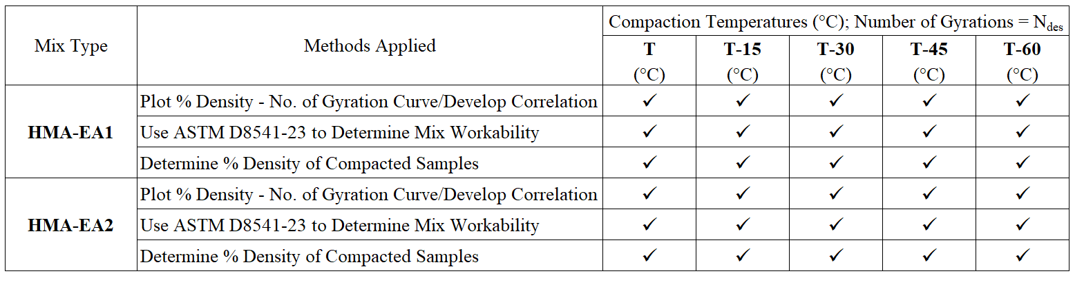

After profiling the HMA-EA1 and HMA-EA2 compaction sensitivity to temperature variation, the minimum mix temperature for adequate compaction will be determined based on the iso-density curves. Then, a model developed for the thermal diffusivity and conductivity accounting for paving site parameters developed by Chadboum et al. [4] will be applied to plot the asphalt mat temperature variations with time during the cold season to determine the minimum ambient temperature in which the asphalt mixes containing WMA additives can be adequately compacted (Figure 3).

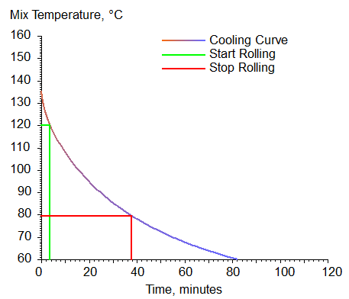

*Figure 3. An example of the asphalt mat cooling*

*Construction Conditions*

Lift Thickness = 75 mm

Mix Type = Dense Graded

Previous Surface = Asphalt

Binder: PG 58-34

Delivery Temp. = 135°C

Latitude = 45°

Air Temp. = 10°C

Wind Speed = 8 km/h

Finally, the effect of using the EA1 and EA2 additives as a compaction aid for HMA and, when used as WMA additives, on the performance of asphalt mixes will be studied. More specifically, HMA-CTRL, HMA-EA1, and HMA EA2 mixes will be produced and compacted at hot mix temperature (additives as compaction aid agents), as discussed in the preceding sections. In addition, WMA-EA1 and WMA-EA2 will be produced and compacted at temperatures recommended by their respective WMA additive manufacturers (additive as a temperature-reducing agent). Mixes will be evaluated for their resistance to rutting and moisture-induced damage, intermediate temperature cracking, thermal cracking, and viscoelastic characteristics. Table 4 summarizes the performance tests proposed to be conducted on asphalt mixes. After completing the study, the results will be analyzed and summarized.

*Table 4. The proposed method for determining the effect of additives on the performance of HMA and WMA mixes*

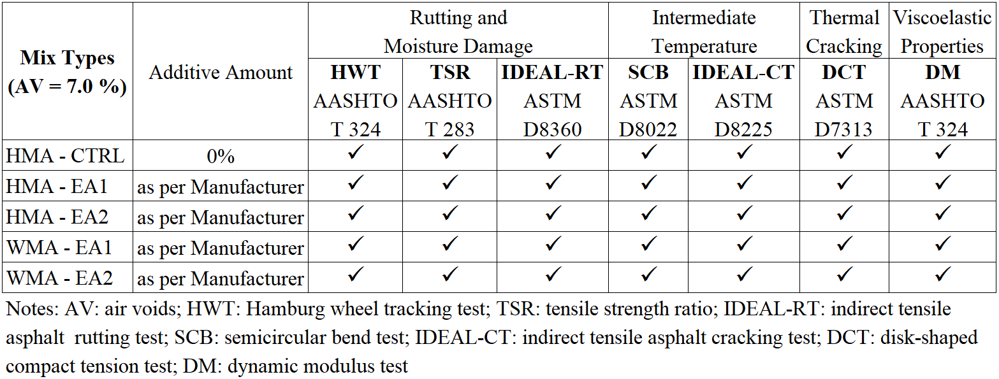

## Relevance to Strategic Goals

The expected outcomes of this project are directly related to the following USDOT strategic goals: Transformation. The outcomes of the proposed project will facilitate the selection and the use of WMA additives to improve field densities at ambient temperatures lower than those normally used for the compaction of the HMA mixes using new technologies and advanced testing methods. This will not only lead to an extended construction season after implementation but also result in the durability and longevity of the asphalt pavements due to improved field densities, contributing to the sustainability of the ground transportation systems and conserving energy.

## Educational Benefits

This project will provide an excellent learning opportunity for graduate and undergraduate students. A graduate student will work on this project as a GRA. The results of this study will be used to provide materials for their thesis. The outcomes of this study will be blended with students’ learning experiences in the classroom. More specifically, they will be used for selected lectures in CEE 765: Pavement Design, CEE 764: Pavement Sustainability, and CEE 411/511/L: Asphalt Materials and Mix Design and Lab.

## Outputs through Technology Transfer

This study will result in the implementation of a new technology, namely aggregate-sized wireless compaction sensor. In addition, the outcomes of this study will result in a data-driven decision process for the selection and utilization of WMA additives as a compaction aid in cold regions to maximize the compaction benefits of the additives. Furthermore, compaction and performance databases for asphalt mixes used in the upper Midwest will be developed as a part of this study. Moreover, new partnerships will be established with Ingevity Co. and Penn State University Altoona, both from outside CTIPS.

The technology transfer plan for this project utilizes different avenues for research dissemination to maximize the project’s impact. The findings of this project will be presented to a broad audience with the help of SDLTAP through the South Dakota Annual Asphalt Conference. This well-attended conference allows broader participation by pavement engineers, the asphalt industry, the South Dakota Department of Transportation’s personnel, NAPA members, and others. In addition, a webinar will be organized through the Transportation Learning Network (TLN) to reach out to a broader audience and disseminate the findings. The research team has a successful track record of reaching the public and professionals through TLN’s webinars. Furthermore, research papers will be published, and presentations will be made at conferences and other occasions to disseminate this study’s findings effectively. Toward building a stronger transportation workforce, a significant component of the CTIPS mission and vision, it is planned to blend research ideas and innovations into the classroom. More specifically, it is expected to bring the research findings into the classroom in the CEE 411-Asphalt Materials and Mix Design course.

## Expected Outcomes and Impacts

The outcomes of this project and the database of testing asphalt mixes and their compaction and performance characteristics developed in this study are expected to help facilitate the development of specifications to be used in design and construction using HMA mixes containing WMA additives as compaction aids and temperature-reducing agents in cold regions. More specifically, the developed database is expected to help select the minimum compaction temperatures at the beginning of the cold season in the Upper Midwest region to improve compaction and field densities without compromising the durability and performance characteristics of the mix.

## Work Plan

The proposed work plan consists of ten major tasks as follows:

***Task 1 – Literature Review:***The literature review for this study will focus on different types of WMA additives and compaction aids. In addition, different methods for assessment of compaction and workability of asphalt mixes in the field and laboratory will be included in the literature review. Also, the available literature on the effect of incorporating different types of WMA additives in asphalt mixes on their mechanical characteristics will be summarized.

***Task 2 – Material Collection:*** The required materials for this study will be collected in close collaboration with our industry partners. Asphalt binders will be collected from Jebro Co. in Sioux City, IA. Aggregates and asphalt mix designs will be collected from Concrete Materials Co. in Sioux Falls, SD. After selection (preferably six types), the WMA additives will be collected from their suppliers, including Ingevity, among other manufacturers. They will be selected for this study based on their use in construction projects and the technology types (organic and chemical) in close collaboration with the local state DOT and pavement industry. The research team has successful experience collaborating with industry partners.

***Task 3 – Superpave****®* ***Asphalt Mix Design:*** The asphalt mix design collected from the asphalt plant will be reproduced in the laboratory using the asphalt binder and the aggregates collected from the supplier. In this process, any necessary adjustments will be made to achieve the volumetric parameters as per the AASHTO M 323 specification [7] and AASHTO R 35 standard practice [8]. The optimum amount of binder content will be determined and used to prepare the mixes in the laboratory.

***Task 4 – Superpave****®* ***Gyratory Compaction of the Designed Asphalt Mix at Different Temperatures:*** As discussed earlier,after determining the compaction temperature of the hot mix (T °C) as per West et al. [6], approximately 2800 g of the prepared HMA will be densified in a Superpave gyratory compactor (SGC) to the design number of gyrations (Ndes) at different temperatures, namely T, T-15, T-30, T-45, and T-60 °C. Replica samples will be compacted at each temperature to ensure the repeatability of the compaction. The bulk-specific gravities of the compacted samples will be measured, and their %density will be determined based on the maximum theoretical specific gravity of the loose mix. Variations of the sample heights with the number of gyrations and compaction temperatures will be collected for each group of samples and will be used to develop iso-density curves for the mix.

***Task 5 – Selection of the Two Most Effective WMA Additives to Enhance Compaction:***

SixHMAmixes containing manufacturer-recommended amounts of WMA additives (6 additives) will be prepared and compacted in an SGC similar to the method used for the control HMA mix at the same temperature (T °C) as specified in Task 4. As discussed in Task 4, variations in the %density with the number of gyrations and the ASTM D8541 method will be applied to determine the two most effective additives (EA1 and EA2) for enhancing the workability of the HMA mixes as compaction aids.

***Task 6 – Evaluating the Temperature-Sensitivity of the Workability of the Mixes Containing EA1 and EA2:*** The sensitivity of the workability of the HMA mixes containing manufacturer-prescribed dosages of the EA1 and EA2 additives to the compaction temperature will be studied in this task. For this purpose, the methodology described in Task 4, including the SGC compaction of mixes at different temperatures, density test, and wireless particle-size sensors (ASTM 8541 [5]) will be conducted for mixes containing EA1 and EA2 WMA additives, and the iso-density curves and the database with mix compaction characteristics will be developed.

***Task 7 – Determining the Minimum Mix Compaction Temperatures for Adequate Density:***

In many cases, the WMA additives are used in cold climates to maintain an acceptable compaction effectiveness and are applied as compaction aids. The minimum mix temperature for adequate compaction will be determined based on the iso-density curves discussed in Tasks 4 and 6. For this purpose, the thermal diffusivity model and conductivity accounting for paving site parameters developed by Chadboum et al. [17] will be utilized to plot the asphalt mat temperature variations with time during the cold season to determine the minimum ambient temperature at which the asphalt mixes containing WMA additives can be adequately compacted. The outcomes of this task will help the construction crew to maximize the improvement of workability as a result of incorporating WMA additives as compaction aids in cold climates.

***Task 8 – Performance of HMA Mixes and WMA Mixes Containing EA1 and EA2:***

The effect of incorporating the EA1 and EA2 additives as compaction aids for HMA and, when used as WMA additives, on the performance of asphalt mixes will be studied. More specifically, control HMA containing no additives (HMA-CTRL), HMA mix containing EA1 and EA2 as compaction aids (HMA-EA1 and HMA EA2) mixes will be produced and compacted at hot mix temperature to 7.0±0.5% air voids. In addition, WMA mixes containing EA1 and EA2 (WMA-EA1 and WMA-EA2) will be produced and compacted at temperatures recommended by their respective WMA additive manufacturers and compacted to contain 7.0±0.5% air voids. The proposed performance tests will include resistance to rutting and moisture-induced damage, intermediate temperature cracking, thermal cracking, and viscoelastic characteristics. This will be achieved by following Sub-Tasks 8.1 to 8.7.

*Sub-Task 8.1. Hamburg Wheel Tracking Test (HWT):* The HWT tests will be conducted on asphalt mixes per the AASHTO T 324 standard method [9]. The test specimens of 150 mm diameter and 60 mm height prepared using a Superpave® SGC will be tested. The test will evaluate the rutting resistance up to a maximum of 20,000 wheel passes on specimens submerged in the water bath with a temperature of 46 ± 1°C (Figure 4). The moisture damage potential of the mixes will be evaluated from a striping inflection point (SIP). A new method introduced by the Texas Transportation Institute for analyzing the HWT test data proposed by Yin et al. [16] will also be applied as an alternative technique to isolate the rutting and moisture-induced damage and study them separately.

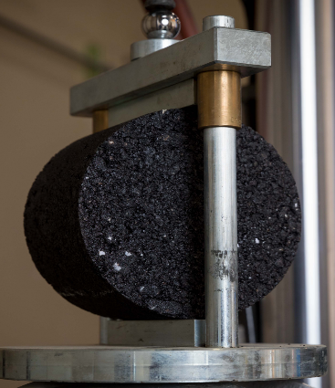

*Figure 5. Typical TSR Test Setup*

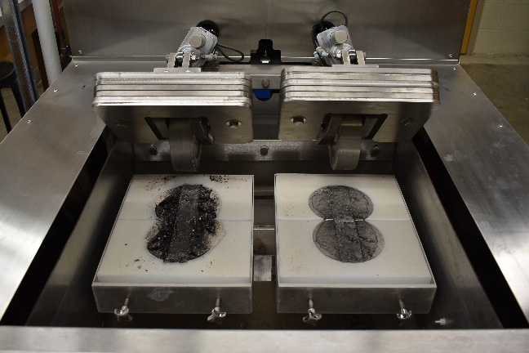

*Figure 4. Hamburg Wheel Tracking Test Setup*

*Sub-Task 8.2 – Tensile Strength Ratio (TSR):*Moisture-induced damage potential of the mixes will be determined based on their retained indirect tensile strength ratio following the AASHTO T 283 standard method [10]. This method measures the tensile strength decay due to accelerated moisture and temperature conditioning to indicate the moisture-induced damage. The TSR value for each mix will be determined by dividing the average tensile strength of conditioned by that of unconditioned specimens. The indirect tensile strength TSR tests will be conducted using an MTS loading frame available to researchers (Figure 5).

*Sub-Task 8.3 – IDEAL-RT (TTI Method):* Shear strength and the resistance of the HMA and WMA mixes to rutting will also be determined by conducting IDEAL rutting test (IDEAL-RT) as per ASTM D8360 standard method [11]. In this method, the cylindrical specimen is placed in a special fixture with two fixed U-shaped supports at the bottom and a loading strip at the top (Figure 6). The IDEAL-RT test will be conducted at 46°C (HWT test temperature) using an MTS loading frame available to researchers. In this method, two shear planes are developed as the load is applied to the cylindrical sample. At the end of the test, the peak load and the shear strength of the specimens will be determined and reported.

*Figure 6. Typical IDEAL-RT Test Fixture [18]*

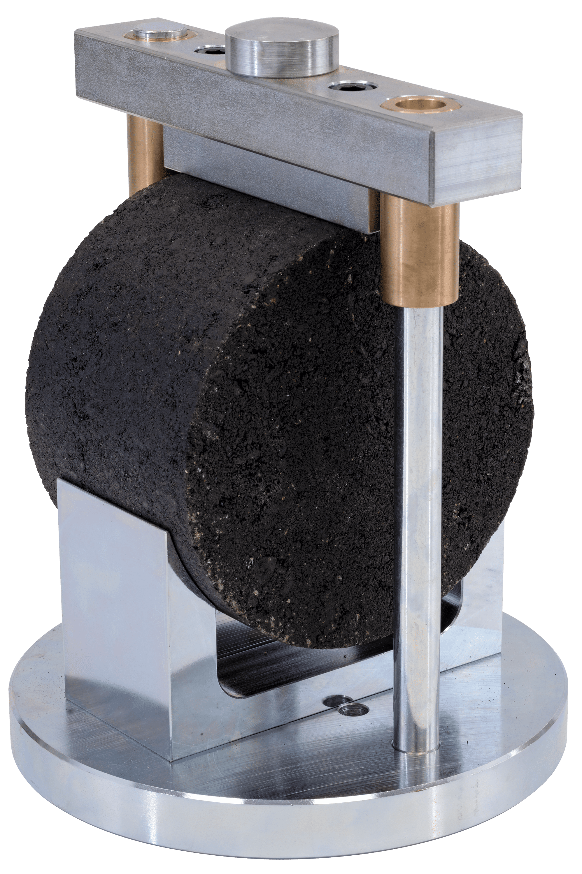

*Sub-Task 8.4 – IDEAL-CT Test:* The IDEAL-CT tests will be conducted on the SGC-compacted samples at 25°C in accordance with the ASTM D8225 standard test method [13] to determine the cracking potential of the asphalt mixes. The cracking index (CTIndex) will be calculated according to the methodology described in the standard.

*Sub-Task 8.5 – Semicircular Bend (SCB) Test:*The SCB test will be conducted on semicircular specimens 150 mm. in diameter, 75 mm in height, and 50 mm. in thickness with a 15 mm notch depth per AASHTO T 393 standard method [12]. The notches will be cut into the samples using a heavy-duty precision saw machine. Then, the samples will be tested using a fully automated test procedure in an IPC Asphalt Mix Performance Tester (AMPT) available in SDSU’s Asphalt Laboratory. During the testing, the temperature will be maintained at 25°C. This test will be conducted by applying a monotonically increasing load at a 50 mm/min rate until failure (Figure 7). The flexibility index (FI) will be calculated and reported by drawing the load-deformation graph. The SCB test results will be used to characterize the cracking potential of the asphalt mixes based on the fracture mechanic’s concept.



*Figure 7 A photographic view of SCB test*

*Sub-Task 8.6 – Disk-Shaped Compact Tension Test:* The resistance of the asphalt mixes to low-temperature cracking will be determined by performing the disk-shaped compact tension (DCT) test as per ASTM D 7313 standard test method [14]. The DCT tests will be conducted at a temperature of 10°C greater than the continuous low-temperature performance grade (PG) of the asphalt binder used for preparing the samples (Figure 8). The DCT test consists of subjecting a cylindrical specimen with a single edge notch to tension at low temperature. The load-crack mouth opening displacement curve is used to determine the fracture energy and the resistance of the asphalt mix to thermal cracking.

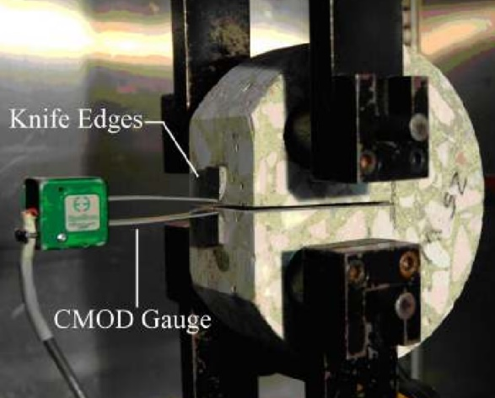

*Figure 8. Disk-Shaped Compact Tension T Test Setup [16]*

*Sub-Task 8.7 – Dynamic Modulus Test:* The viscoelastic response of asphalt mixes to loading frequencies at different temperatures will be determined by conducting dynamic modulus tests on SGC-compacted asphalt samples in an AMPT by following the AASHTO T 342 standard method [15]. The specimens of cylindrical geometry having a diameter and a height of 100 mm and 150 mm, respectively, will be tested (Figure 9). As a result, complex modulus (E*), dynamic modulus |E*|, and phase angle (ϕ) values will be determined by applying an axial sinusoidal compressive stress within samples’ linear viscoelastic range at each test temperature and loading frequency. Specimens will be tested at 4, 21, 37, and 54°C temperatures (temperature sweep) and 25, 10, 5, 1, 0.5, and 0.1 Hz loading frequencies (frequency sweep). Dynamic modulus master curves will also be developed to gain a complete picture of the thermo-viscoelastic behavior of each asphalt mix.

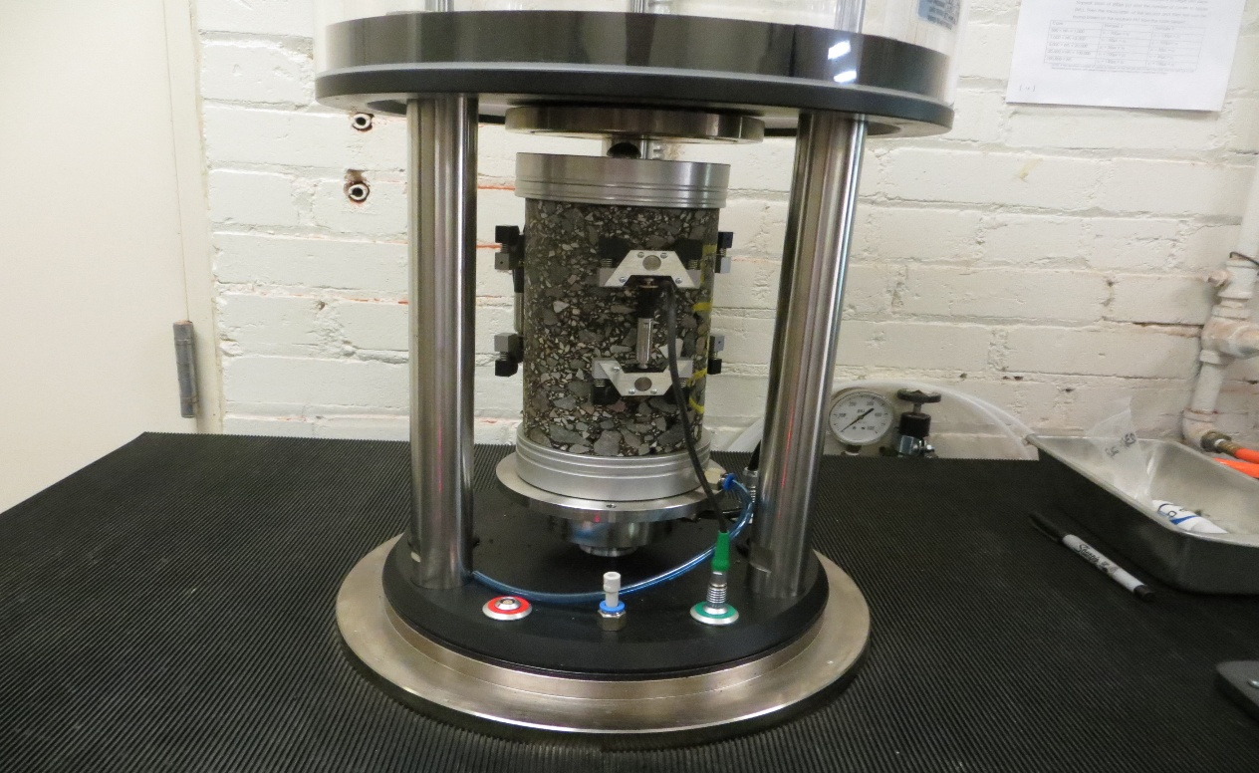

*Figure 9. Dynamic Modulus Test Setup*

***Task 9 – Analyze Test Results, Summarize the Findings, and Report:***

After completing the testing program, the findings of this study will be compiled and analyzed. The important effects of using different WMA additives on asphalt mix compaction and mix properties will be summarized and reported in the project’s final reports.

***Task 10 – Outreach and Technology Transfer Initiatives:***

It is proposed to present the findings of this project to a broad audience with the help of SDLTAP through the South Dakota Annual Asphalt Conference. This well-attended conference allows broader participation by pavement engineers, the asphalt industry, the South Dakota Department of Transportation’s personnel, NAPA members, and others. In addition, research papers will be published, and presentations will be made at conferences and other occasions to effectively disseminate this study’s findings. Toward building a stronger transportation workforce, a major component of the CTIPS mission and vision, it is planned to blend research ideas and innovations in the classroom.

## Project Cost

Total Project Costs: $273,098

CTIPS Funds Requested: $136,549

Matching Funds: $136,549

Source of Matching Funds: South Dakota State University

## References

1. Diab, A., You, Z., Yang, X. and Mohd Hasan, M.R., 2017. Towards an alternate evaluation of moisture-induced damage of bituminous materials. *Applied Sciences*, *7*(10), p.1049.
2. Lv, S., Peng, X., Liu, C., Ge, D., Tang, M. and Zheng, J., 2020. Laboratory investigation of fatigue parameters characteristics of aging asphalt mixtures: A dissipated energy approach. *Construction and Building Materials*, *230*, p.116972.
3. Vuthipalli, H., Raju, S., Sahu, P.K. and Peachara, R.R., 2023. Field data to investigate the impact of initial air-voids on the performance of bituminous pavements–a case study. *Road Materials and Pavement Design*, *24*(8), pp.1960-1976.
4. Chadbourn, B.A., Newcomb, D.E., Voller, V.R., DeSombre, R.A., Luoma, J.A. and Timm, D.H., 1998. An asphalt paving tool for adverse conditions. Final Report. Minnesota Department of Transportation - 395 John Ireland Boulevard Mail Stop 330, St. Paul, MN 55155. pp 145.
5. ASTM D8541, 2023. Standard Test Method for Determination of Relative Rotation to Evaluate the Workability of Asphalt Mixture Using Wireless Particle-Size Sensors. 2023 Annual Book of ASTM Standards, ASTM International, West Conshohocken, PA.
6. West, R.C., Watson, D.E., Turner, P.A. and Casola, J.R., 2010. Mixing and compaction temperatures of asphalt binders in hot-mix asphalt. NCHRP Report 648 (No. Project 9-39). Transportation Research Board Business Office, 500 Fifth Street, NW, Washington, DC 20001. pp. 155.
7. AASHTO M 323, 2017. Standard Specification for Superpave Volumetric Mix Design. Standard Specifications for Transportation Materials and Methods of Sampling and Testing, American Association of State Highway and Transportation Officials (AASHTO), Washington, D.C.
8. AASHTO R 35, 2021. Standard Practice for Superpave Volumetric Design for Asphalt Mixtures. Standard Specifications for Transportation Materials and Methods of Sampling and Testing, American Association of State Highway and Transportation Officials (AASHTO), Washington, D.C.
9. AASHTO T 324, 2019. Standard Method of Test for Hamburg Wheel-Track Testing of Compacted Hot Mix Asphalt (HMA). Standard Specifications for Transportation Materials and Methods of Sampling and Testing, American Association of State Highway and Transportation Officials (AASHTO), Washington, D.C.
10. AASHTO T 283, 2014. Standard Method of Test for Resistance of Compacted Asphalt Mixtures to Moisture-Induced Damage. Standard Specifications for Transportation Materials and Methods of Sampling and Testing, American Association of State Highway and Transportation Officials (AASHTO), Washington, D.C.
11. ASTM D8360, 2022. Standard Test Method for Determination of Rutting Tolerance Index of Asphalt Mixture Using the Ideal Rutting Test. 2022 Annual Book of ASTM Standards, ASTM International, West Conshohocken, PA.
12. AASHTO T 393, 2022. Standard Method of Test for Determining the Fracture Potential of Asphalt Mixtures Using the Illinois Flexibility Index Test (I-FIT). Standard Specifications for Transportation Materials and Methods of Sampling and Testing, American Association of State Highway and Transportation Officials (AASHTO), Washington, D.C.
13. ASTM D8225, 2019. Standard Test Method for Determination of Cracking Tolerance Index of Asphalt Mixture Using the Indirect Tensile Cracking Test at Intermediate Temperature. 2019 Annual Book of ASTM Standards, ASTM International, West Conshohocken, PA.
14. ASTM D7313, 2020. Standard Test Method for Determining Fracture Energy of Asphalt Mixtures Using the Disk-Shaped Compact Tension Geometry. 2020 Annual Book of ASTM Standards, ASTM International, West Conshohocken, PA.
15. AASHTO T 342, 2022. Standard Method of Test for Determining Dynamic Modulus of Hot Mix Asphalt (HMA). Standard Specifications for Transportation Materials and Methods of Sampling and Testing, American Association of State Highway and Transportation Officials (AASHTO), Washington, D.C.
16. Amirkhanian, A., Spring, D., Roesler, J., Park, K. and Paulino, G., 2011. Disk-shaped compact tension test for plain concrete. In Transportation and Development Institute Congress 2011: Integrated Transportation and Development for a Better Tomorrow (pp. 688-698).
17. Chadbourn, B.A., Newcomb, D.E., Voller, V.R., DeSombre, R.A., Luoma, J.A. and Timm, D.H., 1998. An asphalt paving tool for adverse conditions. Report No. MN/RC - 1998-18. Submitted to Minnesota Department of Transportation 395 John Ireland Boulevard Mail Stop 330 St. Paul, Minnesota 55155, pp. 145.
18. Humboldt Manufacturing Co. (n.d.) IDEAL-RT Test Head. Available at: https://www.humboldtmfg.com/ideal-rt-test-head.html (Accessed: 16 January 2025).