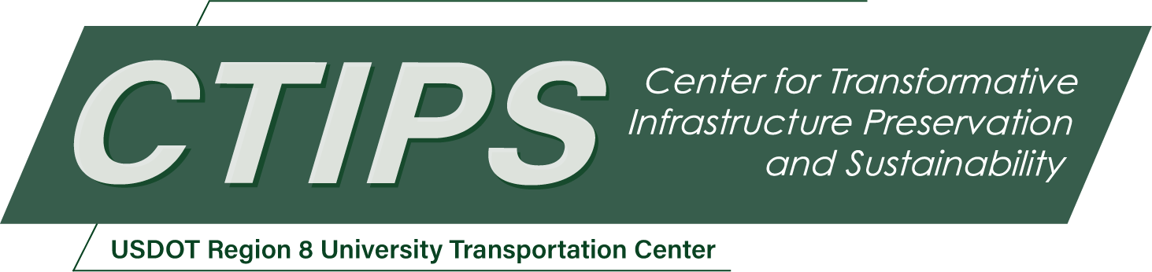

# Cryosuction and Its Role in Infrastructure Distress from Freeze-Thaw Cycles

*CTIPS-041 – UTC Project Information*

|  |  |
| --- | --- |
| **Recipient/Grant Number:** | North Dakota State University, South Dakota State University  Grant No. 69A3552348308 |
| **Center Name:** | Center for Transformative Infrastructure Preservation and Sustainability |
| **Research Priority:** | Preserving the Existing Transportation System |
| **Principal Investigator(s):** | Aritra Banerjee, Ph.D., P.E. |
| **Project Partners:** | USDOT, Office of the Assistant Secretary for Research and Technology – $70,000  SDSU Foundation – $20,000  South Dakota State University – $57,000 |
| **Total Project Cost:** | $147,000 |
| **Project Start and End Date:** | 3/21/2025 to 3/20/2027 |

## Project Description

Pavement infrastructure in cold regions experiences significant distress due to freeze-thaw cycles, which govern moisture migration, frost heave, and post-thaw weakening. Cryosuction, the process by which water is drawn toward freezing fronts due to soil suction, plays a critical role in this phenomenon by intensifying frost heave and accelerating pavement deterioration. However, the influence of cryosuction on moisture migration and subsequent pavement damage remains insufficiently understood, particularly concerning varying soil properties, salinity levels, and environmental conditions. The proposed study aims to quantify the role of cryosuction in moisture distribution during freeze-thaw cycles and examine its effects on soil freezing characteristic curves (SFCC) and soil water characteristic curves (SWCC) across different salinity levels. An experimental approach will be employed, involving soil suction measurements, moisture content analysis, and frost heave observations using advanced geotechnical instrumentation in a setup that will be fabricated as a part of this study. The results will provide clarification regarding the relationship between cryosuction, soil properties, and pavement distress, enabling the development of advanced models and potential mitigation strategies. This study through its findings will contribute to the design of more resilient pavement systems, reducing maintenance costs and extending infrastructure lifespan in cold climates.

## USDOT Priorities

The expected outcomes of the proposed project are directly related to the strategic goals, such as Transformation where the project informs the design of infrastructure for the future. The aim would be to modernize a transportation infrastructure system that will serve everyone in the decades to come. From the proposed project, enhanced material behavior prediction when subjected to freeze-thaw cycles will aid in the design of resilient pavements. This increased quality of the pavements that will cater to the conditions of Region 8 will result in better rehabilitated pavements that will have better ride quality for the users and increase the life of the pavement between repairs. Addressing the issues of distresses from freeze-thaw cycles will result in fewer maintenance activities during the life of the pavement. This will lead to higher savings and decreased user cost in the form of loss of time due to slower traffic during construction and less vehicle maintenance cost due to better ride quality. This would also lead to Economic Strength and Global Competitiveness.

## Outputs

The primary form of technology transfer would be through the final report and dissemination through journal publications and presentations at conferences. The target conferences include the ASCE annual Geo-Congress and Transportation Research Board (TRB) Annual Meetings in Washington, DC. The latter has a broader participation and includes personnel from various universities, FHWA, various state DOTs, and private agencies. These presentations and classroom teaching will aid in building a stronger transportation workforce which is a major portion of CTIPS mission and vision. The findings will be summarized and shared with the local DOT engineers to disseminate the findings.

## Outcomes/Impacts

The essential outcome of this proposed study is to develop a quantitative understanding of the role of cryosuction in moisture migration and frost heave and to compare the SFCCs and SWCCs for one soil type at different salinity levels. The impact of the study would be to enhance the design of pavement systems for regions experiencing pavement distresses from freeze-thaw cycles. Due to the current concern regarding the impact of extreme weather conditions and more frequent freeze-thaw cycles, this study will highlight the need to consider cryosuction and soil salinity levels in the life-cycle cost analysis. It is expected that properly designed systems reduce the risk of premature failure and thereby reduce the cost and frequency of pavement maintenance.

## Final Report

Upon completion, the final report link will be added to the [project page on the CTIPS website](https://www.ctips.org/projects/details.php?id=639).