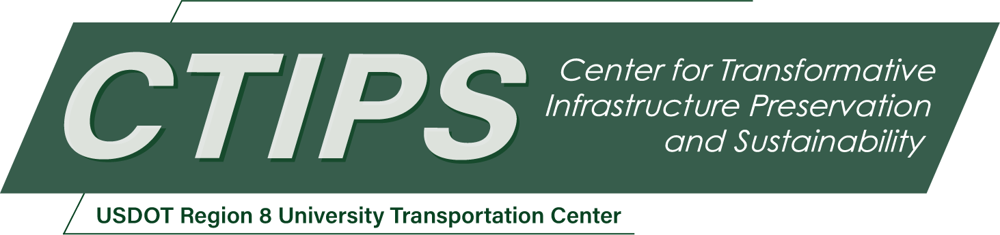

# Creating Multimedia Resources for Engineering Curriculum on Environmental and Social Impacts and Sustainability Aspects of Transportation Projects

*CTIPS-039 – UTC Project Information*

|  |  |
| --- | --- |
| **Recipient/Grant Number:** | North Dakota State University, Colorado State University  Grant No. 69A3552348308 |
| **Center Name:** | Center for Transformative Infrastructure Preservation and Sustainability |
| **Research Priority:** | Preserving the Existing Transportation System |
| **Principal Investigator(s):** | Pinar Omur-Ozbek, Ph.D. |
| **Project Partners:** | USDOT, Office of the Assistant Secretary for Research and Technology – $30,000  Colorado State University – $30,000 |
| **Total Project Cost:** | $60,000 |
| **Project Start and End Date:** | 11/26/2024 to 11/25/2026 |

## Project Description

Transportation projects have significant environmental impacts including air, water and noise pollution, habitat disruption and land use alterations. These environmental impacts also affect the communities, some more than others. As ethical engineers, it is our responsibility to be guardians of public safety and to protect the environment. Transportation projects have great potential in engaging in and promotion of sustainable and equitable practices, however in engineering curriculum, we often skip discussions on the environmental and social impacts, and sustainability considerations of transportation practices. This is mainly due to lack of easily accessible and interactive resources. This project aims to fill this gap, through development of educational multimedia resources that faculty can easily access, adopt and share with their students. This project will integrate essential content on transportation projects with environmental impacts assessment of transportation applications, sustainability considerations of materials used for transportation projects, and the ethical and social justice dimensions of transportation projects. The educational resources will include materials (active learning activities, examples, discussion prompts), short informative videos, resources list for related content, interviews with experts in environmental impact assessment, sustainability and social justice in transportation. The multimedia materials will be hosted through the website created by the CSU CEE Department.

## USDOT Priorities

This initiative aligns with the U.S. Department of Transportation's long-term strategic goals, particularly in the areas of Safety, Climate and Sustainability, and Equity. By integrating sustainability, ethics, and social justice considerations into our curriculum, this project aims to contribute to a safer, more equitable, and environmentally sustainable transportation infrastructure and practices. As presented in the above sections, the project objectives and expected outcomes overlap well with the U.S. DOT’s strategic goals. Creating and covering new course content on social and environmental justice, ethics, and sustainability will allow us to educate the next generation of transportation engineers and make them aware of the considerations beyond the technical content.

## Outputs

1. Educational Multimedia Resources: Development of an online repository of educational materials:

* Short informative videos on environmental impact assessment, sustainable transportation practices, and ethical decision-making.
* Active learning activities such as case studies and group discussions that engage students in analyzing real-world transportation projects.
* Discussion prompts and examples designed to foster classroom conversations on equity, sustainability, and social justice in transportation.
* Interviews with experts in environmental impact assessment, sustainability, and social justice in transportation, providing students with diverse perspectives.
* Resource lists for further exploration of related topics.

1. New Teaching Modules: Creation of teaching modules on the social and environmental justice aspects of transportation projects, integrating technical content with ethics and sustainability.
2. Collaborative Partnerships: Establishment of partnerships with transportation agencies, environmental NGOs, and academic experts outside of the CSU community to provide guest lectures and real-world project data for classroom use.

## Outcomes/Impacts

* Curriculum Enhancement: Increased integration of sustainability and social justice topics in transportation engineering courses, leading to a more comprehensive curriculum.
* Student Preparedness and Improved Decision Making: Graduates entering the workforce with a deeper understanding of the ethical, social, and environmental impacts of transportation projects, making them better prepared to design equitable and sustainable solutions. Encouragement of sustainable decision making in transportation project design, contributing to reduced environmental impacts, minimized habitat disruption, and more equitable land-use planning.
* Influence on Practice and Policy: Adoption of active learning modules and case studies by transportation engineering educators nationwide improving the student learning. Potential use of developed materials in professional training programs, influencing the practices of transportation agencies and consultants, such as the need for environmental impact assessment and inclusive community engagement during project planning stages.
* Climate and Sustainability Benefits: Long term reductions in greenhouse gas emissions due to more sustainable transportation design choices inspired by the curriculum improvements, contributing to U.S. DOT’s goals for climate resilience.

## Final Report

Upon completion, the final report link will be added to the [project page on the CTIPS website](https://www.ctips.org/projects/details.php?id=637).