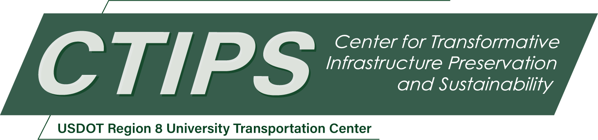

# Driving Futures: Empowering Tribal Communities through CDL Training Hub and Infrastructure Sustainability

*CTIPS-038 – Full Project Description*

*Approved 10/17/2024*

## University

United Tribes Technical College

## Principal Investigators

Matthew Mastel

HEO/CVO Instructor

Academic Affairs

United Tribes Technical College

Phone: (701) 221-1571

Email: mmastel@uttc.edu

ORCID: 0009-0001-4588-9806

Shelby Martell

CTE & WIOA Coordinator

Academic Affairs

United Tribes Technical College

Phone: (701) 221-1412

Email: smartell@uttc.edu

ORCID: 0009-0003-0969-0159

## Description

The proposed activities include establishing a CDL testing hub, standardizing training methods across Tribal schools, and coordinating with relevant organizations. These activities aim to enhance workforce development and offer a multidisciplinary multimodal transportation education curriculum.

## Project Objectives

1. Establish a CDL testing hub for Tribal schools.
2. Standardize training methods for Commercial Driving programs.
3. Foster collaboration among Tribal schools and transportation organizations.
4. Enhance workforce development opportunities for students.

## Relevance to Strategic Goals

This project aligns with the USDOT strategic goal of Economic Strength and Global Competitiveness by enhancing workforce development in the transportation sector. Additionally, it promotes equity by providing opportunities for students from Tribal communities to access high-quality education and employment opportunities.

## Outputs through Technology Transfer

United Tribes Technical College (UTTC) will be working with the other Tribal Schools around the state of North Dakota to develop a uniform Curriculum. Along with the Curriculum, UTTC will become a central testing facility for students to take their driver’s test. This will help people enter the workforce sooner than having to wait for the North Dakota DOT, which will help the shortage of truck and bus drivers. UTTC also involves professional development for instructors to meet with industry leaders to see if any changes need to be made for our students to become successful.

## Expected Outcomes and Impacts

The project will result in strengthened educational and workforce development programs, providing students with valuable skills and opportunities for professional growth. Long-term impacts include improved infrastructure sustainability and enhanced community engagement.

## Work Plan

1. Establish CDL testing hub (Months 1-3)
2. Coordinate with Tribal schools and transportation organizations (Months 4-6)
3. Standardize training methods (Months 7-9)
4. Implement post-testing events and community engagement activities (Months 10-12)

## Project Cost

Total Project Costs: $ 205,542

CTIPS Funds Requested: $ 100,000

Matching Funds: $ 105,542

Source of Matching Funds: United Tribes Technical College