

# Using Automated Low-Cost Track Monitoring Technologies for Rail Thermal Buckling Prevention

*CTIPS-037*

*Approved 9/18/2024*

## University

University of Utah

## Principal Investigators

Xuan Zhu, Ph.D., Assistant Professor

Dept. of Civil and Environmental Engineering

University of Utah

Phone: (801) 585-7961

Email: xuan.peter.zhu@utah.edu

ORCID: 0000-0002-5360-3222

## Research Needs

Safety is the principal concern of the railway industry, and track alignment irregularities pose risks to the safe operation of trains. According to the Federal Railroad Administration (FRA) accident database, ‘Track alignment irregular (buckled/sun kink)’ is the most severe accident cause. It has led to more derailed cars than other causes between 1999 and 2018. Further, these accidents have led to $250M in reportable damage. Effective management of longitudinal rail force is crucial to prevent track thermal buckling. Significant effort has been invested over the past 30 years to develop a technology that characterizes the rail stress state. The PI’s team recently performed a comprehensive review and covered a broad range of technologies for rail neutral temperature (RNT) estimation1, covering physical phenomena of static deformations, mechanical vibrations, stress waves, magnetoelasticity, and resonance fluorescence. The rail uplift approach, originally proposed and validated by Kish2, has been widely accepted by the industry. Despite being more convenient to operate than rail cutting, the method has limitations and is still time-consuming in execution. It requires unclipping the rail 30 to 40 ft on both sides of the lifting point3, and the commercial product VERSE® is only applicable when the rail is in a state of tension. Approaches relying on mechanical vibrations have also been investigated for its sensitivity to axial loads and potential for portable solutions. The Transportation Technology Center evaluated the performance of D’stresen, whose performance is affected by support conditions (spiked rail, elastic fasteners, rail seats, tie types and conditions, ballast)4. Boggs et al. investigated resonance frequencies of flexural modes in rails as a proxy of longitudinal rail force, which is also significantly affected by varying support conditions in a field environment5. More recently, Damljanovic and Weaver exploited wavenumber rather than resonance frequencies of lateral flexural mode in rails6, whose performance depends on whether the model can capture wearing condition and material properties. Researchers studied video images to extract rail vibrational response and developed machine learning (ML) algorithms for RNT estimation7. Despite these efforts, the industry has not yet realized vibration-based technology for rapid rail thermal stress assessment.

## Research Objectives

The research objectives of this project include

* develop a data acquisition system for long-term local resonance measurement;
* deploy the developed system in the field over a 12-month period;
* train and evaluate ML-RNT predictive tool based on the field collected data; and
* present the results at national conferences and journal publications.

## Research Methods

The critical challenge of using vibrational measurements in a field environment is that the vibrational behavior of continuous welded rail (CWR) is drastically different from short rail samples usually used in laboratory studies. Global vibrational modes manifest themselves in a finite-length sample and are suppressed in CWR. Moreover, CWR typically resonates in much lower amplitudes than rail samples of finite length. Therefore, the proposal team will focus on high-frequency rail vibrations in CWR composed of stationary wave modes as proxies of longitudinal rail forces, and the proposed methodology will be based on the research outcomes of the PI’s previous FRA research effort1,8,9.

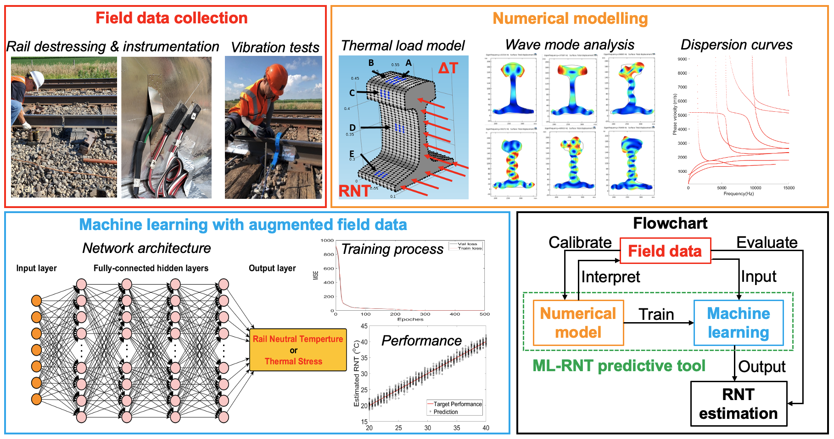

*Figure 1. Developed ML-RNT predictive tool using local resonances and temperature to estimate RNT.*

The overall framework of the machine learning for RNT (ML-RNT) predictive tool developed through our FRA research effort is shown in Figure 1. The envisioned system estimates in-situ RNT using directly measurable quantities, rail temperature and local resonant frequencies, as input. The PI’s team collected local resonance data, in terms of amplitude spectra, from revenue-service sites along with rail temperature, thermal load, and RNT. Moreover, we used numerical models to simulate local resonance behavior and verified that resonances observed in amplitude spectra are caused by the unique guided waves, zero-group velocity (ZGV) modes andcutoff frequency resonances. Once we understood the collected field data, ML models were trained for RNT estimation.

## Relevance to Strategic Goals

The ML-RNT predictive tool technology to be improved and verified in this proposal has a great potential for rail thermal stress measurement. Based on FRA safety statistics, rail thermal buckling and internal defects are among the top rail accident causes for railroad networks in the U.S. The proposed sensing and data processing technologies for local rail vibration promotion will enable rail internal condition characterization (thermal stress and internal defect detection) with high accuracy and immune from influences of boundary conditions. The proposed research primarily addresses the USDOT strategic goal of Safety. The specific rail thermal buckling prevention has become increasingly challenging with the raising average temperature and more frequent extreme heat events. Therefore, the proposed research also addresses the USDOT strategic goal of Climate and Sustainability.

## Educational Benefits

One Ph.D. student will be involved in the analytical and experimental work. The PI and the student will make presentations at national conferences, such as the SPIE Smart Structures + NDE conference and International Workshop of Structural Health Monitoring.

## Outputs through Technology Transfer

The main objective of this research is to develop a reliable approach for high-frequency local rail vibration excitation, which has potential applications of RNT measurement. There is a need for developing such innovative technology and the proposal addresses that need. The resulting technology will lead to sensing systems that are capable of thermal stress measurement and management. The work will be presented at conferences, such as the SPIE Smart Structures+NDE conference and International Workshop of Structural Health Monitoring, and leading journals, such as the Journal of Structural Health Monitoring. In addition, technology transfer will occur through journal publications.

## Expected Outcomes and Impacts

Expected outcomes and impacts include improving rail safety by developing accurate RNT measurement technology. The proposed research will contribute to further improvement and verification of the ML-RNT predictive tool, which can support nondestructive and non-disrupting RNT measurement without the need for baseline measurement. The proposed long-term data collection system and ML models will contribute to stress-sensitive information extraction and a better understanding of wave propagation in rails. While boundary condition variations prevent existing vibration-based technologies to provide accurate RNT measurement, the proposed technology is highly likely to be not influenced by variations of tie conditions, clippers, and fasteners.

## Work Plan

Throughout this study, a low-cost data acquisition system will be developed and deployed for long-term field data collection. The collected data (local resonances, rail temperature, and RNT) will be used to train and further improve the statistical ML models. The proposed study will consist of the following tasks:

**Task 1. Develop a data acquisition system for long-term measurement – 6 months**

The existence of local resonances associated with ZGV and cutoff frequency points in rails was recently reported by the PI’s team, which has great potential for RNT measurement. As shown in Figure 2, both the cutoff frequency resonance in the vicinity of 85 kHz and a ZGV resonance close to the 92 kHz are clearly identified in a free rail and a CWR, where a piezoelectric patch and a broadband ultrasound sensor were used. In this task, the team will develop an automated data acquisition system that can perform local resonance data collection with a fixed time interval. We will use National Instruments data acquisition hardware and LabVIEW to materialize the target performance. The NI system will apply a 2-Volt chirp signal from 20 to 120 kHz on the piezoelectric patch and record the local responses via digitizing the waveforms collected by broadband ultrasound sensors. Automating this data acquisition and storage process enables the long-term monitoring of rail local resonance frequencies, which are functions of RNT. By incorporating the existing capabilities on data streaming of rail temperature and RNT, the team will establish a large dataset for ML model training.

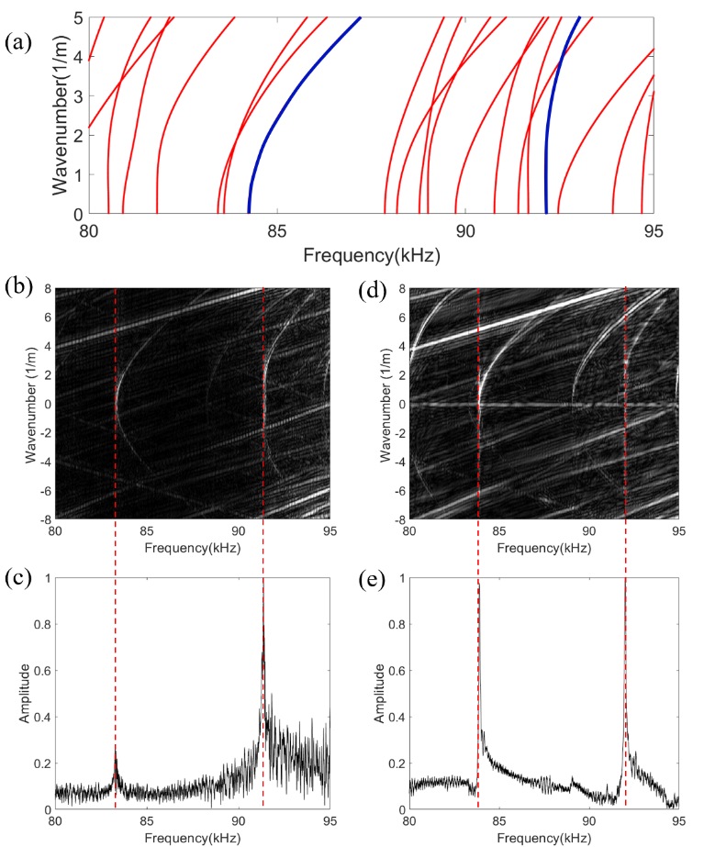

*Figure 2. (a) Dispersion curves predicted by SAFE. Dispersion relations and local resonances collected from (b & c) a free rail and (d & e) CWR.*

**Task 2. Deploy the system to the revenue-service site – 12 months**

The data acquisition mechanism will be automated such that the system can perform field data collection every ten minutes over six project months. Moreover, the instrumented sites supported by our instrumentation contractor (ISI rail) will stream and record data of rail temperature, thermal stress, RNT, and passing trains, as shown in Figure 3. Such a system was installed and calibrated during the track construction of the Frontrunner track operated by Utah Transit Authority (UTA), which provides the ground truth of zero force, and has been used for the previous FRA project. The updated system can keep collecting and storing data over the project period. The system installation, repair, and maintenance will be done via site visits. The team has been collaborating and coordinating with UTA for this project, where they will support and oversee the instrumentation and data collection.

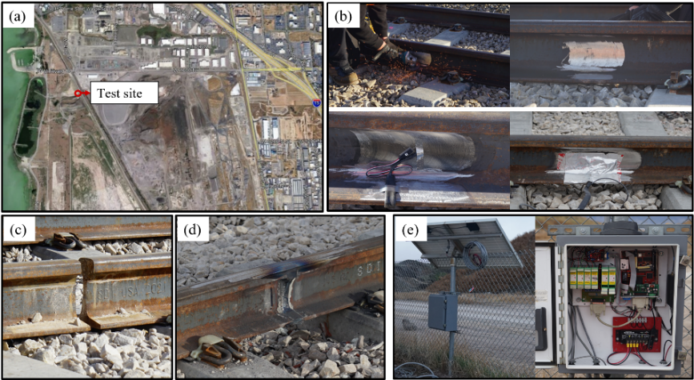

*Figure 3 (a) Instrumented site, (b) rail instrumentation, (c & d) welding process, and (e) DAQ system.*

**Task 3. Train and evaluate ML-RNT predictive tool – 6 months**

Upon the completion of Task 2, the team will train the ML-RNT predictive tool and evaluate its effectiveness. We will explore using probabilistic ML models, including Gaussian process and Student-t process, for RNT prediction. The local resonance frequencies collected with the long-term data acquisition system as well as rail temperatures will serve as the features for the input of ML algorithms. Meanwhile, the Gaussian kernel and Matern kernel will be used for RNT predictions. Features (different ZGV and cutoff frequency resonance frequencies) will be ranked by the Laplacian scores for feature selections. As a comparison, artificial neural network (ANN) will be used to predict the RNTs. As shown in Figure 4, our preliminary results indicate that the probabilistic models are well capable of coping with RNT predictions. Bayesian information criterion was used to balance model complexity and data scale. The root mean squared errors by Student-t process is the smallest. Moreover, the probabilistic models can also give the predictions variance which is unavailable for ANN.

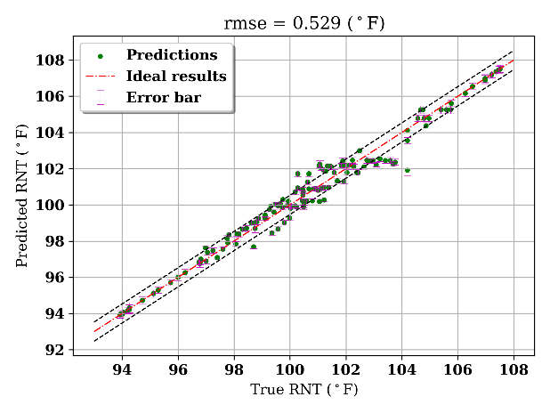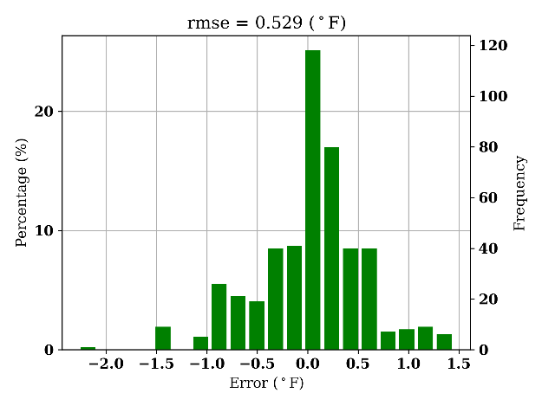

*Figure 4. Performance of a Gaussian Process and Matern kernel for RNT prediction with a small dataset.*

## Project Cost

Total Project Costs: $ 162,000

CTIPS Funds Requested: $ 81,000

Matching Funds: $ 81,000

Source of Matching Funds: Association of American Railroads

## References

[1] Huang, C.L., Wu, Y., He, X., Dersch, M., Zhu, X. and Popovics, J.S., 2023. A review of non-destructive evaluation techniques for axial thermal stress and neutral temperature measurement in rail: Physical phenomena and performance assessment. *NDT & E International*, 137, p.102832, doi: 10.1016/j.ndteint.2023.102832.

[2] Kish, A., Samavedam, G., 1987. Longitudinal force measurement in continuous welded rail from beam column deflection response. *Proceedings of the American Railway Engineering Association*, 1987, 88, pp. 280-301.

[3] Tunna J., 2000. Vertical rail stiffness equipment (VERSE®) trials*. Letter Report for Vortex International Transportation Technology Center, Inc.* Pueblo, CO.

[4] Read, D., 2008. Investigation of D’stresen rail neutral temperature measurement system. *Technology Digest*.

[5] Béliveau, J.G. et al., 1995. Determination of lateral stiffness and axial load in rails from low-frequency flexural vibrations. S*tability problems related to aging, damaged & deteriorated structures*, pp. 129-138.

[6] Damljanović, V. and Weaver, R. L., 2005. Laser vibrometry technique for measurement of contained stress in railroad rail. *Journal of Sound and Vibration*, 282(1-2), pp. 341-366, doi: 10.1016/j.jsv.2004.02.055.

[7] Enshaeian, A. et al. 2021. A contactless approach to monitor rail vibrations. *Experimental Mechanics*, vol. 61, no. 4, pp. 705–718, doi: 10.1007/s11340-021-00691-z.

[8] Wu, Y., Zhang, K., Zhang, P., Zhu, X. and Popovics, J.S., 2023. Dynamic behavior of a zero-group velocity guided mode in rail structures. *JASA Express Letters*, 3(10), doi: 10.1121/10.0021186.

[9] Wu, Y., Cui, R., Zhang, K., Zhu, X. and Popovics, J.S., 2022. On the existence of zero-group velocity modes in free rails: Modeling and experiments. *NDT & E International*, 132, p.102727, doi: 10.1016/j.ndteint.2022.102727.