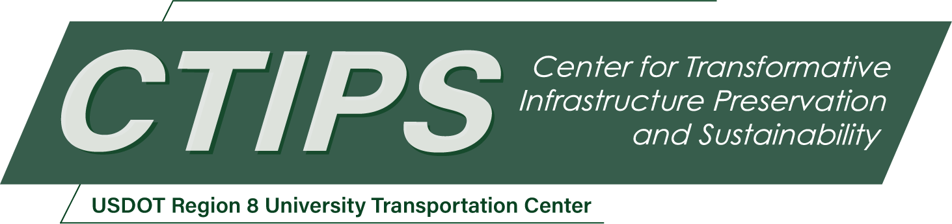

# Using Automated Low-Cost Track Monitoring Technologies for Rail Thermal Buckling Prevention

*CTIPS-037 – UTC Project Information*

|  |  |
| --- | --- |
| **Recipient/Grant Number:** | North Dakota State University, University of Utah  Grant No. 69A3552348308 |
| **Center Name:** | Center for Transformative Infrastructure Preservation and Sustainability |
| **Research Priority:** | Preserving the Existing Transportation System |
| **Principal Investigator(s):** | Xuan Zhu, Ph.D. |
| **Project Partners:** | USDOT, Office of the Assistant Secretary for Research and Technology – $81,000  Association of American Railroads – $81,000 |
| **Total Project Cost:** | $162,000 |
| **Project Start and End Date:** | 9/18/2024 to 9/17/2026 |

## Project Description

Safety is the principal concern of the railway industry, and track alignment irregularities pose risks to the safe operation of trains. According to the Federal Railroad Administration (FRA) accident database, ‘Track alignment irregular (buckled/sun kink)’ is the most severe accident cause. include improving rail safety by developing accurate rail neutral temperature (RNT) measurement technology. The proposed research will contribute to further improvement and verification of the machine learning (ML)-RNT predictive tool, which can support nondestructive and non-disrupting RNT measurement without the need for baseline measurement. The proposed long-term data collection system and machine learning models will contribute to stress-sensitive information extraction and a better understanding of wave propagation in rails.

## USDOT Priorities

The ML-RNT predictive tool technology to be improved and verified in this proposal has a great potential for rail thermal stress measurement. Based on FRA safety statistics, rail thermal buckling and internal defects are among the top rail accident causes for railroad networks in the U.S. The proposed sensing and data processing technologies for local rail vibration promotion will enable rail internal condition characterization (thermal stress and internal defect detection) with high accuracy and immune from influences of boundary conditions. The proposed research primarily addresses the USDOT strategic goal of Safety. The specific rail thermal buckling prevention has become increasingly challenging with the raising average temperature and more frequent extreme heat events. Therefore, the proposed research also addresses the USDOT strategic goal of Climate and Sustainability.

## Outputs

The main objective of this research is to develop a reliable approach for high-frequency local rail vibration excitation, which has potential applications of rail neutral temperature measurement. There is a need for developing such innovative technology and the proposal addresses that need. The resulting technology will lead to sensing systems that are capable of thermal stress measurement and management. The work will be presented at conferences, such as the SPIE Smart Structures+NDE conference and International Workshop of Structural Health Monitoring, and leading journals, such as the Journal of Structural Health Monitoring. In addition, technology transfer will occur through journal publications.

## Outcomes/Impacts

Expected outcomes and impacts include improving rail safety by developing accurate RNT measurement technology. The proposed research will contribute to further improvement and verification of the ML-RNT predictive tool, which can support nondestructive and non-disrupting RNT measurement without the need for baseline measurement. The proposed long-term data collection system and machine learning models will contribute to stress-sensitive information extraction and a better understanding of wave propagation in rails. While boundary condition variations prevent existing vibration-based technologies to provide accurate RNT measurement, the proposed technology is highly likely to be not influenced by variations of tie conditions, clippers, and fasteners.

## Final Report

Upon completion, the final report link will be added to the [project page on the CTIPS website](https://www.ctips.org/projects/details.php?id=635).