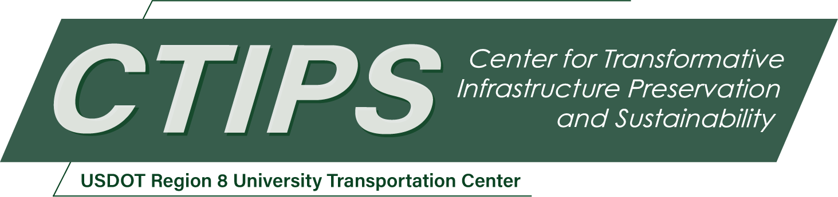

# Delamination of Partial-Depth Panels in Concrete Bridge Decks: Inspection and Repair

*CTIPS-035*

*Approved 9/15/2024*

## University

University of Utah

## Principal Investigators

Chris P. Pantelides, Ph.D.

Professor, Dept. of Civil and Environmental Engineering

University of Utah

Phone: (801) 599-0643

Email: c.pantelides@utah.edu

ORCID: 0000-0003-3309-3488

## Research Needs

Safety of bridges is of major importance for the traveling public. Partial-depth precast concrete deck panels (PDDPs) are relatively thin precast prestressed concrete panels that span between girders which combine to act compositely with a cast-in-place (CIP) concrete topping to provide the full structural thickness of a bridge deck. Recommendations for improved details and guidelines for PDDPs to accelerate bridge construction in California have been published (Matsumoto 2016). PDDPs have some advantages including faster and safer construction, ease of design, improved quality, and accelerated bridge construction duration (FHWA 2022).

A potential concern regarding partial-depth concrete deck panels is that the CIP deck will experience substantial amounts of cracking, typically exhibited as reflective cracking of the panel edges. In Utah, some failures of PDDPs have been observed on the 800 South Bridge on Interstate 15. A proposed solution for these failures is epoxy injection which has some challenges with real world application. Finding the delamination is one problem but so is having some assurance that the delamination has been adequately filled with epoxy when you know one is "in the area" but not necessarily perfectly defined. Increasing the challenge is the application of the epoxy from below the bridge deck to minimize disruption to traffic.

The proposed project involves experiments during which epoxy injection will take place from below the deck so that there is no traffic interruption. The project will address the need to determine the number of ports to ensure that the epoxy will reach the delaminated deck and verify that the repair installation is successful. The proposed project will develop a numerical model to replicate the experiments and extend the application to realistic bridge deck panel configurations. Finally, the proposed project will result in guidelines for applying the repair method and draft specifications.

## Research Objectives

The main objective of this research project is to develop implementation methods in the laboratory for repairing delaminated partial-depth precast bridge deck panels using epoxy injection from below the bridge deck and provide recommendations for field implementation.

The topic of this project is important since recent failures of partial depth bridge decks have shown that closure of the bridge may be required for removal and replacement. The current repair method involves removing complete sections of the deck and replacing them with rapid hardening hydraulic cement concrete. This has a detrimental effect on travel times and cost. If the research is successful, the bridge deck repair can be performed from below the bridge deck without interruption to traffic and the installation would be verified. This benefits UDOT in that there would not be delays or closures of such bridge decks. Moreover, such repairs improve serviceability and durability of bridges.

## Research Methods

This project involves experimental methods, numerical analysis methods and field observation of actual implementation. Research methods involved in this project include:

* Investigate the distribution of the epoxy injection in the delaminated panel and the effectiveness of the epoxy injection repair method under realistic conditions using laboratory experiments
* Develop finite element numerical models to predict the response of delaminated and repaired decks and compare the numerical results with the experiments
* Carry out field observations of actual implementation of epoxy injection in a Utah bridge

## Relevance to Strategic Goals

The proposal is relevant to the Safety USDOT Strategic goal. The proposed project improves the safety of bridges by improving horizontal shear transfer in bridge decks. The use of epoxy injection materials, innovative practices of epoxy injection, and improved finite element analysis of such bridge decks will enhance their performance and longevity. The project improves bridge managementsince the repair methods will result in low-crack bridge decks and promote their serviceability and durability. The research will assist in estimating safe loads for existing bridge decks based on the composite performance of bridge decks constructed with partial depth panels and a cast in place concrete topping. Finally, the project promotes bridge resilience since the experiments and the finite element model will improve our understanding of material deterioration and repair techniques.

## Educational Benefits

Under the supervision of the PI two graduate students are directly involved with every aspect within the proposed research. This includes specimen preparation, design, data analysis, development of a finite element program, application guidelines and draft specifications. This research will contribute to the course offered in Bridge Design at the University of Utah.

## Outputs through Technology Transfer

Outcomes from this project are expected to have multiple avenues for technology transfer activities, including a seminar and presentations to researchers and practitioners, as well as serving as a significant step towards further development into guidelines related to repair of bridge decks of similar construction but also extending to general repair methods for bridge decks. The guidelines and specifications are expected to lead to a sustainable program for maintenance of such bridge decks and ultimately improve safety.

In terms of the proposed seminar and presentations, among a number of alternatives, the PI is expected to accomplish the following:

* Seminar as part of UDOT’s Continuing Education program using a hybrid format with participants joining in person and online. Such seminars are widely attended by practitioners from the agency as well as consultants in the area, both within the state and regionally.
* Presentation to the annual Utah Transportation Conference.
* Webinar for practitioners through the Transportation Learning Network.
* Conference presentation to disseminate the outcomes of the project, with a main target being TRB’s Annual Meeting. Likewise, technical committee presentations are an open avenue for such presentations with multiple committees as potential target in the project’s topic.

Enhancements to the proposed project will allow the PI to disseminate the research outcomes and finite element method results through avenues discussed in coordination with UDOT. Thus, the outcomes of the project will have further potential to reach practitioners and researchers through the recommendations and specifications to be developed which will be directly available through a website maintained by the PI or through a site provide by UDOT.

## Expected Outcomes and Impacts

This research is expected to provide the following research outcomes:

* A new methodology to repair delaminated bridge deck panels from below the deck using epoxy injection methods based on experimental evidence.
* Develop a numerical analysis finite element program that simulates the experimental results of the proposed repair method.
* Develop guidelines for repair/strengthening methods, draft working drawings, and draft specifications. Several recommendations will be made including how many ports are required for the epoxy injection, how much epoxy is feasible to penetrate the interface, and how many verification holes for epoxy penetration are required.

Altogether, this research is expected to produce a significant advancement of addressing the repair of bridge decks with delaminated partial depth panels and cast in place concrete topping. Guidelines for such repairs will be developed and widely disseminated though research reports and journal publications. This will result in preserving bridge decks by improving serviceability and durability, thus extending their lifespan and improving infrastructure resilience.

## Work Plan

The following are the proposed major tasks required to accomplish the project objectives, which will require approximately two calendar years to complete:

**Task 1 - Review relevant literature on existing repair methods (3 months)**

All repair methods will be investigated with preference to methods that involve working underneath the deck. Emphasis will be placed on literature regarding available repair methods using epoxy injection and delamination detection. The review will focus on epoxy injection methods including the effect of chlorides on the bond of epoxy to concrete.

**Task 2 - Investigate the distribution of epoxy injection (3 months)**

The composite panels will be constructed by using a 3.5 in. thick precast and prestressed concrete panel portion and a 5.0 in. thick cast-in place reinforced concrete deck portion. Delamination between the precast and cast-in-place portion of the panels will be achieved using vegetable oil and care will be taken to localize it such that delamination of a specific area will take place. Pre-determined localized known areas will be delaminated in the form of a “donut” or a “U-shape” to simulate field conditions. The planned laboratory method of epoxy injection will be carried out from the underside of the deck panels.

After the delaminated deck panels are repaired with epoxy injection, they will be tested to verify the extent of filling the known (created) delamination with epoxy; push-off tests are proposed as well as concrete cutting. Several questions need to be answered: (a) whether it is necessary to flush the voids; (b) how chlorides affect the epoxy bond – this will be studied using some of the push-off and beam-type (described in Task 3) specimens using a 23% saltwater solution; (c) develop a method to test and validate the repair in the field – determined by the amount of epoxy that is able to penetrate the interface between the precast and cast-in-place portions of the deck panel; extra verification holes will be drilled into the push-off and beam-type specimens and used to detect areas of epoxy penetration.

**Task 3 - Investigate effectiveness of the epoxy injection under realistic conditions (12 months)**

Eight panels will be built, 48 in. wide by 92 in. long, and tested under three-point beam-type cyclic loads, as shown in Figure 1. One panel will be tested without delamination (control) for comparison, one panel will be tested with 100% are of delamination, and six panels will be partially delaminated, repaired with epoxy injection and tested. In addition, the following two variables will be studied: (i) flushing with air/water or other solvent; this would not only clean the surface but also indicate the connection of ports to the delamination; (ii) investigate any potential negative effects of vibration (low cycle deformation) on the polymerization of the epoxy; low cycle deformation of the deck panel will be enforced during the cure before the beam-type load test.

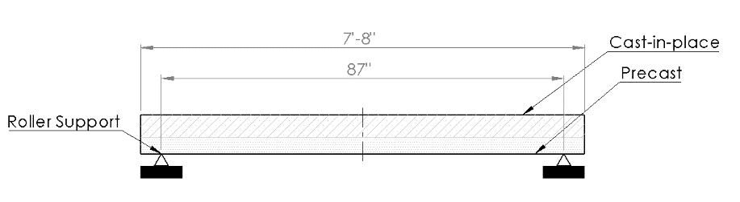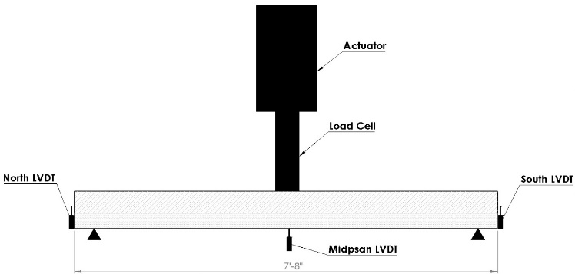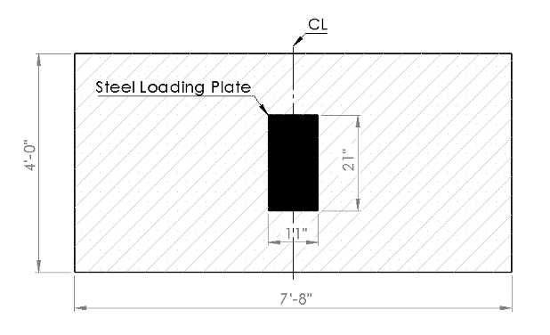

Figure 1. Test panel and schematic of beam-type loading and instrumentation.

**Task 4 - Develop numerical models to predict the response of delaminated and repaired decks (6 months)**

A finite element program will be developed to determine the strength and displacement capacity of the deck panels based on the extent of the delamination. This will involve a finite element analysis to capture details of the deck panels and their expected performance; this includes modeling delamination of partial depth precast deck panels, as well as modeling of the repaired panels. The finite element model will be used to verify the experimental results and extend the application to realistic bridge decks.

**Task 5 - Field observation of actual implementation**

UDOT is planning to repair an existing bridge deck with delaminated partial-depth panels during the duration of the proposed project. Even though the field repair is planned to be carried out from the top of the bridge deck, the researchers are planning to participate in observing the process which undoubtedly will benefit this project. The researchers will observe the top-side epoxy injection deck field repair. This provides an opportunity to see the effectiveness of the repair and improve application details in real life.

## Project Cost

Total Project Costs: $248,740

CTIPS Funds Requested: $124,370

Matching Funds: $124,370

Source of Matching Funds: Utah Department of Transportation – $84,247

University of Utah – $22,953

Contech Engineered Solutions – $17,170

## References

Federal Highway Administration (FHWA) 2022. Partial-depth Precast Concrete Deck Panels: State-of-the-Practice Report. Publication No. FHWA-HIF-22-031. <https://rosap.ntl.bts.gov/view/dot/72981/dot_72981_DS1.pdf>

Matsumoto, E. E. 2016. “Recommendations for improved details and guidelines for partial-depth precast deck panels to accelerate bridge construction in California.” Precast/Prestressed Concrete Institute-National Bridge Conference. <https://www.pci.org/PCI_Docs/Papers/2016/Recommendations-for-Improved-Details-and-Guidelines-for-Partial-Depth-Precast-Deck-Panels-To-Accelerate-Bridge-Construction-in-California.pdf>