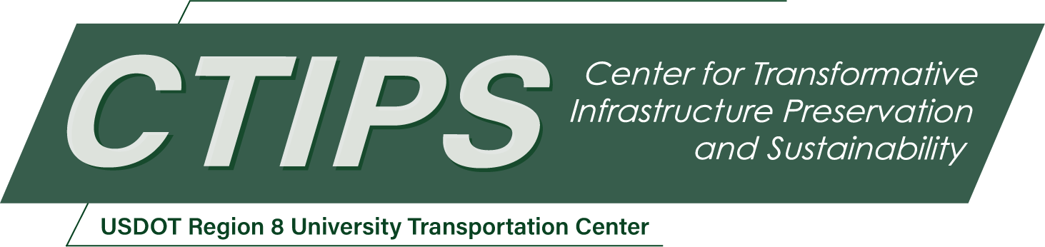

# Delamination of Partial-Depth Panels in Concrete Bridge Decks: Inspection and Repair

*CTIPS-035 – UTC Project Information*

|  |  |
| --- | --- |
| **Recipient/Grant Number:** | North Dakota State University, University of Utah  Grant No. 69A3552348308 |
| **Center Name:** | Center for Transformative Infrastructure Preservation and Sustainability |
| **Research Priority:** | Preserving the Existing Transportation System |
| **Principal Investigator(s):** | Chris P. Pantelides, Ph.D. |
| **Project Partners:** | USDOT, Office of the Assistant Secretary for Research and Technology – $124,370  Utah Department of Transportation – $84,247  University of Utah – $22,953  Contech Engineered Solutions – $17,170 |
| **Total Project Cost:** | $248,740 |
| **Project Start and End Date:** | 9/15/2024 to 9/14/2026 |

## Project Description

Delamination of bridge decks at the interface between precast concrete deck panels and the cast-in-place concrete portion has been observed which causes non-composite behavior and results in deck damage which affects the serviceability and durability of bridge decks. The main objective of this research project is to develop implementation methods in the laboratory for repairing delaminated partial-depth precast bridge deck panels using epoxy injection from below the bridge deck and provide recommendations for field implementation. The topic of this project is important since recent failures of partial depth bridge decks have shown that closure of the bridge may be required for removal and replacement. The current repair method involves removing complete sections of the deck and replacing them with rapid hardening hydraulic cement concrete. If the research is successful, the bridge deck repair can be performed from below the bridge deck without interruption to traffic and the installation could be verified. This benefits UDOT in that there would not be delays or closures of such bridge decks.

## USDOT Priorities

The proposal is relevant to the Safety USDOT Strategic goal. The proposed project improves the safety of bridges by improving horizontal shear transfer in bridge decks. The use of epoxy injection materials, innovative practices of epoxy injection, and improved finite element analysis of such bridge decks will enhance their performance and longevity. The project improves bridge management since the repair methods will result in low-crack bridge decks and promote their serviceability and durability. The research will assist in estimating safe loads for existing bridge decks based on the composite performance of bridge decks constructed with partial depth panels and a cast in place concrete topping. Finally, the project promotes bridge resilience since the experiments and the finite element model will improve our understanding of material deterioration and repair techniques.

## Outputs

Outcomes from this project are expected to have multiple avenues for technology transfer activities, including a seminar and presentations to researchers and practitioners, as well as serving as a significant step towards further development into guidelines related to repair of bridge decks of similar construction but also extending to general repair methods for bridge decks. The guidelines and specifications are expected to lead to a sustainable program for maintenance of such bridge decks and ultimately improve safety.

## Outcomes/Impacts

This research is expected to produce a significant advancement of addressing the repair of bridge decks with delaminated partial depth panels and cast in place concrete topping. Guidelines for such repairs will be developed and widely disseminated though research reports and journal publications. This will result in preserving bridge decks by improving serviceability and durability, thus extending their lifespan and improving infrastructure resilience.

## Final Report

Upon completion, the final report link will be added to the [project page on the CTIPS website](https://www.ctips.org/projects/details.php?id=633).