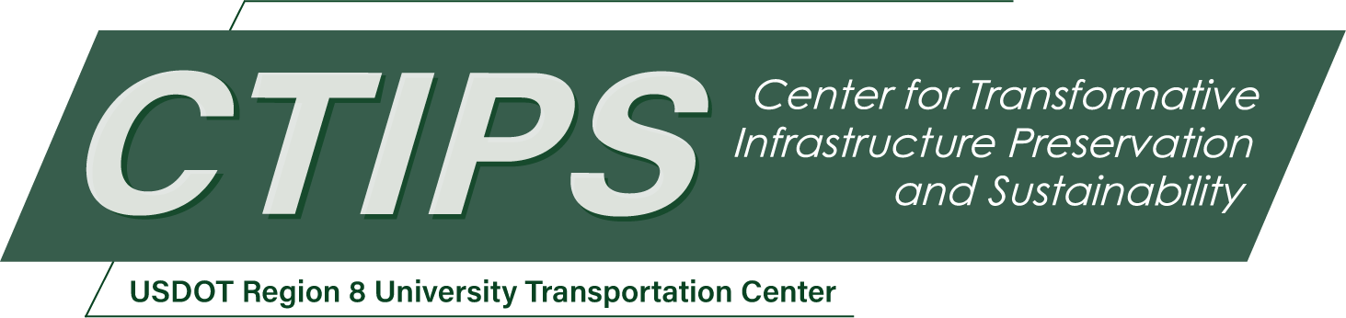

# Evaluating Pavement Preservation Performance in Dry Freeze and Wet Freeze Regions Using LTPP Dataset and a Questionnaire Survey

*CTIPS-034 – UTC Project Information*

|  |  |
| --- | --- |
| **Recipient/Grant Number:** | North Dakota State University, University of Wyoming  Grant No. 69A3552348308 |
| **Center Name:** | Center for Transformative Infrastructure Preservation and Sustainability |
| **Research Priority:** | Preserving the Existing Transportation System |
| **Principal Investigator(s):** | Shahbaz Khan, Ph.D.  Mohamed S. Yamany, Ph.D.  Khaled Ksaibati, Ph.D., P.E. |
| **Project Partners:** | USDOT, Office of the Assistant Secretary for Research and Technology – $101,048  Wyoming LTAP – $101,048 |
| **Total Project Cost:** | $202,096 |
| **Project Start and End Date:** | 9/15/2024 to 9/14/2026 |

## Project Description

The main goal of this proposed research project is to evaluate the effectiveness of various preventive maintenance treatments in cold regions, including both dry-freeze and wet-freeze areas. To achieve this, the project will begin with a comprehensive review of state-of-the-art practices and established methodologies in preventive maintenance. Following this, the research will involve collecting long term pavement performance data on pavement conditions and preventive maintenance treatments.

A questionnaire survey will be developed to gather information on current preventive maintenance techniques and their perceived effectiveness in cold regions across the United States. Statistical analysis will then be conducted to identify and assess the significant factors influencing the effectiveness of these maintenance treatments. The final objective is to evaluate the impact of different preventive maintenance treatments by measuring performance improvements or immediate enhancements in pavement conditions following treatment application.

## USDOT Priorities

Climate and sustainability are primarily addressed by the proposed project. The primary goal of this proposed project is to determine the effective preventive maintenance technique for a pavement management system (PMS) in cold climatic regions. These regions include dry-freeze climatic zone, which is for the state of Wyoming. This research will help aid decision-makers in making better choices to ensure good preventive maintenance for their roads. This, in turn, supports the CTIPS statutory research priority area by aiding policymakers in preserving their current transportation systems in a sustainable manner. Improving the condition of pavements across dry-freeze and wet-freeze regions including Wyoming will lead to a better allocation of resources and a boost in customer satisfaction. The proposed system aims to help highway agencies in effectively implementing pavement preservation plans to align with the USDOT strategic goals and achieve socio-economic objectives.

## Outputs

The results and products of this project, such as developed effective maintenance preventive, decision trees, will be disseminated through peer-reviewed journal articles and showcased at scientific research conferences like the annual Transportation Research Board (TRB). This will help in transferring methodologies, results, and products to the national and international pertinent research communities. Workshops, seminars, and webinars will be arranged to further disseminate the research findings and communicate its outcomes with professionals, practitioners, and highway agencies. The incremental results and progress of this project will be consolidated in a semi-annual progress report. Upon the completion of this project, it will be synthesized along with recommendations and guidelines in a technical report.

## Outcomes/Impacts

The outcome of this research project will help to better understand the preventive maintenance techniques utilized in cold climatic regions. It includes the effectiveness of different preventive techniques in two regions of wet-freeze and dry-freeze. This effectiveness will be determined through LTPP dataset and the questionnaire survey. Finally, the outcome of this research can be used by policy makers to implement the best practices of preventive maintenance in their respective region.

## Final Report

Upon completion, the final report link will be added to the [project page on the CTIPS website](https://www.ctips.org/projects/details.php?id=632).