

# Developing a Prototype System for Measuring Intersection Sight Distances

*CTIPS-033*

*Approved 9/15/2024*

## University

University of Wyoming

## Principal Investigators

**Ahmed Farid**,Ph.D.

Transportation Engineering Researcher, Wyoming Technology Transfer Center

University of Wyoming

Phone: (307) 766-6743

Email: [afarid](mailto:ahmedtf91@knights.ucf.edu)@uwyo.edu

ORCID: 0000-0002-5101-3237

**Khaled Ksaibati**, Ph.D., P.E.

Professor, Civil & Architectural Engineering

University of Wyoming

Phone: (307) 766-6230

Email: [khaled@uwyo.edu](mailto:khaled@uwyo.edu)

ORCID: 0000-0002-9241-1792

**Suresh Muknahallipatna**, Ph.D.

Professor, Electrical & Computer Engineering

University of Wyoming

Phone: (307) 766-3174

Email: sureshm@uwyo.edu

ORCID: 0000-0003-4153-524X

## Research Needs

The intersection sight distance (ISD) is that from which drivers can see vehicles entering the intersection from the cross street and stop safely or avoid an impending collision if needed. The drivers’ views may be blocked by buildings or other objects as shown in Figure 1.

The minimum required ISD varies depending on a variety of factors, mainly the intersection’s control type, whether uncontrolled, priority-controlled, stop-controlled, signal-controlled, or rail crossing-controlled. Measuring the sight distances at existing or new intersections is performed manually (Smith et al., 2002). However, state-of-the-art measurement methods are available such as the light detection and ranging (LiDAR) method (Kilani, et al., 2021) or a geographic information system-based (GIS-based) method (Quan et al., 2022). In this research, a cutting-edge vehicle boardable prototype that measures ISDs will be developed and provided to the Wyoming Department of Transportation (WYDOT).

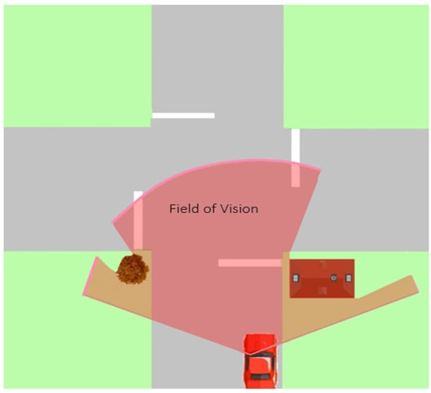

**Figure 1: Driver’s field of view**

Source: Kilani et al. (2021).

## Research Objectives

The objective of this research is to develop a vehicle boardable prototype for WYDOT that measures ISDs in real-time. With the prototype, WYDOT will be able to perform the following:

1. Assess/reassess the sight distances of existing and new intersections irrespective of type.
2. Reduce the costs of assessing ISDs since most of the process’s tasks are now automated.
3. Reduce intersection related crashes, mainly those that are attributed to inadequate sight distances.
4. Protect itself from liability in cases of crashes, especially severe ones, that occurred as a result of inadequate ISDs.
5. Assist local jurisdictions in efficiently assessing sight distances of existing and new intersections.

## Research Methods

### 1. Literature Review

A detailed literature review will be carried out on the local and federal ISD criteria, particularly the AASHTO Green Book’s guidelines (2018). The review will also cover ISD measuring methods including both the early and most recent ones that are documented in the transportation engineering literature.

### 2. Prototype Instrumentation Development and Software Setup

This research effort aims to develop a cutting-edge two-vehicle boardable prototype that measures the ISD of intersections in real-time. The proposed ISD prototype of the two-vehicle system will have the following functionalities implemented:

* Vehicle-to-vehicle (V2V) communication based on long-range (LoRa) communication protocol
* Global Positioning System (GPS) synchronized data collection for constructing the approach sight triangles
* Autonomous real-time detection of the vehicle on the major road (V_major)
* Graphical user interface-based (GUI-based) software program with a real-time visual display of the detected V_major vehicle and capability of storing images/measured data in the vehicle on the minor road (V_minor)

The proposed ISD prototype of the two-vehicle system comprises an integrated GPS-based V2V LoRa communication system in both vehicles. In addition to the V2V communication system, the V_minor vehicle will have a high-resolution multiple lens synchronized camera system and a laptop interfaced with the sensors providing a real-time graphical display to the driver. The high-resolution camera system in the V_minor vehicle will be mounted at 3.5 ft from the pavement surface, the typical height of the driver’s eye, and synchronized multiple lenses to have a maximum view of 180°. Depending on whether the left-approaching or right-approaching sight triangle is being investigated, the maximum view of the camera system will be restricted to 90° mimicking a driver’s eye view. The following content describes the system in more detail.

1. *GPS-based Approach Sight Triangles Construction System*

The software in both vehicles will read their raw GPS data and compute their respective driving speeds. The time-stamped, computed driving speeds, and corresponding raw GPS data are exchanged between the V_major and V_minor vehicles over the LoRa communication device. The computed driving speeds exchanged are used to provide feedback to the drivers to ensure speed synchronization of both vehicles. The raw GPS data of both vehicles are stored in the V_minor vehicle and are used to construct the approach sight triangles in real-time.

1. *Autonomous Real-Time Detection of the Major Road Vehicle System*

The high-resolution camera system in the V_minor vehicle will be synchronized with the GPS sensor. We propose developing a vehicle detection vision system (VDVS) to track the V_major vehicle continuously in real-time using a deep learning algorithm, namely the convolutional neural network (CNN) algorithm. The CNN algorithm is ideally suited to extract essential features in an image by exploiting local spatial correlation. The algorithm operates by performing a convolution of image sequences and detecting features learned through training. A CNN typically consists of multiple layers of neurons with the first layer detecting edges, which are vehicle edges in this context, and the subsequent layers learning to detect complex shapes. A training dataset consisting of V_major vehicle images will be used to train CNN to detect the presence or absence of a V_major vehicle in an image. Currently, a dataset of a vehicle approaching intersections does not exist. We propose manually creating an image dataset of vehicles approaching intersections in rural and urban settings. The dataset will consist of images with a vehicle and no vehicle on the major road of an intersection.

The input images of the V_major vehicle captured by the camera system in the V_minor vehicle will be tagged with the V_major vehicle's GPS coordinates and fed into the trained CNN to detect the presence or absence of the V_major vehicle in an image in real-time.

1. *Intersection Sight Distance Computation*

Depending on the maneuver being made by the vehicle on the minor road approach (whether turning right, crossing, or turning left), traffic control type, and other ISD criteria such as approach grades, the sight distance will be computed using the listed ISD in the AASHTO Green Book (2018) that corresponds to the intersection design speed and the output of the VDVS. The decision sight distance for the case in which a stop is required on a rural road, a scenario that is typical in Wyoming, will be incorporated in the list of sight distances as well. This distance is computed as the stopping sight distance (SSD) assuming a perception-reaction time of 3 s and a vehicle deceleration rate of 11.2 ft/s2 (AASHTO Green Book, 2018; Wyoming Department of Transportation, 2014). Note that the AASHTO Green Book’s (2018) ISDs of Case B1, which concerns vehicles on the minor road approach making left turns from a stopped state, are consistent with those of the local rural intersection safety manual (Golembiewski and Chandler, 2011). If the VDVS detects the presence of the V_major vehicle in an image, using the tagged GPS coordinates, the distance *b*, shown in Figures 2 and 3, is computed and stored in a list. The computation will resume, and its result will be stored for subsequent images until the VDVS detects the absence of the V_major vehicle.

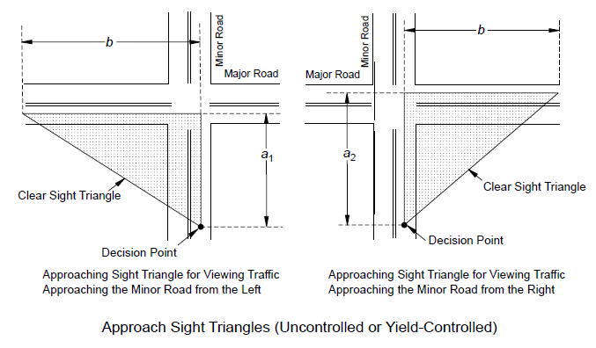

**Figure 2: Approach sight triangles at intersections**

Source: AASHTO (2018)

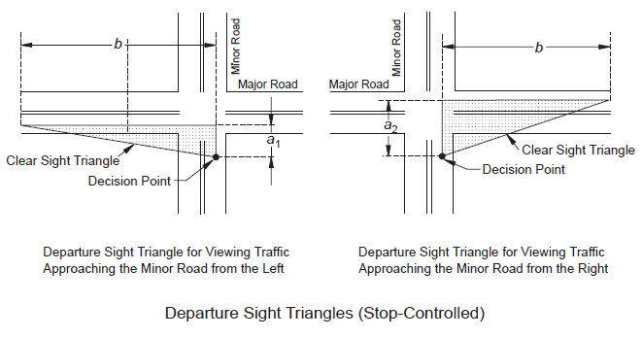

**Figure 3: Departure sight triangles at intersections**

Source: AASHTO (2018)

1. *Sight Triangle Display*

In the V_minor vehicle, the sight triangles will be displayed in real-time with the corresponding ISD and GPS coordinates of both the V_major and V_minor vehicles. The software will also be designed to save the constructed sight triangles along with their images for offline analysis.

1. *Simulator Development for Studying the Effect of Obstructions on ISD*

The obstructions at intersections that reduce the ISD are crops, hedges, trees, parked vehicles, utility poles, or buildings. During the activity of measuring the ISD using the prototype device, for example, there may be no parked vehicles causing sight obstruction which would lead to a wrong ISD computation. To address this and other sources of sight obstruction, we propose developing a simulator using the industry standard open-source simulator CARLA for autonomous driving research (Dosovitskiy et al., 2017). CARLA provides open digital assets (urban layouts, buildings, vehicles), obstacles (plants, human beings, animals, etc.), and flexible sensor suites. The simulator will be developed with the capability of importing the videos and the corresponding GPS coordinates collected when measuring the ISD. The simulator will be designed with the capability of placing different types of virtual objects representing obstructions at the intersections along with virtual sensors such as a camera, LiDAR, radar, etc., on a virtual vehicle at the GPS coordinates collected when measuring the ISD. The simulator will be capable of simulating the measuring of the ISD and allowing the WYDOT operators to analyze the effect of sight obstructions at the intersection on the ISD. In Figures 4 and 5, a simulation of an intersection and the view from the V_minor vehicle camera are shown.

|  |  |
| --- | --- |
| Figure 4  **Figure 4: Intersection simulation** | Figure 5  **Figure 5: View of the camera in the vehicle** |

In Figures 6 and 7, a simulation of a sight obstruction at an intersection and the view from the V_minor vehicle camera is shown.

|  |  |
| --- | --- |
| Figure 6  **Figure 6: Sight obstruction simulation** | Figure 7  **Figure 7: View of the camera in the vehicle** |

Figure 8 presents a simulation of vehicles on both the major and minor road approaches while Figure 9 shows the same scenario from the viewpoint of the camera in the vehicle on the minor road approach.

|  |  |
| --- | --- |
| Figure 8  **Figure 8: Vehicles on both approaches** | Figure 9  **Figure 9: Minor road vehicle’s viewpoint** |

Figure 10 is similar to Figure 8 except that a sight obstruction exists, whereas Figure 11 presents the scenario of Figure 10 from the viewpoint of the vehicle on the minor road approach.

|  |  |
| --- | --- |
| Figure 10  **Figure 10: Vehicles on both approaches with obstacle** | Figure 11  **Figure 11: V_minor’s viewpoint** |

### 3. Field Testing of the Prototype

Producing the prototype is not less important than testing it. This will involve conducting field measurements for each case listed in the preliminary literature review section (Cases A through G, a skewed intersection, a railroad crossing, and a stop on a rural road). For each case, two locations will be identified for carrying out the testing. The test ISD results will be compared with those that are documented in the as-built intersection design specifications or logs that are maintained by the jurisdictional agencies that manage the selected intersections. For intersections that have undergone design changes, such as the construction of sight blocking buildings nearby, the previously documented ISDs are no longer valid. Hence, the ISDs will have to be measured via the manual method and their results ought to be compared with the test ISDs.

### 4. Preparing the Final Report and Implementation Plan

The literature review, prototype development, and its testing will be documented in a final report to be submitted to WYDOT. A user manual of the prototype will also be drafted and provided to WYDOT. Furthermore, studies that are relevant to this research will be conducted and their results will be featured in scientific peer reviewed journals such as the *American Society of Civil Engineers* (*ASCE*) *Journal of Transportation Engineering, Part A: Systems*.

### Summary

Ultimately, an extensive literature review about the ISD and its measuring methods will be performed. Afterward, the cutting-edge ISD measurement prototype will be developed and tested for its application in the wide spectrum of cases. The literature review, prototype development, and testing will all be documented in a final report to be provided to WYDOT. A manual of the prototype will be submitted too. On the side, ISD studies will be conducted, and their results will be published in peer reviewed scientific research articles.

## Relevance to Strategic Goals

The primary goal of this proposed project is to improve the safety of intersection by developing a prototype to measure the intermediate sight distance (ISD).

## Educational Benefits

The study of ISD and development of vehicle boardable prototype for measuring ISDs in real time will improve safety and develop a manual for use for WYDOT. This manual will be used to offer several educational opportunities for students specialized in civil engineering, transportation engineering, or related areas at the University of Wyoming. The anticipated benefits to be attained are as follows:

* In-class case studies: The University of Wyoming offers courses in such as Transportation Engineering (CE3500), Transport Network Analysis (CE5545), Transportation Planning (CE5570), and Intelligent Transportation Systems (CE5575). The outcome could be used for the case studies in transportation and traffic courses.
* Research opportunities: The Data that is gathered and analyzed through the process of developing efficient ISDs in real time can be utilized for further research purposes, aiding students in the creation of new research ideas or the enhancement of existing research ideas that are pertinent to transportation engineering, and transportation planning. Additionally, more datasets can be explored for developing new research ideas.
* Industry relevance: Effective safety protocol can be useful to improve the overall efficiency of the transportation system. Therefore, these will be shared with the Wyoming Department of Transportation.

## Outputs through Technology Transfer

The results and products of this project, such as developed prototype for ISDs in real time will be disseminated through peer-reviewed journal articles and showcased at scientific research conferences like the annual Transportation Research Board (TRB). This will help in transferring methodologies, results, and products to the national and international pertinent research communities. Workshops, seminars, and webinars will be arranged to further disseminate the research findings and communicate its outcomes with professionals, practitioners, and highway agencies. The incremental results and progress of this project will be consolidated in a semi-annual progress report. Upon the completion of this project, it will be synthesized along with recommendations and guidelines in a technical report.

## Expected Outcomes and Impacts

The outcome of this project is a development of a two-vehicle protype that efficiently measures the ISD in the field. It will be utilized by WYDOT, other agencies, and local jurisdictions in Wyoming to assess and reassess sight distances at intersections. This prototype is critical for the daily operations of WYDOT’s traffic program. This outcome will help the WYDOT engineer to improve the safety program.

## Work Plan

This research effort is anticipated to be realized in three years. Conditional on the premise that the project is set to start on July 2024, the two-vehicle ISD prototype will be developed and tested by July 2026. Dry runs of the prototype will be made with WYDOT personnel to receive their feedback. The prototype will be modified to address the feedback, the final report of this research will be drafted, and the user manual will be prepared. The three items, namely the prototype, final report, and user manual will be delivered to WYDOT to receive additional feedback. With that, tweaks to the three items will be made prior to delivering the items to WYDOT. This culminates in the completion of the project by July 2027.

## Project Cost

Total Project Costs: $ 276,616

CTIPS Funds Requested: $ 90,569

Matching Funds: $ 186,047

Source of Matching Funds: Wyoming DOT

## References

1. American Association of State Highway and Transportation Officials, 2018. A Policy on Geometric Design of Highways and Streets 7th Edition. American Association of State Highway and Transportation Officials, Washington, D.C.
2. Dosovitskiy, A., Ros, G., Codevilla, F., López, A., Koltun, V., 2017. CARLA: An Open Urban Driving Simulator. Proceedings of the 1st Annual Conference on Robot Learning, pp. 1-16. Mountain View, California.
3. Golembiewski, G., Chandler, B., 2011. Intersection Safety: A Manual for Local Rural Road Owners. Report No. FHWA-SA-11-08. Science Applications International Corporation (SAIC). Federal Highway Administration Office of Safety, U.S. Department of Transportation, Washington, D.C.
4. Kilani, O., Gouda, M., Weiß, J., El-Basyouny, K., 2021. Safety Assessment of Urban Intersection Sight Distance Using Mobile LiDAR Data. Sustainability, 13 (16), p. 9259. https://doi.org/10.3390/su13169259.
5. Quan, L., Zhang, B., Zhou, H., Liu, P., 2022. Developing a Google Earth-Based Method to Measure Sight Distance for U-Turns at Unsignalized Intersections on Multilane Divided Highways. Transportation Research Record, 2676 (1), pp. 152-161. https://doi.org/10.1177/03611981211036358.
6. Smith, D., McIntyre, J., Anderson-Wilk, M., Moreau, S., 2002. Handbook of Simplified Practice for Traffic Studies. Iowa DOT Project TR-455. Center for Transportation Research and Education (CTRE) Project 01-80. Iowa State University, Ames, Iowa. http://publications.iowa.gov/11874/1/tr455web.pdf. Accessed December 18, 2023.
7. Wyoming Department of Transportation, 2014. Traffic Program Access Manual. Wyoming Department of Transportation, Cheyenne, Wyoming.