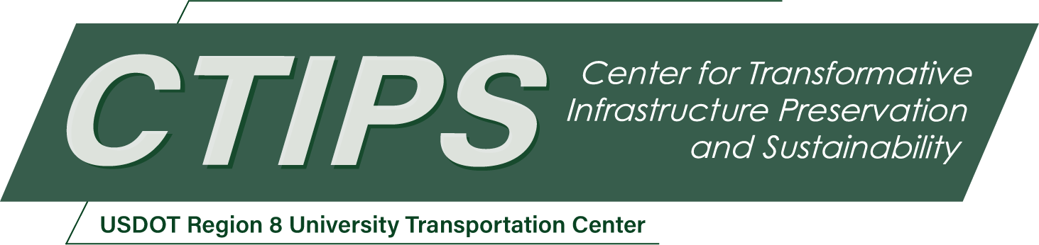

# Transforming Infrastructure Inspection by Integrating a UAS with a Continuum Robotic Arm and AI-enabled Multimodal Sensing for Comprehensive Damage Assessment

*CTIPS-025*

*Approved 7/16/2024*

## University

Colorado State University

## Principal Investigators

Jianguo Zhao, Ph.D.

Associate Professor

Dept. of Mechanical Engineering

Colorado State University

Phone: (970) 491-5927

Email: jianguo.zhao@colostate.edu

ORCID: 0000-0003-0305-2597

Yanlin Guo, Ph.D.

Assistant Professor

Dept. of Civil and Environmental Engineering

Colorado State University

Phone: (970) 491-3518

Email: yanlin.guo@colostate.edu

ORCID: 0000-0002-7162-6508

Hussam Mahmoud, Ph.D.

Professor

Dept. of Civil and Environmental Engineering

Colorado State University

Phone: (970) 491-6605

Email: hussam.mahmoud@colostate.edu

ORCID: 0000-0002-3106-6067

## Research Needs

Regular inspections of existing transportation infrastructure—including bridges, railroads, and pavements—are critical for their preservation. Bridges, in particular, require specialized attention due to their complex structures and the potential consequences of their failure. The Federal Highway Administration mandates biennial bridge inspections for bridges with nonredundant steel tension members. Traditional bridge inspection methods often rely on manual labor, which is not only time-consuming but also poses significant risks to personnel and requires expensive snooper trucks or lane closures. Recently, uncrewed Aerial Systems (UAS) has been used to inspect bridges for rapid, cost-effective, and safe assessments [1]. However, their utility is predominantly limited to relying on vision sensors (e.g., optical and infrared cameras) to detect surface-level defects, such as visible cracks or erosion [2]. Examples include Co-PI Guo’s recent work to use UAS to visually inspect bridges [3].

However, solely relying on vision for UAS inspections presents significant gaps in our ability to conduct thorough evaluations. Visual images alone may not be sufficient to comprehensively characterize the structural defects, as visual inspection inherently misses internal or subsurface damage (e.g., internal cracks) or surface defects not evident without specific interventions, such as the application of chemical dyes. Such limitations necessitate other inspection methods that are currently only conducted in a manual fashion. The alternative inspection methods include ultrasonic testing which uses high-frequency sound waves to detect internal flaws or material thickness, radiographic testing which uses X-rays or gamma rays to produce a radiograph of an inspected structure to detect any changes in thickness and defects, or magnetic particle testing that uses a magnet yoke to scan close to the surface to detect the magnetic field change, etc. [4]. All these methods require certain physical contact with the structure being inspected, which is beyond the reach of current UAS platforms. Therefore, there is a critical need to develop a UAS platform that can perform contact-based inspections to fully unleash the potential of using UAS for enhanced inspection and more accurate damage prediction for our transportation infrastructure, especially bridges.

The current limitations in sensing modalities have constrained damage assessment practices to predominantly rely on image-based evaluations. For instance, Co-PI Guo has used captured images together with fracture mechanics to estimate stress intensity factors [5]. This prior research is limited to surface cracks on steel plates. If additional sensing data from contact-based inspections is available, there is a critical gap in how we can fuse the contact sensing data with the visual images to better predict the damage mechanism. This integration between camera vision data and contact-based sensing data is essential for creating a more holistic view of the infrastructure's condition, enabling the development of predictive models that can more reliably determine the state of defects so that we can prescribe plans to potentially mitigate structural deterioration.

This project aims to investigate a transformative approach for infrastructure inspection by developing an integrated UAS platform equipped with a manipulator to enable contact-based inspection (see an overview of the proposed approach in Fig. 1), such as ultrasonic, magnetic, or eddy current testing. With such a new capability, this project aims to surpass the limitations of current vision sensor-based UAS inspections by incorporating multimodal sensing techniques for comprehensive damage assessment. Specifically, we will focus on the integration and fusion of multimodal sensors (e.g., vision, ultrasonic) to predict damage modes more accurately, enhancing the preservation of transportation infrastructure. Using steel bridges as a case study, our UAS platform will feature a lightweight continuum arm designed for tasks such as dust removal, application of dye chemicals for revealing hidden cracks, and placement of ultrasonic sensors to detect internal damages. This integrated approach will generate multimodal sensing datasets for Machine Learning analysis, complemented by finite element analysis models, to precisely predict defect formation mechanisms and inform necessary repairs.

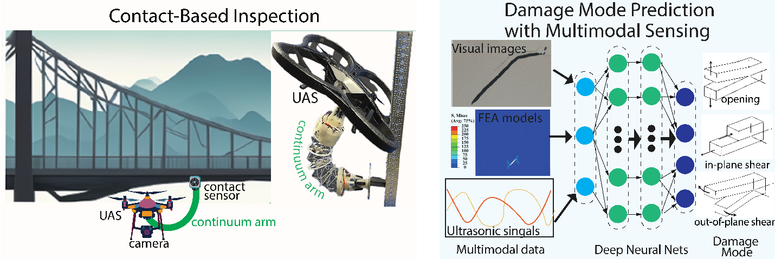

Fig. 1: Overview of the proposed research with two main objectives. Left: an integrated UAS system equipped with a continuum arm that can place a contact sensor onto the inspected surface for contact-based inspection. Right: an approach to fuse multimodal sensing data to accurately predict damage modes.

## Research Objectives

The project will aim to accomplish the following two major objectives.

***Objective 1:*** *Develop an advanced UAS platform with a continuum manipulator.*

We will develop a UAS integrated with a lightweight, collapsible continuum arm designed for direct interaction with infrastructure surfaces. This arm, characterized by its compliant spine, can bend in three-dimensional space to navigate challenging environments, such as inspecting interior components through small openings—a capability not feasible with conventional rigid-link manipulators. Additionally, we will also design control algorithms to maintain UAS stability during its interaction with infrastructure surfaces.

***Objective 2:*** *Develop an advanced damage assessment framework through Machine Learning.*

We will also develop advanced Machine Learning models that not only can identify damage but also can indicate the mechanism of damage formation. These models will be trained using integrated multimodal sensing data (e.g., visual imagery and ultrasonic feedback) and simulation data from finite element (FE) analysis to identify damage and classify different damage formation modes.

## Research Methods

* An advanced UAS platform with a continuum manipulator

We will develop a continuum arm tailored for integration with the UAS platform. This arm will be constructed from a series of self-tensioning structures made from rigid rods and elastic cables — a structure called tensegrity. Using such tensegrities can generate compliant motions by compressing the structure using cables actuated by motors [6]. PI Zhao’s group has developed a preliminary prototype with a customizable number of tensegrities for the arm (Fig. 2). This prototype has three actuators (motors) at the bottom that can individually pull three cables placed along the tensegrities guided by some thin plates (cable guides). One end of the cables is attached to the end effector that will interact with the environment. In this case, by pulling the cables to specific lengths, we can control the end-effector to reach different positions with desired orientations.

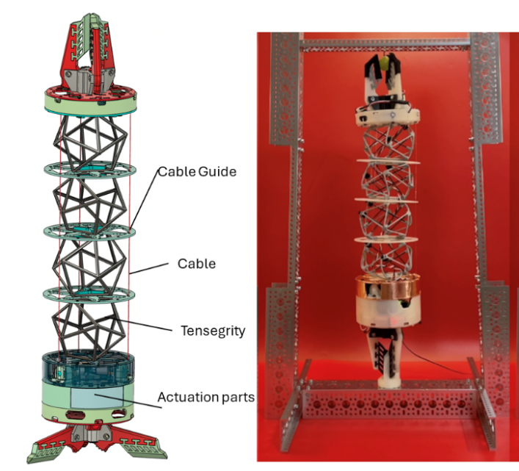

Fig. 2: The working principle of the continuum arm (left) and a preliminary prototype (right).

This tensegrity-based continuum arm presents two significant advantages over conventional robotic arms constructed from rigid links. Firstly, its unique design ensures minimal impact on the UAS's stability and performance: (1) it can fully collapse to the bottom of the UAS; (2) the motors, located at the base, exert negligible influence on the UAS's stability and maneuverability; (3) its lightweight nature, owing to the use of rigid rods and elastic cables, contrasts with the heavier materials typical of traditional robotic arms. Second, similar to an elephant's trunk, the continuum arm can flex into various shapes and curvatures to navigate difficult-to-reach spaces that will be encountered when inspecting bridges. Note that some recent works have used UAS to perform ultrasonic measurements, but it requires precise control due to the rigid mechanism that holds the sensor [7,8]. Other mobile robots have also been used, but they require manual placement of the robot onto the bridge [9]. Our tensegrity-based continuum arm is advantageous in that it does not require precise control due to its compliant structure and can fly to the desired location to perform measurements.

Despite the advantages of the continuum arm, our current prototype cannot precisely control the end effector's position and orientation, a critical requirement for conducting contact-based inspections. To address this limitation, we will improve the arm’s design by incorporating additional actuators, thereby enhancing its control accuracy. We will also improve the payload capabilities and expand its workspace by using a different number of tensegrities to ensure potential successful contact-based inspections.

* Develop advanced damage assessment through Machine Learning

The damage assessment framework utilizing Machine Learning includes three steps.

*Step 1: Establishment of as-built 3D geometric structural model*: A photo-realistic model of the structure will be built using images collected by the optical camera of a UAS system. Structural-from-motion algorithm will be employed to generate 3D point cloud and the photo-realistic model.

*Step 2: Damage identification using multimodal sensing data*: The developed new UAS system equipped with the continuum arm will enable automated contact-based inspection using ultrasonic devices. Sub-surface defects will be detected using the ultrasonic data [4]. Meanwhile, the surface defects of the structure will be identified from image data collected by the camera of UAS using Machine Learning algorithms with new network architectures, such as transformer-based ones that have demonstrated enhanced performance compared with existing network architectures (e.g., convolutional neural networks) [10,11]. Then the characteristics of defects (e.g., length and width of cracks, kink angles of cracks, etc.) will be determined. In the end, the sub-surface defect information derived from ultrasonic signals and surface defect information extracted from images will be fused with 3D point cloud information from Step 1 to indicate the location of the defects.

*Step 3: Machine learning model to evaluate structural damage mechanism*: Finite element (FE) models of generalizable structural members with various simulated defect scenarios (including both surface and sub-surface defects) will be firstly built to provide data for training Machine Learning models. The input of the data includes the characteristics of defects and boundary loading, while the output of the data includes the engineering metrics to assess fatigue (e.g., crack growth rate) and fracture (e.g., brittle versus ductile). Using the data generated from FE models, fast computing Machine Learning models will be built. Leveraging the Machine Learning models, the fatigue and/or fracture mechanism will be evaluated using defect information obtained from sensing data and boundary loading estimated by a simple structural analysis model without the need to run high fidelity FE analysis. Co-PIs Guo and Mahmoud have proved the concept of using a Machine Learning model to estimate one engineering metric – stress intensity factor for steel plates [5]. This project will extend this concept to investigate the estimation of more engineering metrics for different types of structural elements with the fusion of both surface and sub-surface damage data.

## Relevance to Strategic Goals

The proposed project will primarily address the USDOT strategic goal on safety, since it will develop a new robotic platform and new algorithms that will enable inspection or monitoring of existing bridges that cannot be performed using traditional UAS or other existing methods. With the new monitoring capability, we can enhance the safety for our transportation system, potentially eliminating bridge-related serious injuries and fatalities.

## Educational Benefits

Two graduate students will participate in the project including writing several papers and a report, which will result in part of their dissertation. One student will gain valuable research experience for robotic system development, while the other student will acquire cutting edge techniques for fusing multimodal sensing data to advance structural inspection.

## Outputs through Technology Transfer

We will publish our research findings in peer-reviewed journal or conference articles for both the development of UAS platform and the Machine Learning algorithms for damage mode predictions. We will also post videos for the UAS platform in PI Zhao lab’s YouTube Channel as well as social media (e.g., LinkedIn, X, etc.). We will also deliver our findings through webinars that will be organized by CTIPS.

## Expected Outcomes and Impacts

We expect the project will generate the following four major outcomes:

1. A prototype of a UAS platform with a tensegrity-based continuum arm, including both the mechanical and electrical parts that will allow the UAS to fly under remote control.
2. Control methods that will allow the arm to place a sensor onto a surface for measurement, which is essential for contact-based inspection.
3. Machine Learning algorithms that can take images and ultrasonic sensing data to predict the damage modes of bridges.
4. A detailed report documenting the design and control of the UAS as well as the Machine Learning approach.

## Work Plan

***Task 1:*** *Develop the continuum arm including both mechanical and electrical components.*

We will improve the continuum arm based on our existing prototype. This includes adding more motors so that we can control the arm to reach a desired position with a desired orientation. We will also improve the arm’s payload capability so that we can still control its position and orientation when a sensor is added at the end. This can be accomplished by using stiffer elastic cables in the tensegrity structures.

***Task 2:*** *Integrate the arm with an open-source quadcopter for a complete UAS platform and demonstrate its initial flying capability.*

We will integrate the arm with an open-source quadcopter that can carry a payload heavier than the arm’s weight and the potential sensor that will be attached to the arm’s end-effector. The open-source quadcopter will be based on the system used in PI Zhao’s previous work in another project [12]. We will also demonstrate initial indoor flying using a motion tracking system inside PI Zhao’s lab.

***Task 3:*** *Demonstrate preliminary contact-based inspection using the developed UAS platform in indoor environments.*

We will develop control algorithms to allow the UAS to interact with the environment using the continuum arm, e.g., spraying chemicals onto a desired location or placing a sensor against a rigid surface that emulates an inspection scenario in indoor environments with the motion tracking system. The control algorithms can be adapted from existing algorithms for UAS that use rigid links for contact-based inspection [13]. The sensor can be a miniature ultrasonic thickness tester [14] to perform the measurement.

***Task 4:*** *Collect and process data from the multimodal sensors to create a comprehensive dataset that captures a wide range of damage signatures from steel components of bridges.*

The team will collect the damage data from public datasets and experimental datasets from Co-PI Mahmoud’s lab, as well as explore potential data from state DOTs. If unlabeled data are collected, the team will manually label the data to prepare for training Machine Learning models.

***Task 5:*** *Generate simulation data of various damage mechanisms using FE analysis.*

FE models for generalizable structure members, with specific defects, will be built. An automated code for generating FE models will be developed to allow the efficient building of FE models with randomly simulated defect scenarios.

***Task 6:*** *Develop Machine Learning algorithms capable of fusing sensing data with FE simulation data to accurately assess damage types and severities.*

The first series of Machine Learning models will be developed to extract damage characteristics from multi-modal sensing data. The second series of Machine Learning models will be trained to predict damage mechanisms using simulation data from FE analysis. Taking damage characteristics obtained from the first series of Machine Learning models, the second series of Machine Learning models will be used to predict fatigue and fracture of structure.

***Task 7:*** *Validate the Machine Learning models against known damage cases to refine accuracy and ensure reliability in real-world scenarios.*

Known damage cases with specified fatigue and fracture scenarios on testing structures will be created in the laboratory. The developed UAS system with the continuum arm will be used to inspect the testing structure. Using the collected data from both contact and vision-based sensing as input, the developed two series of Machine Learning models will be adopted to predict the damage mechanism. The predicted damage mechanism will be evaluated against the known damage mechanism to validate the efficacy of the proposed methodologies.

## Project Cost

Total Project Costs: $60,000

CTIPS Funds Requested: $30,000

Matching Funds: $30,000

Source of Matching Funds: Colorado State University

## References

1. Hubbard, Bryan, and Sarah Hubbard. "Unmanned aircraft systems (UAS) for bridge inspection safety." Drones 4, no. 3 (2020): 40.
2. Congress, Surya Sarat Chandra, Jesse Escamilla III, Hiramani Chimauriya, and Anand J. Puppala. "Eye in the Sky: 360° Inspection of Bridge Infrastructure Using Uncrewed Aerial Vehicles (UAVs)." Transportation Research Record (2023): 03611981231185138.
3. Perry, Brandon J., Yanlin Guo, Rebecca Atadero, and John W. van de Lindt. "Streamlined bridge inspection system utilizing unmanned aerial vehicles (UAVs) and Machine Learning." Measurement 164 (2020): 108048.
4. Khedmatgozar Dolati, Seyed Saman, Nerma Caluk, Armin Mehrabi, and Seyed Sasan Khedmatgozar Dolati. "Non-destructive testing applications for steel bridges." Applied Sciences 11, no. 20 (2021): 9757.
5. Perry, B. J., Guo, Y., & Mahmoud, H. N. (2022). Automated site-specific assessment of steel structures through integrating machine learning and fracture mechanics. Automation in Construction, 133, 104022.
6. Spiegel, Sydney, Jiefeng Sun, and Jianguo Zhao. "A Shape-Changing Wheeling and Jumping Robot Using Tensegrity Wheels and Bistable Mechanism." IEEE/ASME Transactions on Mechatronics (2023).
7. Watson, Robert, Mina Kamel, Dayi Zhang, Gordon Dobie, Charles MacLeod, S. Gareth Pierce, and Juan Nieto. "Dry coupled ultrasonic non-destructive evaluation using an over-actuated unmanned aerial vehicle." IEEE Transactions on Automation Science and Engineering 19, no. 4 (2021): 2874-2889.
8. Zhang, Dayi, Robert Watson, Charles MacLeod, Gordon Dobie, Walter Galbraith, and Gareth Pierce. "Implementation and evaluation of an autonomous airborne ultrasound inspection system." Nondestructive Testing and Evaluation 37, no. 1 (2022): 1-21.
9. Otsuki, Yu, Son Thanh Nguyen, Hung Manh La, and Yang Wang. "Autonomous ultrasonic thickness measurement of steel bridge members using a climbing bicycle robot." Journal of Engineering Mechanics 149, no. 8 (2023): 04023051.
10. Shamsabadi, E. A., Xu, C., Rao, A. S., Nguyen, T., Ngo, T., & Dias-da-Costa, D. (2022). Vision transformer-based autonomous crack detection on asphalt and concrete surfaces. Automation in Construction, 140, 104316.
11. Ding, W., Yang, H., Yu, K., & Shu, J. (2023). Crack detection and quantification for concrete structures using UAV and transformer. Automation in Construction, 152, 104929.
12. Zhang, Haijie, and Jianguo Zhao. "An integrated unmanned aerial vehicle system for vision based control." In Dynamic Systems and Control Conference, vol. 58295, p. V003T39A011. American Society of Mechanical Engineers, 2017.
13. Bodie, Karen, Maximilian Brunner, Michael Pantic, Stefan Walser, Patrick Pfändler, Ueli Angst, Roland Siegwart, and Juan Nieto. "Active interaction force control for contact-based inspection with a fully actuated aerial vehicle." IEEE Transactions on Robotics 37, no. 3 (2020): 709-722.
14. PCE Americas Inc., Ultrasonic thickness tester with data memory, [PCE-TG 150 F2.5-ICA](https://www.pce-instruments.com/us/measuring-instruments/test-meters/ultrasonic-tester-ultrasonic-testing-pce-instruments-ultrasonic-thickness-tester-pce-tg-150-f2.5-ica-incl.-iso-calibration-certificat-det_6046334.htm?_list=kat&_listpos=10).