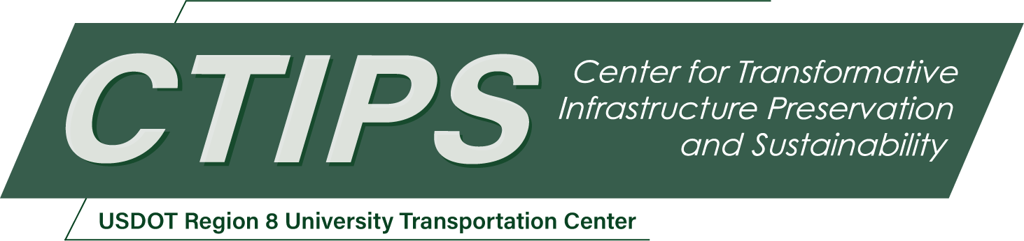

# Transforming Infrastructure Inspection by Integrating a UAS with a Continuum Robotic Arm and AI-enabled Multimodal Sensing for Comprehensive Damage Assessment

*CTIPS-025 – UTC Project Information*

|  |  |
| --- | --- |
| **Recipient/Grant Number:** | North Dakota State University, Colorado State University  Grant No. 69A3552348308 |
| **Center Name:** | Center for Transformative Infrastructure Preservation and Sustainability |
| **Research Priority:** | Preserving the Existing Transportation System |
| **Principal Investigator(s):** | Jianguo Zhao, Ph.D.  Yanlin Guo, Ph.D.  Hussam Mahmoud, Ph.D. |
| **Project Partners:** | USDOT, Office of the Assistant Secretary for Research and Technology – $30,000  Colorado State University – $30,000 |
| **Total Project Cost:** | $60,000 |
| **Project Start and End Date:** | 7/16/2024 to 7/15/2026 |

## Project Description

Uncrewed Aerial Systems (UAS) hold promise for revolutionizing the inspection of transportation infrastructure by enabling rapid and safe assessments. However, the application of UAS is predominantly limited to detecting surface-level defects, such as visible cracks, due to the reliance on vision sensors. This approach inherently misses subsurface damage, which, to date, requires direct contact-based methods (e.g., ultrasonic, magnetic, and radiographic techniques) that are currently carried out by manual inspection. This project aims to investigate a transformative approach to infrastructure inspection by developing 1) an integrated UAS platform equipped with a continuum robotic arm to enable contact-based inspection, 2) novel machine learning algorithms to fuse multimodal sensors (e.g., vision, ultrasonic) to predict damage modes more accurately. The continuum robotic arm will be based on lightweight and collapsible tensegrity structures, whereas the machine learning algorithms will be based on the recent transformer architecture. This proposed system aims to establish a foundational approach for future developments in multimodal and autonomous infrastructure inspection, significantly advancing the field by overcoming current limitations in damage assessment capabilities.

## USDOT Priorities

The proposed project will primarily address the USDOT strategic goal on safety, since it will develop a new robotic platform and new algorithms that will enable inspection or monitoring of existing bridges that cannot be performed using traditional UAS or other existing methods. With the new monitoring capability, we can enhance the safety for our transportation system, potentially eliminating bridge-related serious injuries and fatalities.

## Outputs

We will publish our research findings in peer-reviewed journal or conference articles for both the development of UAS platform and the Machine Learning algorithms for damage mode predictions. We will also post videos for the UAS platform in PI Zhao lab’s YouTube Channel as well as social media (e.g., LinkedIn, X, etc.). We will also deliver our findings through webinars that will be organized by CTIPS.

## Outcomes/Impacts

We expect the project will generate the following four major outcomes:

1. A prototype of a UAS platform with a tensegrity-based continuum arm, including both the mechanical and electrical parts that will allow the UAS to fly under remote control.
2. Control methods that will allow the arm to place a sensor onto a surface for measurement, which is essential for contact-based inspection.
3. Machine Learning algorithms that can take images and ultrasonic sensing data to predict the damage modes of bridges.
4. A detailed report documenting the design and control of the UAS as well as the Machine Learning approach.

## Final Report

Upon completion, the final report link will be added to the [project page on the CTIPS website](https://www.ctips.org/projects/details.php?id=623).