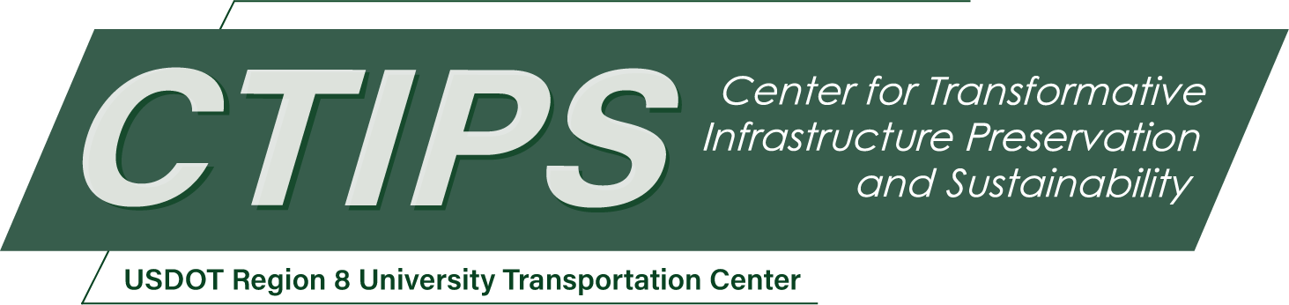

# Development of an Advanced Snow-Melting Geopolymer Concrete Utilizing Graphene Nanoplatelets and Landfilled Fly Ash

*CTIPS-024*

*Approved 7/16/2024*

## University

Colorado State University

North Dakota State University

## Principal Investigators

Mahmoud Shakouri, Ph.D.

Assistant Professor

Dept. of Construction Management

Colorado State University

Phone: (970) 491-8284

Email: mahmoud.shakouri@colostate.edu

ORCID: 0000-0003-3755-5942

Mijia Yang, Ph.D.

Associate Professor

Dept. of Civil, Construction and Environmental Engineering

North Dakota State University

Phone: (701) 231-5647

Email: mijia.yang@ndsu.edu

ORCID: 0000-0002-5781-8765

## Research Needs

Concrete pavements in the Midwest, Northern, and Mountainous regions of the United States endure extreme environmental conditions, including harsh winters, significant snowfall, and frequent freeze-thaw cycles. Many state and local agencies apply deicing and anti-icing salts to ensure public safety and reduce winter accidents. However, extensive research indicates that these predominantly chloride-based salts can compromise the integrity and service life of concrete pavements [1-4].

A promising solution to these challenges is the development of conductive concrete, which offers a sustainable alternative to traditional deicing methods [5-8]. By generating heat upon electrical activation, conductive concrete can melt snow and ice, reducing reliance on chemical deicers and minimizing infrastructure damage. Researchers have explored various materials to enhance the heat conductivity of concrete, including steel mesh, carbon and steel fibers, and graphite powders, achieving promising results [6, 9-11].

Despite these advancements, the current state-of-the-art in conductive concrete faces several challenges and research needs. These include issues related to material composition, performance optimization, economic viability, and environmental considerations. For instance, using carbon-based conductive fillers often leads to particle agglomeration, adversely affecting the mechanical properties and the uniformity of heat distribution across the concrete pavement surface [12-14]. Moreover, while conductive concrete eliminates the need for traditional deicing chemicals, it requires electricity to melt ice [15]. Further research into the energy efficiency of these systems and the potential integration of renewable energy sources is crucial for ensuring sustainability. Additionally, the production of conductive concrete relies heavily on cement as the main binder, and in light of ongoing efforts to reduce the carbon footprint of the cement and concrete industries, exploring alternative binders becomes essential to ensure the cost-effective production of conductive concrete while minimizing its environmental impact [16].

Given the critical importance of transportation infrastructure and the pressing need for innovative practices to enhance the service life and performance of such infrastructure under extreme environmental conditions, the overarching goal of this proposal is to develop and test a novel conductive geopolymer using landfilled fly ash (LFA) as a sustainable alternative to traditional cement-based conductive concrete [17-19]. Geopolymer is created by combining industrial by-products rich in silicon (Si) and aluminum (Al), such as fly ash or slag, with an alkaline activating solution, usually a mix of sodium or potassium hydroxide and sodium silicate. This process offers advantages over traditional concrete, including reduced carbon emissions, enhanced durability, superior resistance to chemicals and heat, and the utilization of waste materials [20, 21].

To improve the heating properties of geopolymer concrete, the research team proposes a novel approach that combines the incorporation of graphene nanoplatelets (GNPs) and mechanically activated LFAs into geopolymer concrete. GNPs are carbon-derived nanomaterials characterized by a multilayer structure. Due to their extensive surface area and small particle size, GNPs have been demonstrated to serve as nucleation sites for cement, contributing to the enhanced mechanical properties of concrete [22-25]. Previous research conducted by PI Shakouri demonstrates that incorporating GNPs into concrete can increase its conductivity (i.e., reduce its electrical resistivity) [26, 27]. This property can be leveraged to enhance ice-melting efficiency in geopolymer concrete. Additionally, PI Shakouri’s studies have explored the impact of the fineness of landfilled fly ash on their pozzolanic properties, revealing that a finer LFA—achieved through extended grinding times—leads to increased reactivity. This, in turn, contributes to the improved mechanical and durability characteristics of the concrete [17, 18].

Building on these findings, this project aims to enhance the ice-melting efficiency and overall performance of geopolymer concrete, advancing toward more sustainable, durable, and climate-resilient infrastructure. By emphasizing the utilization of waste materials and aiming to reduce the environmental impact of cement production, the proposal aligns with the principles of the circular economy. The transition to conductive geopolymer technology represents a significant opportunity, offering the potential to lower maintenance costs and extend the lifespan of concrete pavements by reducing the reliance on deicing chemicals. This advancement aligns with strategic goals to preserve transportation infrastructure and boost economic strength and global competitiveness.

## Research Objectives

In this study, researchers from Colorado State University and North Dakota State University will collaborate to develop and test a new conductive geopolymer with enhanced snow-melting properties and a reduced environmental footprint. Optimizing the proportion of conductive fillers and ensuring their uniform distribution in the mix is crucial to achieving this goal. Additionally, using LFA as an alternative binder necessitates enhancing its reactivity through mechanical beneficiation techniques. In addressing these challenges, the specific research objectives of this study are as follows:

1. Develop effective strategies to prevent the agglomeration of graphene nanoplatelets and ensure their uniform dispersion within the geopolymer matrix, enhancing the composite’s overall performance.
2. Investigate the extent of mechanical activation required to optimize the reactivity of landfilled fly ash, aiming to improve the strength and microstructure of the geopolymer.
3. Assess the combined impact of activated LFA and GNPs on the geopolymer’s mechanical properties and electrical conductivity, exploring potential synergies that could enhance performance.
4. Examine the durability of the conductive geopolymer under various stressors, including repeated freeze-thaw cycles, abrasion, and alkali-silica reaction, to determine its long-term viability for practical applications.
5. Evaluate the efficiency of ice melting on geopolymer surfaces integrated with activated LFA and GNPs, focusing on the practical implications for cold climate infrastructure.

## Research Methods

We will use five tasks to address the five scientific questions discussed above.

*Task 1. Investigating Methods of GNP Dispersion*

GNPs are inherently hydrophobic and tend to agglomerate when added in significant quantities, potentially leading to mechanical and durability issues in the composite material. In a recent project, PI Shakouri explored the impact of GNPs on the properties of Portland cement-based mortar. The findings revealed that ultrasonication of GNPs in the mixing water for approximately 30 minutes can effectively disperse GNPs, but only when used in small amounts (for example, 0.05% by weight of cement) [26, 27]. Given that incorporating GNPs in larger quantities could enhance the conductivity of geopolymers, this task is dedicated to identifying an alternative method for the efficient dispersion of GNPs in water. To achieve this, we will investigate using various surfactants to determine the most effective combination for achieving a more stable GNP dispersion. The following points summarize the activities planned for this task:

* We tentatively plan to investigate the stability of GNP dispersion in water using sodium dodecyl sulfate (SDS), Triton X-100, Polyvinylpyrrolidone (PVP-40), and Cetyltrimethylammonium bromide (CTAB). We will test four different weight concentrations of GNPs: 0.05%, 0.1%, 0.5%, and 1%, mixed with surfactants in an alkaline activator. The surfactant-GNP weight ratios to be examined are 0.5:1, 1:1, 1.5:1, and 2:1. The alkaline activator will be prepared by mixing NaOH and Na2SiO3 in a SiO2/Na2O molar ratio of 1.2, a formulation supported by previous research by Co-PI Yang [19].
* To assess the stability of the GNP dispersion over time, we will employ two techniques: zeta potential measurements and ultraviolet-visible (UV-Vis) spectroscopy techniques. The outcomes of this task are expected to provide insights into the optimal surfactant-GNP combinations that yield uniform and stable dispersions of GNPs.

*Task 2. Investigating Activation Requirements of LFA*

In a previous project, PI Shakouri collected a considerable amount of landfilled fly ash, encompassing bottom ash, mixed ash, and Class F and C ashes, from the Dave Johnson and Jim Bridger power plants in Wyoming. These LFAs will be used in this study to prepare geopolymer concrete. Since the reactivity of LFAs is critical to the performance of geopolymers, this task focuses on determining the optimal fineness of LFAs to maximize their reactivity and enhance the mechanical properties of geopolymer concrete. The following tests will be conducted on the LFA samples as part of this task:

* The physical and chemical characteristics of the collected LFA samples will be analyzed using a suite of techniques. X-ray fluorescence (XRF) spectroscopy will be employed to assess the chemical composition; X-ray diffraction (XRD) spectroscopy will be used to evaluate the crystallinity of the ashes. The particle size and morphology will be examined using Dynamic Light Scattering (DLS) scanning electron microscopy (SEM).
* To increase the reactivity of LFA, we will initially sieve the ashes through a #100 sieve to eliminate any large unburned coal particles. Subsequently, these ashes will be finely ground in a ball mill for 30, 60, 90, and 120 minutes.
* The reactivity of the LFAs will be investigated by measuring the degree of polymerization within the alkaline activator solution (comprising NaOH and Na2SiO3). This will involve tracking the heat of hydration through calorimetry and conducting thermogravimetric analysis (TGA) to quantify the sodium aluminosilicate hydrate (NASH) content. For the calorimetry tests, approximately 30 g of LFA will be mixed with the alkaline activator, maintaining a water-to-binder ratio of 0.3. Around 6 g of this paste will be encapsulated in glass ampules and positioned within an isothermal calorimeter pre-set to 50°C. The heat release is monitored over a span of 10 days.
* After 10 days, the paste will be extracted from the ampules, and a small sample, roughly 10 mg, will be taken from the core of the paste for TGA analysis. This sample will be heated at a rate of 10°C per minute up to 900°C in a nitrogen-purged environment. The mass loss observed between 120°C and 200°C, typically indicative of the dihydroxylation of the NASH gel, will be measured.

The activation method that yields the highest heat release and NASH content will be selected for subsequent tasks to develop conductive geopolymer.

*Task 3. Assessing the Properties of Conductive Geopolymer*

The aim of this task is to assess the performance of conductive geopolymers, focusing on their electrical conductivity and compressive strength. These geopolymers will incorporate GNPs and LFA, using the optimal surfactant-GNP mixture and activated LFA determined in Tasks 1 and 2, respectively. For this purpose, mortar geopolymer specimens will be prepared using a binder-to-sand mass ratio of 1:2. A total of twelve distinct mixtures will be prepared by adjusting the GNP content (at 0.05%, 0.1%, 0.5%, and 1% by wt. of the binder) and the steel fiber content (at 0.5%, 1%, and 1.5% by volume). A mixture with no GNPs and steel fibers will also be prepared to serve as the control group. Below is a summary of the mixture proportions used in this task.

Table 1. Geopolymer mix design

|  |  |  |  |  |  |
| --- | --- | --- | --- | --- | --- |
| MIX ID | GNP Content (% by wt. of binder) | Steel fiber content (% by volume) | Binder: Sand ratio | Water-to-binder ration | Alkaline activator SiO2/Na2O molar ratio |
| 1 | 0.05 | 0.5 | 1:2 | 0.3 | 1.2 |
| 2 | 0.05 | 1 | 1:2 | 0.3 | 1.2 |
| 3 | 0.05 | 1.5 | 1:2 | 0.3 | 1.2 |
| 4 | 0.1 | 0.5 | 1:2 | 0.3 | 1.2 |
| 5 | 0.1 | 1 | 1:2 | 0.3 | 1.2 |
| 6 | 0.1 | 1.5 | 1:2 | 0.3 | 1.2 |
| 7 | 0.5 | 0.5 | 1:2 | 0.3 | 1.2 |
| 8 | 0.5 | 1 | 1:2 | 0.3 | 1.2 |
| 9 | 0.5 | 1.5 | 1:2 | 0.3 | 1.2 |
| 10 | 1 | 0.5 | 1:2 | 0.3 | 1.2 |
| 11 | 1 | 1 | 1:2 | 0.3 | 1.2 |
| 12 | 1 | 1.5 | 1:2 | 0.3 | 1.2 |
| Control | 0 | 0 | 1:2 | 0.3 | 1.2 |

For each mixture, 2-inch cubic geopolymer mortar specimens will be cast. These specimens will undergo curing at room temperature for up to 91 days. The compressive strength of these cubes will be assessed on days 7, 28, and 91, with three replicates tested on each of these days. Additionally, the conductivity of the specimens will be evaluated by measuring their bulk electrical resistivity. These measurements will subsequently be inverted to represent the bulk electrical conductivity of the specimens.

*Task 4. Durability Assessment of Conductive Geopolymer*

In this task, we will investigate the influence of GNPs and LFAs on the durability performance of geopolymer concrete. Drawing from the findings of Task 3, we will select the optimal GNPs and steel fiber content for the geopolymer mixtures. The properties that are very important to pavements and will be examined include Rapid Chloride Permeability (ASTM C1202), Drying Shrinkage (ASTM C157), Alkali-Silica Reaction (ASTM C1260), and Abrasion Resistance (ASTM C944).

* Six 4" × 8" cylindrical specimens (three control + three from the optimum mix design in Task 3) will be prepared and cured at room temperature. These specimens will be prepared following ASTM C1202 guidelines to assess their chloride ingress resistance.
* Six mortar prisms measuring 1" × 1" × 10" will be cast (three control + three from the optimum mix design in Task 3) and cured for 28 days, then placed in a drying room maintained at 73°F (23°C). These specimens will be made with standard sand, and their length change will be monitored using a length comparator.
* Another set of six mortar prisms measuring 1" × 1" × 10" will be cast (three control + three from the optimum mix design in Task 3) and conditioned as per ASTM C1260 to test for ASR-induced expansion in geopolymer mortars. Highly reactive washed sand will be used with a recorded 14-day expansion of 0.9% according to ASTM C1260. Length measurements of these specimens will be taken over 14 days.
* Freeze-thaw tests will be conducted on geopolymer beams measuring 4" × 3" × 16" according to ASTM C666. Three specimens from the control mix and three from the optimum mix in Task 3 will be used. After 14 days of curing as per ASTM C666, the specimens will be placed in a freezer and subjected to 300 freeze-thaw cycles. Each cycle will involve a temperature decrease from 4.44°C to −17.8°C over 1.5 hours, a hold at −17.8°C for 0.5 hours, followed by a temperature increase from −17.8°C to 4.44°C over 1.5 hours, and a final hold at 4.44°C for 0.5 hours (total of 4 hours). The specimens’ dynamic modulus of elasticity and weight loss will be measured every 30 cycles.
* To evaluate the abrasion resistance of the conductive geopolymer per ASTM C944, six cylindrical specimens (three control + three from the optimum mix in Task 3) measuring 6" × 12" will be cast and cured at room temperature for 28 days. These specimens will then be mounted on a rotating-cutter drill press, and the mass loss and depth of abrasion under a normal load of 22 lbf will be measured every two minutes for a total duration of six minutes.

*Task 5. Ice Melting Performance Testing*

Prisms measuring 4" × 3" × 8" will be cast—comprising three control samples and three from the optimized mixes from Task 3—and then cured for 28 days at ambient temperature. The casting process for the specimens used for the ice melting test will involve three stages. Initially, two-thirds of the mold will be filled with the conductive geopolymer mix, followed by careful tamping to ensure proper consolidation. Subsequently, a copper mesh will be positioned on top of this layer. The final third of the mold will then be filled with the same geopolymer mix and tamped again for consolidation. To monitor the temperature variations within the geopolymer during the ice melting experiment, thermocouple sensors will be placed at the bottom, midpoint, and surface of the specimens.

After 28 days of curing, a thin layer of epoxy will be applied on the surface of the specimens. After epoxy hardens, a 2" tall and 1/4" thick plexiglass will be glued to the top of each prism to form a water reservoir, as illustrated in Figure 1. For the test, the plexiglass reservoir will be filled with 1" of tap water, which is then frozen by placing the specimens in a freezer overnight. The following day, the prisms will be placed inside an insulated box with an aluminum liner and connected to a power supply through the copper mesh. An electricity consumption meter will track the total energy expended during the test. The efficiency of the geopolymer samples in ice melting will be evaluated by comparing the time and energy required to melt the ice.

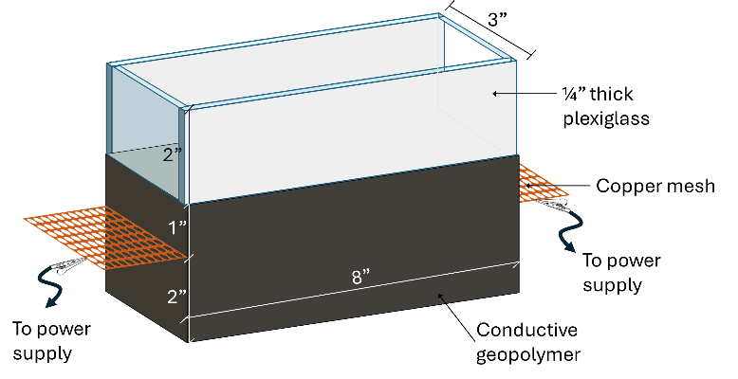

Figure 1. Schematics of ice-melting test setup

## Relevance to Strategic Goals

This project aligns closely with the U.S. Department of Transportation’s strategic goals of Climate and Sustainability, and Transformation. By substituting landfilled fly ash for cement in the production of conductive geopolymer concrete, it significantly contributes to reducing greenhouse gas emissions, directly addressing cement’s notable impact on global warming. This initiative not only propels the transition towards more resilient and sustainable transportation infrastructure but also charts a definitive course towards achieving net-zero emissions by 2050, ensuring a pivotal role for transportation in climate solutions. Concurrently, the project embodies the Department’s ‘Transformation’ goal through innovative experimentation and the collaborative synergy of leading research institutions. The integration of nanotechnology into conductive geopolymer concrete offers a pioneering approach to addressing ice management challenges and reducing the reliance on road salts. This strategy not only mitigates corrosion—the primary cause of infrastructure deterioration in the U.S.—but also sets a foundation for a future-ready, durable transportation system.

## Educational Benefits

This project will provide multifaceted educational benefits for students at both Colorado State University and partner institutions. At the Department of Construction Management at Colorado State University, one of the largest in the nation, the project’s findings and materials will be directly integrated into the curriculum, enriching the educational content and providing real-world examples for students. Specifically, the following classroom and instructional uses of procedures, examples, or discoveries derived from the project are planned:

* *MURALS Participation (diversity, equity, and inclusion)*: PI Shakouri is a research mentor in the Multicultural Undergraduate Research Art and Leadership Symposium (MURALS). This program empowers undergraduate students with marginalized identities by providing a forum for them to present their scholarly work. PI Shakouri will dedicate a segment of this project for MURALS participants to ensure that students from marginalized identities are provided with valuable laboratory research experience and the opportunity to contribute to significant advancements in sustainable construction practices. By doing so, the project aims to enhance the students’ technical and professional skills and foster an inclusive research environment where students can develop a strong sense of belonging and identity within the research community.
* *Workforce development:* This project will significantly contribute to educational development and workforce readiness by hiring a Ph.D. student, thereby nurturing the next generation of the infrastructure workforce. The selected doctoral candidate will receive comprehensive training and mentorship under the guidance of PI Shakouri, equipping them with the necessary skills to address current and future challenges in sustainable infrastructure. This initiative underscores the project’s commitment to academic growth and practical learning. It reinforces our dedication to preparing skilled professionals who are ready to innovate and lead in constructing and maintaining resilient, sustainable transportation systems.
* *Mentoring opportunity for graduate students:* This project provides a unique opportunity for students hired through the Multicultural Undergraduate Research Art and Leadership Symposium program to collaborate and learn from a Ph.D. student engaged in the project. This arrangement will enable a valuable peer-mentoring environment where the PhD students, leveraging their advanced knowledge and research skills, will guide and inspire the MURALS participants. This synergistic teaming aims not only to enhance undergraduate students’ research capabilities and academic understanding but also to cultivate a supportive and inclusive learning atmosphere where diverse perspectives and experiences contribute to the richness of the research endeavor.
* *Incorporation into course content*: PI Shakouri will utilize the research outcomes in his CON-151 course, an introductory class on construction materials, to enhance the educational materials with the latest findings and promote awareness of sustainable construction practices. Students enrolled in CON-370, focusing on Asphalt and Concrete Pavement, will gain practical experience by working with materials produced in the project, such as those incorporating LFAs, to understand their effects on the properties of concrete.

## Outputs through Technology Transfer

PI Shakouri is the Director of the American Concrete Institute - Rocky Mountain Chapter and a member of ACI Committees 365 (Service Life Prediction) and 222 (Corrosion of Metals in Concrete). He will utilize his affiliations to share the outcomes of this research project within industry and academic circles. He and his team will present the findings of this project at several key industry gatherings, such as the 2024 Annual Colorado Concrete Conference, the 2024 Colorado Ready Mixed Concrete Association Annual Conference, and the 2025 Annual Concrete Pavement Workshop by the Colorado/Wyoming chapter of the American Concrete Pavement Association. Additionally, the research will be presented during technical committee sessions of Committees 365 and 222 at the 2025 Annual ACI Convention in Baltimore, MD. Shakouri also plans to extend the project’s reach by publishing in well-regarded peer-reviewed journals, including Construction and Building Materials and Construction and Concrete Composites, ensuring that the insights gained from this study contribute to advancing the field of sustainable construction materials.

In addition, PI Shakouri has a proven track record of collaborating with CSU Ventures, a private, not-for-profit corporation dedicated to managing intellectual property and facilitating technology transfer for the Colorado State University System. His experience includes successfully filing a US patent through CSU Ventures on a previous project, demonstrating his ability to bridge innovative research with practical applications. Given this background, Dr. Shakouri is optimistic about the potential of the current project to yield creative solutions that may lead to patentable technology, further contributing to the advancement of sustainable construction materials and practices.

## Expected Outcomes and Impacts

The expected outcomes, potential findings, and impacts of this research project can be categorized into several key areas:

* *Development of a new conductive geopolymer composite*: The successful development of a geopolymer with enhanced snow-melting properties and a reduced environmental footprint could represent a significant advancement in the field. This could lead to the publication of novel findings related to the synthesis, characterization, and application of such materials.
* *Infrastructure and public safety:* The developed geopolymer could be used in critical infrastructure (e.g., roads, bridges) to enhance safety by reducing ice formation, thereby potentially saving lives and reducing the economic impact of winter weather conditions.
* *Environmental benefits:* By utilizing waste materials (LFA) and reducing the need for traditional cement, the geopolymer could contribute to environmental sustainability and reduced pollution.
* *Industry white paper:* We plan to translate the outcomes of this study into a white paper, which will serve as a comprehensive guide, detailing the practical benefits, applications, and environmental advantages of the newly developed conductive geopolymer for stakeholders in the construction and infrastructure sectors. This document is intended to resonate with industry professionals, policymakers, and relevant stakeholders by presenting the research findings in an actionable and user-friendly format, thereby advocating for the material’s integration into future projects. The ultimate goal of the white paper is to facilitate the transition from theoretical research to real-world applications, paving the way for more resilient, environmentally friendly, and cost-efficient infrastructure practices. To ensure broad reach and impact, the white paper will be disseminated through various industry channels, including conferences, professional networks, and digital platforms.

## Work Plan

Figure 2 shows the breakdown of research tasks, the institution leading the task, and the duration of each task. Each task in the project is critical for achieving the overall goal of developing and understanding conductive geopolymer concrete, with specific milestones set to track progress.

* **Task 1:** Investigating Methods of GNP Dispersion (2 months) - Led by CSU, this task focuses on preparing and testing surfactant-GNP solutions. It includes zeta potential measurement and UV-Vis spectroscopy. The milestone for this task is identifying the optimum GNP dispersion method.
* **Task 2:** Investigating Activation Requirements of LFA (1 month) - This task is also managed by CSU and is dedicated to ball milling LFAs (latent hydraulic ashes), which encompasses the chemo-physical characterization of LFA, calorimetry, and Thermogravimetric Analysis (TGA). The milestone is to establish the optimum LFA activation method.
* **Task 3:** Assessing the Properties of Conductive Geopolymer (4 months) - CSU prepares 13 geopolymer mixtures and evaluates their properties over time, specifically their compressive strength at 7, 28, and 91 days and conductivity at 91 days. The associated milestone is determining the optimum geopolymer mixture.
* **Task 4:** Durability Assessment of Conductive Geopolymer (6 months) - A collaborative effort by CSU and NDSU, this task involves preparing control and test specimens and conducting a series of tests: rapid chloride permeability (CSU), drying shrinkage (CSU), ASR testing (CSU), freeze-thaw testing (NDSU), and abrasion resistance testing (CSU). The milestone for this task is the creation of a comprehensive durability report.
* **Task 5:** Ice Melting Performance Testing (1 month) - The final task at CSU involves preparing specimens for ice-melting and testing both the energy consumption and the ice-melting efficiency. The milestone for this task is the production of an ice-melting efficiency report.

All the materials needed for this project will be prepared at CSU and shipped to NDSU. PI Shakouri from CSU and Co-PI Yang from NDSU will hold biweekly meetings to ensure a cohesive and coordinated effort throughout the project. These meetings will serve as a platform to report progress on assigned tasks, facilitate the exchange of knowledge and findings, and address any challenges or necessary adjustments to the research methodology.

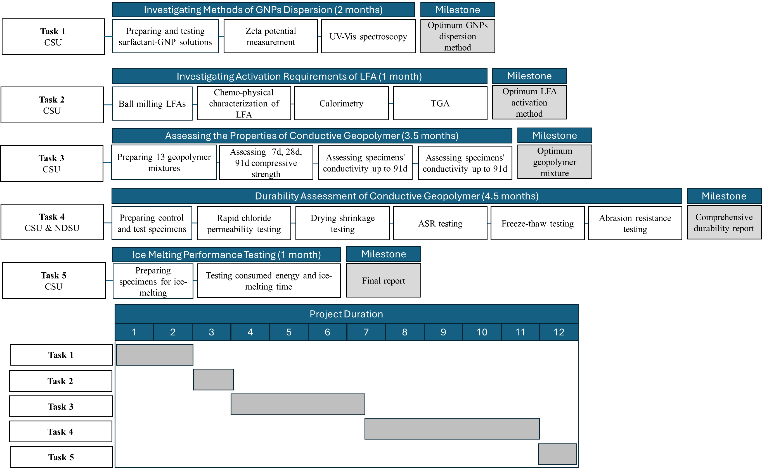

Figure 2. Work plan summary

## Project Cost

Total Project Costs: $ 110,000

CTIPS Funds Requested: $ 55,000

Matching Funds: $ 55,000

Source of Matching Funds: Colorado State University – $50,000

North Dakota State University – $5,000

## References

1. Wang, K., D.E. Nelsen, and W.A. Nixon, *Damaging effects of deicing chemicals on concrete materials.* Cement and concrete composites, 2006. **28**(2): p. 173-188.

2. Darwin, D., J. Browning, L. Gong, and S.R. Hughes, *Effects of deicers on concrete deterioration*. 2007, University of Kansas Center for Research, Inc.

3. Shi, X., L. Fay, M.M. Peterson, and Z. Yang, *Freeze–thaw damage and chemical change of a portland cement concrete in the presence of diluted deicers.* Materials and structures, 2010. **43**: p. 933-946.

4. Sajid, H.U., A. Jalal, R. Kiran, and A. Al-Rahim, *A survey on the effects of deicing materials on properties of Cement-based materials.* Construction and Building Materials, 2022. **319**: p. 126062.

5. Kim, H.-S., C. Jang, H.G. Kim, and B.-H. Woo, *Snow-melting performance of the thermally conductive concrete pavement–experimental evaluation in field application.* Construction and Building Materials, 2024. **411**: p. 134508.

6. Wang, X., Y. Wu, P. Zhu, and T. Ning, *Snow melting performance of graphene composite conductive concrete in severe cold environment.* Materials, 2021. **14**(21): p. 6715.

7. Won, J.-P., C.-K. Kim, S.-J. Lee, J.-H. Lee, and R.-W. Kim, *Thermal characteristics of a conductive cement-based composite for a snow-melting heated pavement system.* Composite Structures, 2014. **118**: p. 106-111.

8. Rahman, M.L., A. Malakooti, H. Ceylan, S. Kim, and P.C. Taylor, *A review of electrically conductive concrete heated pavement system technology: From the laboratory to the full-scale implementation.* Construction and Building Materials, 2022. **329**: p. 127139.

9. Wang, X., X. Liu, C. Zhao, P. Zhu, and H. Liu, *The permeability, mechanical and snow melting performance of graphene composite conductive-pervious concrete.* Journal of Building Engineering, 2023. **79**: p. 107929.

10. Li, C., H. Ge, D. Sun, and X. Zhou, *Novel conductive wearing course using a graphite, carbon fiber, and epoxy resin mixture for active de-icing of asphalt concrete pavement.* Materials and Structures, 2021. **54**: p. 1-17.

11. Ding, S., S. Dong, X. Wang, S. Ding, B. Han, and J. Ou, *Self-heating ultra-high performance concrete with stainless steel wires for active deicing and snow-melting of transportation infrastructures.* Cement and Concrete Composites, 2023. **138**: p. 105005.

12. Vilaverde, C., R. Santos, M. Paiva, and J. Covas, *Dispersion and re-agglomeration of graphite nanoplates in polypropylene melts under controlled flow conditions.* Composites Part A: Applied Science and Manufacturing, 2015. **78**: p. 143-151.

13. Ashkezari, G.D., F. Fotouhi, and M. Razmara, *Experimental relationships between steel fiber volume fraction and mechanical properties of ultra-high performance fiber-reinforced concrete.* Journal of Building Engineering, 2020. **32**: p. 101613.

14. Sarsam, W.S., A. Amiri, S. Kazi, and A. Badarudin, *Stability and thermophysical properties of non-covalently functionalized graphene nanoplatelets nanofluids.* Energy conversion and management, 2016. **116**: p. 101-111.

15. Heymsfield, E., A. Osweiler, P. Selvam, and M. Kuss, *Developing anti-icing airfield runways using conductive concrete with renewable energy.* Journal of Cold Regions Engineering, 2014. **28**(2): p. 04014001.

16. de Souza, F.B., X. Yao, W. Gao, and W. Duan, *Graphene opens pathways to a carbon-neutral cement industry.* Science Bulletin, 2022. **67**(1): p. 5-8.

17. Shakouri, M., A.A. Ahmed, and M. Teymouri, *Evaluating the performance of thermomechanically beneficiated fly ash blended mortar.* Construction and Building Materials, 2024. **411**: p. 134401.

18. Shakouri, M., M. Teymouri, N.P. Vaddey, C. Zhang, K. Ksaibati, M.S. Kuinkel, and P. Liu, *Enhancing physiochemical properties and reactivity of landfilled fly ash through thermo-mechanical beneficiation.* Cement and Concrete Composites, 2023. **144**: p. 105310.

19. Yang, M., S.R. Paudel, and Z.J. Gao, *Snow-proof roadways using steel fiber–reinforced fly ash geopolymer mortar–concrete.* Journal of Materials in Civil Engineering, 2021. **33**(2): p. 04020444.

20. Zakka, W.P., N.H.A.S. Lim, and M.C. Khun, *A scientometric review of geopolymer concrete.* Journal of Cleaner Production, 2021. **280**: p. 124353.

21. Singh, B., G. Ishwarya, M. Gupta, and S. Bhattacharyya, *Geopolymer concrete: A review of some recent developments.* Construction and building materials, 2015. **85**: p. 78-90.

22. Chen, G., M. Yang, L. Xu, Y. Zhang, and Y. Wang, *Graphene nanoplatelets impact on concrete in improving freeze-thaw resistance.* Applied Sciences, 2019. **9**(17): p. 3582.

23. Jiang, Z., O. Sevim, and O.E. Ozbulut, *Mechanical properties of graphene nanoplatelets-reinforced concrete prepared with different dispersion techniques.* Construction and Building Materials, 2021. **303**: p. 124472.

24. Kilic, U., M.M. Sherif, and O.E. Ozbulut, *Tensile properties of graphene nanoplatelets/epoxy composites fabricated by various dispersion techniques.* Polymer Testing, 2019. **76**: p. 181-191.

25. Shen, M.-Y., T.-Y. Chang, T.-H. Hsieh, Y.-L. Li, C.-L. Chiang, H. Yang, and M.-C. Yip, *Mechanical properties and tensile fatigue of graphene nanoplatelets reinforced polymer nanocomposites.* Journal of Nanomaterials, 2013. **2013**: p. 1-1.

26. Shakouri, M. and O.F. Abraham, *Influence of Graphene Nanoplatelets on Passivation and Corrosion Resistance of Carbon Steel Bars in Ordinary Portland Cement Mortar.* Construction and Building Materials, 2024. **under review**.

27. Shakouri, M., O.F. Abraham, and A.A. Ahmed, *Investigating the Influence of Graphene Nanoplatelets on the Properties of Ordinary Portland Cement Mortar.* Cement and Concrete Composites, 2024. **under review**.