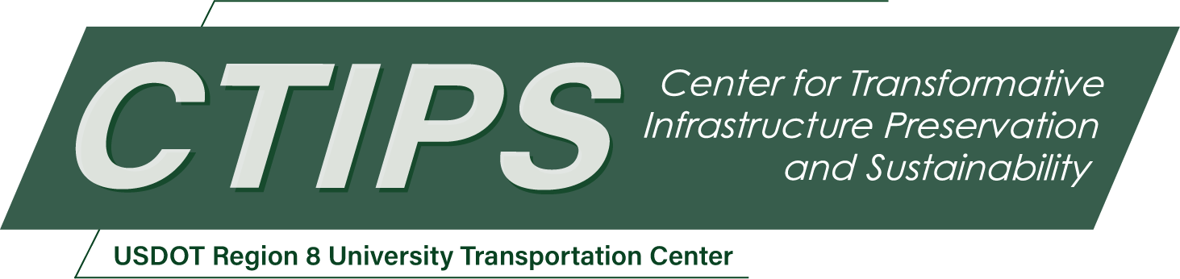

# Development of an Advanced Snow-Melting Geopolymer Concrete Utilizing Graphene Nanoplatelets and Landfilled Fly Ash

*CTIPS-024 – UTC Project Information*

|  |  |
| --- | --- |
| **Recipient/Grant Number:** | North Dakota State University, Colorado State University  Grant No. 69A3552348308 |
| **Center Name:** | Center for Transformative Infrastructure Preservation and Sustainability |
| **Research Priority:** | Preserving the Existing Transportation System |
| **Principal Investigator(s):** | Mahmoud Shakouri, Ph.D.  Mijia Yang, Ph.D. |
| **Project Partners:** | USDOT, Office of the Assistant Secretary for Research and Technology – $55,000  Colorado State University – $50,000  North Dakota State University – $5,000 |
| **Total Project Cost:** | $110,000 |
| **Project Start and End Date:** | 7/16/2024 to 7/15/2026 |

## Project Description

The construction industry faces the critical challenge of developing sustainable, durable, and high-performance concrete materials capable of withstanding harsh cold climates while contributing to environmental sustainability. Traditional concrete pavements in cold regions suffer from delayed snow melting, which leads to increased accidents, higher road maintenance costs, and a greater need for deicing chemicals. These chemicals not only further degrade infrastructure but also harm the environment. Moreover, the diminishing availability and quality of traditional fly ash, a widely used supplementary cementitious material, presents a considerable obstacle to the sustainability of concrete. Given these challenges, there is an urgent need to explore innovative materials and advanced methods for producing high-performance concrete. This project will investigate a novel concrete system that leverages nanomaterial advancements with initiatives to harvest landfilled fly ash. The primary objective of this research is to develop and test a new type of geopolymer concrete composite that incorporates graphene nanoplatelets, fiber reinforcement, and beneficiated landfilled fly ash to achieve enhanced electrical conductivity for efficient snow melting, improved sustainability, and increased mechanical properties.

## USDOT Priorities

By substituting landfilled fly ash (LFA) for cement in the production of conductive geopolymer concrete, it significantly contributes to reducing greenhouse gas emissions, directly addressing cement’s notable impact on global warming. This initiative not only propels the transition towards more resilient and sustainable transportation infrastructure but also charts a definitive course towards achieving net-zero emissions by 2050, ensuring a pivotal role for transportation in climate solutions. Concurrently, the project embodies the Department’s ‘Transformation’ goal through innovative experimentation and the collaborative synergy of leading research institutions. The integration of nanotechnology into conductive geopolymer concrete offers a pioneering approach to addressing ice management challenges and reducing the reliance on road salts. This strategy not only mitigates corrosion—the primary cause of infrastructure deterioration in the U.S.—but also sets a foundation for a future-ready, durable transportation system.

## Outputs

PI Shakouri is the Director of the American Concrete Institute (ACI) - Rocky Mountain Chapter and a member of ACI Committees 365 (Service Life Prediction) and 222 (Corrosion of Metals in Concrete). He will utilize his affiliations to share the outcomes of this research project within industry and academic circles. He and his team will present the findings of this project at several key industry gatherings, such as the 2024 Annual Colorado Concrete Conference. Additionally, the research will be presented during technical committee sessions of Committees 365 and 222 at the 2025 Annual ACI Convention in Baltimore, MD. Shakouri also plans to extend the project’s reach by publishing in well-regarded peer-reviewed journals, including Construction and Building Materials and Construction and Concrete Composites, ensuring that the insights gained from this study contribute to advancing the field of sustainable construction materials.

In addition, PI Shakouri has a proven track record of collaborating with CSU Ventures, a private, not-for-profit corporation dedicated to managing intellectual property and facilitating technology transfer for the Colorado State University System. His experience includes successfully filing a US patent through CSU Ventures on a previous project, demonstrating his ability to bridge innovative research with practical applications. Given this background, Dr. Shakouri is optimistic about the potential of the current project to yield creative solutions that may lead to patentable technology, further contributing to the advancement of sustainable construction materials and practices.

## Outcomes/Impacts

The successful development of a geopolymer with enhanced snow-melting properties and a reduced environmental footprint could represent a significant advancement in the field. This could lead to the publication of novel findings related to the synthesis, characterization, and application of such materials. The developed geopolymer could be used in critical infrastructure (e.g., roads, bridges) to enhance safety by reducing ice formation, thereby potentially saving lives and reducing the economic impact of winter weather conditions. By utilizing waste materials (LFA) and reducing the need for traditional cement, the geopolymer could contribute to environmental sustainability and reduced pollution.

## Final Report

Upon completion, the final report link will be added to the [project page on the CTIPS website](https://www.ctips.org/projects/details.php?id=622).