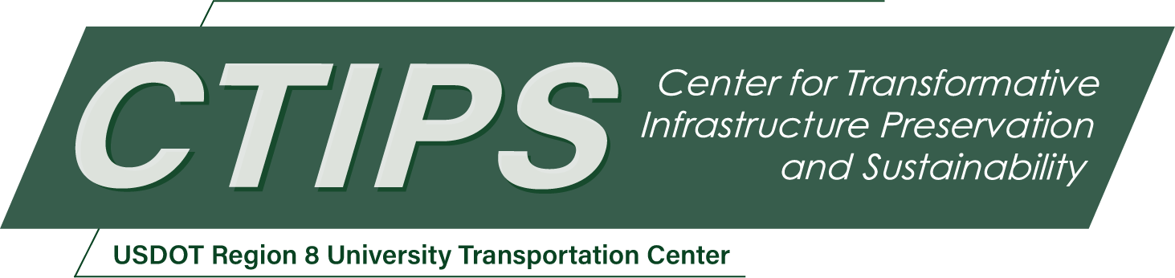

# ReACh: Resuspension Emissions Based on Aerodynamic Characteristics

*CTIPS-023 – UTC Project Information*

|  |  |
| --- | --- |
| **Recipient/Grant Number:** | North Dakota State University, Colorado State University  Grant No. 69A3552348308 |
| **Center Name:** | Center for Transformative Infrastructure Preservation and Sustainability |
| **Research Priority:** | Preserving the Existing Transportation System |
| **Principal Investigator(s):** | Vincent Paglioni, Ph.D.  Erika Gallegos, Ph.D.  Tim Coburn, Ph.D. |
| **Project Partners:** | USDOT, Office of the Assistant Secretary for Research and Technology – $60,000  Colorado State University – $60,000 |
| **Total Project Cost:** | $120,000 |
| **Project Start and End Date:** | 7/16/2024 to 7/15/2026 |

## Project Description

Non-exhaust emissions, including resuspension emissions where vehicles aerosolize road dust and debris, are a major concern for both environmental and human health. As electrified transportation becomes more popular, resuspension is expected to dominate tailpipe emissions as a regulatory concern. However, our current understanding of resuspension emissions is based on fleet-wide and regional values, and there is limited information on vehicle-specific characteristics that contribute to resuspension, with the exception of vehicle weight and road-tire interactions. This yields a regulatory impasse on how to craft appropriate regulations on the basis of limited information. This is a critical discrepancy, especially if weight-based regulations are adopted, which could unnecessarily penalize electric vehicles, jeopardizing the accessibility and equity of electrified transportation. To address this foundational gap, we propose to study the connection between resuspension, road surface type, and vehicle-specific aerodynamic characteristics, including ride height, undercarriage area, and rear bumper overhang. This work will determine why specific vehicles produce more or less resuspension, and whether road surfaces can help mitigate resuspension. This work will be critical to informing vehicle and roadway regulations to mitigate the rising threat of resuspension emissions.

## USDOT Priorities

This project aligns with the USDOT Strategic Goals of Safety, Equity, and Climate and Sustainability. Understanding resuspension emissions (RE) has direct impacts on air quality and associated health outcomes, which relate to safety. We are particularly interested in the effects of roadway surface conditions on RE, motivated by the often disparate surface conditions in rural communities; where this research aims to highlight equity in [re-]pavement projects. Lastly, electric vehicles (EVs) are considered to offer a more sustainable option over internal combustion engine vehicles (ICEVs), and this project seeks to quantitively compare RE as a function of vehicle characteristics beyond the traditionally assumed variable of vehicle weight, which results in EVs likely being incorrectly attributed to higher RE.

## Outputs

This research will be disseminated to researchers and practitioners through a research white paper, suitable for submission to an academic journal, that details the process, results, and policy implications of the research. This research will be further be translated into a preliminary policy statement that will recommend a regulatory strategy appropriate to mitigating RE. We will leverage opportunities to present this work to a wider audience through presentations to relevant academic conferences (e.g., TRB Annual Meeting), the CSU System Engineering department’s *Friday Talk* series, and/or local *Science on Tap* events.

## Outcomes/Impacts

We expect to find that there are correlations between the volume of RE produced by vehicles and their aerodynamic characteristics. Due to their effect on the presence of turbulent flow along the undercarriage and in the vehicle wake, we expect that ride height, rear bumper overhang, and undercarriage area will have significant impacts on RE production. As this study will be among the first to investigate vehicle-specific characteristics for the effect on RE, we anticipate building a predictive model for the RE produced by individual vehicles with more explanatory power than is provided by vehicle weight and road-tire interactions alone. By testing on various roadways (asphalt, concrete, gravel), we will also be able to quantify a multiplier effect on RE based on roadway surface.

The impact of this work will therefore be both academic and pragmatic. Academically, this work will address technical gaps in our current understanding of RE production by determining the vehicle characteristics that contribute to or mitigate RE. Further, this work provides a basis for more in-depth analyses of individual vehicles to design systems that can mitigate RE production. Pragmatically, this work will greatly inform our ability to create reasonable, meaningful regulations to mitigate RE. Previous studies on RE focused on fleet/city averages and/or RE composition, or isolated vehicle weight and road-tire interactions as causal factors for RE. However, the results of these studies are not specific to vehicle designs, and are thus likely insufficient as a basis for effective regulation of vehicles. We expect that studying the aerodynamic characteristics of specific vehicles will allow us to create more effective vehicle regulations.

## Final Report

Upon completion, the final report link will be added to the [project page on the CTIPS website](https://www.ctips.org/projects/details.php?id=621).