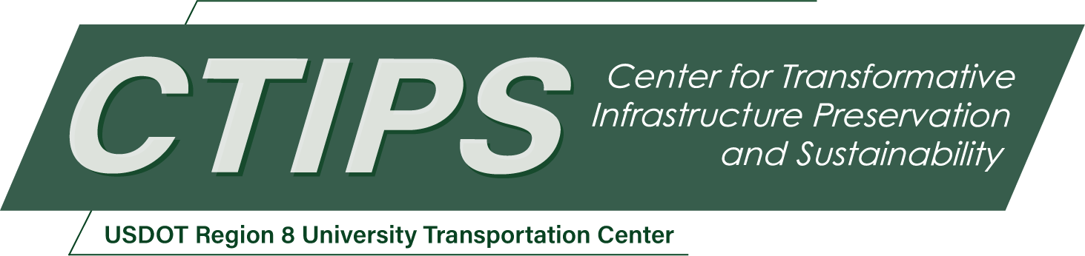

# Field-Testing and Optimizing UAS Transportation Infrastructure Inspection Methods

*CTIPS-020 – UTC Project Information*

|  |  |
| --- | --- |
| **Recipient/Grant Number:** | North Dakota State University, Colorado State University  Grant No. 69A3552348308 |
| **Center Name:** | Center for Transformative Infrastructure Preservation and Sustainability |
| **Research Priority:** | Preserving the Existing Transportation System |
| **Principal Investigator(s):** | Paul R. Heyliger, PhD  Christopher Robertson |
| **Project Partners:** | USDOT, Office of the Assistant Secretary for Research and Technology – $60,000  Colorado State University – $60,000 |
| **Total Project Cost:** | $120,000 |
| **Project Start and End Date:** | 7/16/2024 to 7/15/2026 |

## Project Description

This proposal outlines a plan to synthesize, assess, and prioritize methods used to inspect transportation infrastructure using an existing fleet of fixed and rotary wing UAS aircraft along with state-of-the-art imaging equipment. This includes thermal, RGB, LiDAR, and SfM techniques with a special focus on determining rates at which inspection data can be collected and direct comparisons between more traditional inspection methods and those completed assisted by UAS resources. A significant educational component is included, with a new permanent undergraduate course being developed titled Engineering With Drones. This proposal explains the methods used, the outcomes expected, and the educational/training plan that will be used to train personnel using these tools.

## USDOT Priorities

The USDOT strategic goal that is primarily addressed by the proposed project is Safety. A secondary strategic goal is Transformation. We select these two goals because our proposed work with aim to transform the way in which safety inspections and procedures can be completed.

## Outputs

Our transfer plan involves a combination of refereed journal articles, potential conference presentations, undergraduate research presentations, a bank of online modules containing summary findings of the work, and a group of students educated in the flying of UAS aircraft and experience in making inspection runs using the methods described in this proposal. Our research will be submitted for online distribution via CSU-Source, an online research communication resource with a broad distribution list.

## Outcomes/Impacts

The outcomes of this work are expected to be 1) quantified metrics of the levels of accuracy and rate of collection for the methodologies described above, 2) guidelines on incorporated these inspection tools to decrease the time required for a standard inspection, 3) a series of video lectures that explains the use of these tools in transportation inspection, 4) potential journal and conference publications reporting on these tools, and 5) approximately 30 engineering students with the skills to fly UAS systems and perform some of these inspections.

## Final Report

Upon completion, the final report link will be added to the [project page on the CTIPS website](https://www.ctips.org/projects/details.php?id=618).