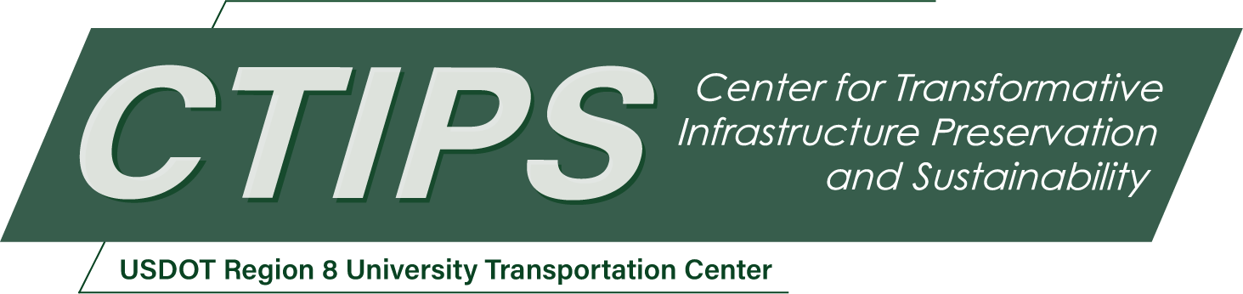

# Developing Course Modules on Social Equity for Transportation Courses in Engineering and Construction

*CTIPS-019 – UTC Project Information*

|  |  |
| --- | --- |
| **Recipient/Grant Number:** | North Dakota State University, Colorado State University  Grant No. 69A3552348308 |
| **Center Name:** | Center for Transformative Infrastructure Preservation and Sustainability |
| **Research Priority:** | Preserving the Existing Transportation System |
| **Principal Investigator(s):** | Rebecca Atadero, Ph.D., P.E.  Mehmet E. Ozbek, Ph.D. |
| **Project Partners:** | USDOT, Office of the Assistant Secretary for Research and Technology – $55,000  Colorado State University – $55,000 |
| **Total Project Cost:** | $110,000 |
| **Project Start and End Date:** | 7/16/2024 to 7/15/2026 |

## Project Description

This project aims to develop several modules on social equity issues in transportation that can be incorporated into transportation courses and general civil engineering and construction courses. The project includes a needs assessment phase where transportation professionals will be interviewed about the equity knowledge engineering and construction students should gain in school. The modules will be structured in a way that allows course instructors to tailor the content to account for the diverse levels of knowledge and needs of students.

## USDOT Priorities

This project primarily addresses the USDOT strategic goal of equity. This project is expected to advance transportation equity by helping to prepare the future transportation workforce to address equity in design and decision-making. This project also addresses the climate and sustainability goal, as equity is a key component of the social pillar of sustainability.

## Outputs

This project will produce learning modules and curriculum activities for use in civil engineering and construction courses. The learning modules will teach students about equity issues in transportation and will provide students with skills in accessing and interpreting data to create more equitable transportation decisions. The learning modules will be shared with faculty and instructors nationwide through conference presentations and by posting modules or assignments in online repositories.

## Outcomes/Impacts

Among the three pillars of sustainability, social equity has received comparatively little attention within the transportation courses offered in both undergraduate and graduate curricula in engineering and construction related programs of study. This project aims to incorporate social equity and justice related education topics, such as the social impacts of the transportation-related decisions on communities and infrastructure end-users, into transportation courses and to bring transportation related topics into general civil engineering and construction courses. The proposed course modules will help undergraduate and graduate engineering and construction students enrolled in these courses to understand and incorporate social equity into their professional roles as key decision-makers for the design and construction of the transportation infrastructure. This will help build stronger societies by reducing negative social impacts of the transportation infrastructure, particularly in communities that are currently overburdened and have a history of underinvestment.

## Final Report

Upon completion, the final report link will be added to the [project page on the CTIPS website](https://www.ctips.org/projects/details.php?id=617).