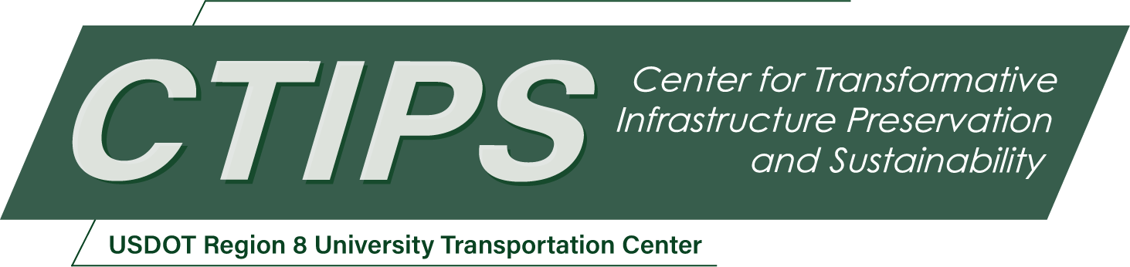

# Assessment of Safety and Operation Performances of CFIs and DDIs in Utah

*CTIPS-014*

*Approved 6/7/2024*

## University

University of Wyoming

## Principal Investigators

Milan Zlatkovic

Associate Professor

University of Wyoming

Email: mzlatkov@uwyo.edu

Phone: (307) 766-2390

ORCID: 0000-0002-6777-230X

## Research Needs

Alternative intersection and interchange designs, such as the Diverging Diamond Interchange (DDI) and the Continuous Flow Intersection (CFI), have garnered significant attention among transportation agencies, researchers and practitioners over the past 15 years, due to their ability to improve operations and safety of transportation systems (*1, 2*).

The DDI eliminates the left turn signal phasing by moving left and through movements to the opposite side of the arterial while crossing the freeway overpass/underpass, as shown in Figure 1. The DDI removes the turning movements from the intersections, and all left and right turning movements are completed before approaching the traffic lights (*3*). A DDI reduces the total number of conflict points from the 26 points associated with a traditional diamond to 14. The signal efficiency of the DDI is enhanced by employing a two-phase signal system, which helps decrease cycle lengths, thereby minimizing delays and increasing the intersection's capacity (*4*).

The fundamental concept of the CFI is to reroute left turn traffic from all directions of the primary intersection across the lanes of oncoming traffic before reaching the main intersection (*3-5*). This arrangement enables left turn maneuvers to be executed simultaneously and without interference from opposing through movements, streamlining the intersection to operate on a two-phase signal. In contrast, a conventional signal with protected left turn arrows must manage eight major movements—four left turns and four through movements—but only two movements can occur concurrently, necessitating a four-phase signal. The left turns preceding the intersection also feature signals, yet they are synchronized with the main signal, allowing left-turning vehicles to traverse the main intersection without delay. The diagram of a partial CFI is presented in Figure 2.

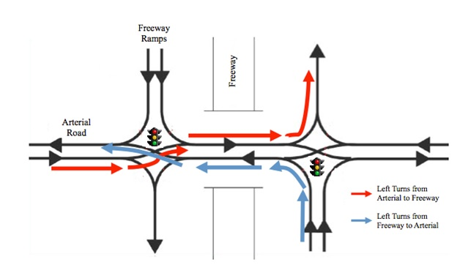

**Figure 1:** Diagram of the Diverging Diamond Interchange (DDI). Source: (*6*)

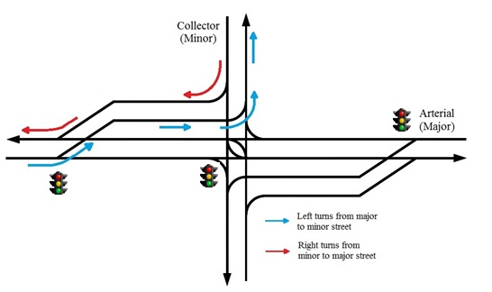

**Figure 2:** Diagram of the Continuous Flow Intersection (CFI). Source: (*6*)

The Utah Department of Transportation (UDOT) is recognized as a national leader in the design and implementation of innovative intersections and interchanges. Currently there is not a lot of information on field-based performance measures of these designs. As it has been 16 years since the first CFI was implemented, followed by many more CFIs and DDIs, UDOT’s databases contain a lot of useful data regarding operations and safety of these designs. In 2015, our research team performed a study regarding performance matrices of innovative designs (*6*). A part of it was a development of first-of-its-kind CMFs for CFIs and DDIs, which attracted a lot of attention from researchers and professionals. A drawback of these studies were the insufficient “after” data, which impacted the accuracy of the results. TRB ACP 25 Traffic Signal Systems Committee has also recognized the need for a comprehensive analysis of CMFs for alternative intersection and interchange designs.

The accelerated deployment of DDIs and CFIs necessitates the needs for more in-depth assessment of their benefits and impacts. First of all, it is important to further understand the safety implications of these designs. Research can provide more insights into how these innovative designs impact crash rates, the severity of collisions, and the overall safety of road users, as well as the implementation of appropriate countermeasures. Investigating the operational dynamics of CFIs and DDIs helps optimize traffic flow and minimize delays. More research is needed to assess the effectiveness of signal timing, lane configurations, and traffic management strategies to ensure smooth and efficient movement of vehicles through these intersections and interchanges. Further fine-tuning of design elements based on empirical data and traffic models can assist with maximizing throughput and minimizing delays. Furthermore, as transportation technology evolves, ongoing research is necessary to adapt CFIs and DDIs to emerging trends and challenges. This includes exploring opportunities to integrate intelligent transportation systems, autonomous vehicles, and other innovative technologies into intersection operations. By fostering a culture of innovation and continuous improvement, future research can ensure that CFIs and DDIs remain effective and relevant in a rapidly changing transportation environment.

## Research Objectives

The objective of this study is to perform safety and operational assessment of CFIs and DDIs in Utah. It will develop Utah-specific Safety Performance Functions (SPFs) and Crash Modification Factors (CMFs) for these designs. The study will also assess the operational performance of CFIs and DDIs, and explore ways in which operations can be improved (geometry, control, signalization). The study will assess various CFI designs, such as partial vs. full CFI, with or without the right-turn bypass lane, and different pedestrian crossing treatments. Safety assessment and cost-benefits analysis will be performed for retrofitted DDI designs (e.g. conversion of a conventional diamond interchange into a DDI), and newly designed and built DDI structures. Furthermore, the study will include lessons learned regarding planning, design, construction and optimizations of CFIs/DDIs. As the DDIs and CFIs see increased implementation in the U.S., this research will benefit other transportation agencies and users, as many of the results of these research will be transferable.

The main outputs of this study will be quantifiable and therefore easy to measure. Optimizations will be performed to improve safety and operations, and through calibrated models and simulation applications be possible to assess the effectiveness of the optimized solutions.

## Research Methods

The previous safety study on CFIs and DDIs in Utah only dealt with “all crashes”, and was performed with limited “after” data (*6*). This research will use more information regarding safety of CFIs/DDIs, and develop Utah-specific SPFs and CMFs for these designs. Comprehensive statistical modeling will be performed in RStudio to assess the significance of characteristics and crash contributing factors, applied across a variety of crash types and crash severities. In addition, machine learning models, which have proven to be efficient in safety studies, will be applied to the datasets to further enhance the safety assessment of CFIs and DDIs. Operational analysis will be performed using field observations, HCM methodologies and traffic microsimulation. VISSIM simulation software will be used extensively to test and optimize geometric designs and traffic signal control programs. The study will utilize videos of CFIs/DDIs operations and computer vision to analyze vehicle trajectories as they navigate the intersection/interchange, and individual vehicle maneuvers and the ways they impact safety and operations. Through a pilot study, the researchers at UW are currently exploring computer vision applications and its uses for intersection assessment, as shown in Figure 3. Potential operational improvements will be recommended where applicable. In addition, the researcher will reach out to UDOT personnel involved in planning, design, construction, operation and optimization/improvements of these designs and perform surveys on lessons learned during these processes.

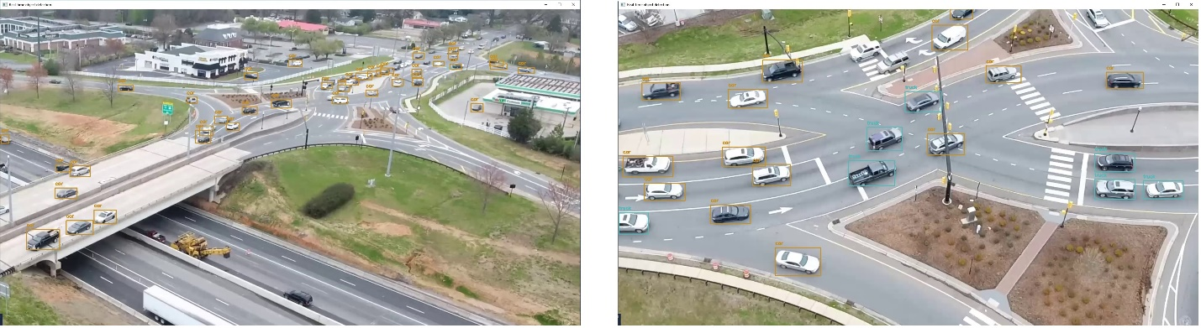

**Figure 3:** Computer vision applications for vehicle tracking through DDI

## Relevance to Strategic Goals

The proposed project will be closely related to the CTIPS Statutory Research Priority Area in preserving the existing transportation systems. The innovative designs target enhanced operational efficiency and safety at high-traffic and congested sites, while minimizing the need for footprint expansion. This is particularly true for DDIs, which maintain the same footprint as the conventional diamond interchange. Both designs have the potential to improve capacity by nearly 50%, primarily due to improved traffic flow and optimized signal management. The proposed study aims to investigate operational and safety enhancements leveraging traffic control and innovative technologies, with minimal to no impacts on existing infrastructure.

The proposed study will be relevant to all USDOT Strategic Goals, to varying degrees. The study will be mostly relevant to the Safety goal, as it will perform detailed safety analyses of DDIs and CFIs using statistical models and machine learning. The safety assessment will incorporate all travel modes. Within the Economic Strength and Global Competitiveness goal, the study will be related to the resilient supply chains, and system reliability and connectivity. Under Equity, the study will have impacts on access and proactive intervention, planning and capacity building. The Climate and Sustainability goal will be impacted through reduced emissions and infrastructure resilience. The Transformation goal will be mainly impacted through flexibility and adaptability. Finally, the Organizational Excellence goal will be mainly related to data-driven programs and policies, and sustainability initiatives.

## Educational Benefits

The study will involve graduate students in all aspects of the research, as well as undergraduate researchers as the needs arise. The students will be trained to use traffic simulation models, statistical models, and machine learning and computer vision applications. The design and traffic control of DDIs and CFIs is already taught in our classes CE 3500 Transportation Engineering, and CE 5540 Traffic Control. The proposed research will provide additional materials and tools to be included in the lectures and labs.

## Outputs through Technology Transfer

The research team will reach out to the transportation community to discuss and present the methodologies and results of the study. Practitioners and researchers will be the target audience, since the study aims to develop control programs that can be implemented in the field. This will be done through personal communication, web sites, social media, conferences and journal publications. The research team will seek input from other interested parties to improve upon the study design and methodology. UDOT has also approved this study, so their personnel will be involved through all phases of the research. The study will be presented at the CTIPS seminars. In addition, the research team will submit and present the results of the study at engineering conferences and journals.

## Expected Outcomes and Impacts

Through a comprehensive review of literature and practice, this study will first provide a synthesis of results, best practices and lessons learned from implementations and analyses of DDIs and CFIs. The review will assist with establishing performance metrics and evaluation criteria to assess the success and effectiveness of DDIs and CFIs in addressing traffic congestion, enhancing safety, and improving mobility. Ultimately, this review will assist with planning and designs of future deployments. Through modeling and simulation applications, the study will enhance the understanding of traffic flow dynamics, operational characteristics and capacity limitations, as well as provide tools to assess the performance of DDIs and CFIs under various traffic volumes, geometric configurations, and signal timings. The study will also provide methodologies for the integration of real-time data, computer vision and machine learning in the optimization of operations and safety of these designs.

The study is expected to have significant implications for future research directions. It will identify the research gaps and priority areas for further investigation, including the impact of emerging technologies, changing travel behavior, and evolving transportation trends on the performance of DDIs and CFIs. The study will have important implications for practitioners, such as technical guidance for design and operational strategies, assessment methodologies and tools and other materials to support planning, design and implementation of DDIs and CFIs.

The study will provide updated SPFs and CMFs for installation of DDIs and CFIs. These functions and factors will be created for Utah conditions; however, it will be possible to calibrate them for applications in other locations. Simulation models will be created and calibrated to assist with operational assessment and optimization, including complex traffic signal operations. Finally, the study will provide machine learning and computer vision tools capable of monitoring vehicle trajectories and vehicle maneuvers, and assisting in the safety and operational assessment using real-time video data.

## Work Plan

The study will be split into six main tasks, and the expected period of performance is 12 months. Some of the tasks will overlap and be performed simultaneously to optimize the work schedule. The tasks and expected timelines are as follows:

***Task 1: Review of literature and practice*** (Month 1 and 2, and updated throughout the study)

The research team will review the existing publications, research studies, guidelines and best practices from different agencies related to the implementation and assessment of CFIs and DDIs. The review will include a detailed assessment of existing related work in Utah.

***Task 2: Data collection*** (Month 2 to 4)

The research team will explore potential sources of safety data to be used in the study, such as UDOT’s AASHTOWare system, the Fatality Analysis Reporting System (FARS), and similar platforms, to obtain the data relevant to the study. The operational data will be collected through UDOT’s TOC, including traffic volumes and compositions, speeds, and signal timing data. Detailed geometrical characteristics of selected locations will be obtained from UDOT and through field observations. Additionally, the team will work to obtain recorded videos of selected DDI and CFI locations, which will be used for visual observation and computer vision applications. The collected data will provide important variables for safety statistical analysis and operational models.

***Task 3: Development of safety statistical models*** (Month 4 to 9)

The safety data collected in the previous task will first be analyzed to obtain descriptive crash statistics for CFIs and DDIs in Utah. This analysis will determine the major crash characteristics and contributing factors, and identify roadway, environmental, traffic and driver characteristics of these crashes. Then, the data will be organized by selected variables (crash characteristics, location, traffic, environmental conditions, geometrical and driver characteristic) and analyzed using statistical methods. In recent years, the research team has been successfully using RStudio software for safety analysis, which is recommended for data analysis and statistical modeling. The analysis will implement Bayesian and other recommended statistical models to assess the contribution and significance of various factors, to the best extent possible considering the available data. The statistical models will be used to develop Utah-specific SPFs for CFIs and DDIs, as well as CMFs for converting conventional intersections/interchanges into these designs. Furthermore, the team will apply machine learning models to the safety datasets to further expand on the safety analyses. Recently, machine learning has proven to be an efficient tool for traffic safety analysis, and our team will leverage our experience in this area to provide added values to DDI and CFI safety assessment. Vehicle trajectories obtained through the computer vision modules will be used to analyze traffic safety parameters on the microscopic level.

***Task 4: Development of operational models*** (Month 7 to 10)

Using the geometry and operational data, the team will develop operational models using traffic microsimulation, HCM-based models and in-house modeling applications. The operational models will be used to test current and future traffic conditions, as well as assess any proposed optimizations and geometry/operational improvements. Additional operational analysis and model calibration will be performed using computer vision module outputs.

***Task 5: Improvement recommendations and optimizations*** (Month 10 and 11)

Using the results from the safety and operational analyses, the research team will provide a set of recommendations for potential improvements in design and operation of existing CFIs and DDIs, as well as the steps for planning, design and implementation of these designs in the future.

***Task 6: Reporting*** (Month 12, and throughout the study)

The research team will provide constant updates throughout the study through reports and presentations. A draft final report will be submitted for review in the last month. After receiving review comments, the team will submit an official final report at the end of the study. In addition to the reports, the research team will publish parts of the research in journal and conference publications.

## Project Cost

Total Project Costs: $ 152,644

CTIPS Funds Requested: $ 76,322

Matching Funds: $ 76,322

Source of Matching Funds: Utah Department of Transportation – $58,581

University of Wyoming – $17,741

## References

1. Do, D., Chen, Y.-Y., & Chang, G.-L. (2022). Concurrent Optimization of Cycle Length, Green Splits, and Offsets for the Diverging Diamond Interchange. *Transportation Research Record*, 2676(12):653-665. <https://doi.org/10.1177/03611981221096664>
2. Qu, W. R., S. J. Liu, Q. Zhao, and Y. Qi. (2021). Development of a Progression-Based Signal-Timing Strategy for Continuous-Flow Intersections. *Journal of Transportation Engineering, Part A: Systems.* 147(3):04021002. <https://doi.org/10.1061/JTEPBS.0000508>
3. Siromaskul, S. *Diverging Diamond Interchange Design 101: Things to Know Before You Start*. ITE Annual Meeting and Exhibit, Vancouver, Canada, 2010.
4. Missouri Department of Transportation. *Missouri’s Experience with a Diverging Diamond Interchange: Lessons Learned.* Final Report, May 2010.
5. *Alternative Intersections/Interchanges: Informational Report (AIIR)*. Federal Highway Administration, Publication No. FHWA-HRT-09-060, 2010.
6. Zlatkovic, M. (2015). Development of Performance Matrices for Evaluating Innovative Intersections and Interchanges.” UT-15.13. Utah Department of Transportation Research Division. https://www.udot.utah.gov/main_old/uconowner.gf?n=25601022404950131