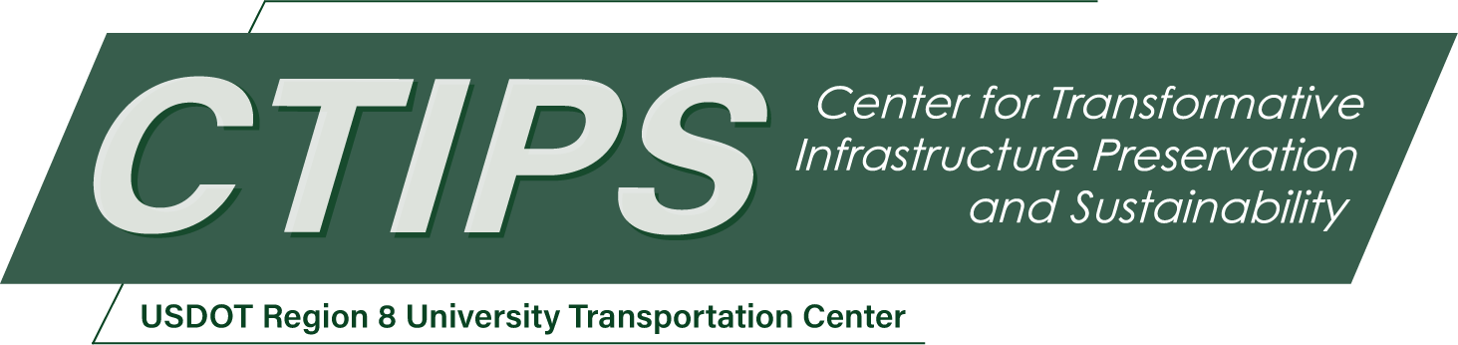

# The Impact of Connected and Autonomous Vehicle Technologies on North Dakota’s Highway Infrastructure

*CTIPS-012 – UTC Project Information*

|  |  |
| --- | --- |
| **Recipient/Grant Number:** | North Dakota State University, University of North Dakota  Grant No. 69A3552348308 |
| **Center Name:** | Center for Transformative Infrastructure Preservation and Sustainability |
| **Research Priority:** | Preserving the Existing Transportation System |
| **Principal Investigator(s):** | Sherif Moustafa Gaweesh, PhD, PE, RSP1 |
| **Project Partners:** | USDOT, Office of the Assistant Secretary for Research and Technology – $76,243  University of North Dakota – $76,243 |
| **Total Project Cost:** | $152,486 |
| **Project Start and End Date:** | 6/7/2024 to 6/6/2026 |

## Project Description

As the transportation landscape evolves, the integration of Connected and Autonomous Vehicle (CAV) technologies into highway infrastructure becomes increasingly critical. This proposal outlines research needs, objectives, methods, and expected outcomes regarding CAV implementation, particularly in rural areas like North Dakota (ND). It emphasizes understanding the impact of CAVs on infrastructure, operations, safety, maintenance, and environment. Challenges, both technical and non-technical, are identified, underscoring the importance of proactive preparation.

The research objectives include synthesizing regulatory frameworks, assessing infrastructure needs, and evaluating CAV impacts through microsimulation modeling and safety assessments. Expected outcomes encompass valuable insights for policy development, infrastructure enhancement, and public acceptance strategies. Aligning with US Department of Transportation goals, this research aims to enhance safety, sustainability, and transportation efficiency.

The proposed work plan spans literature review, regulatory analysis, infrastructure assessment, microsimulation modeling, safety evaluation, expert review, and recommendation documentation. Through comprehensive analysis and stakeholder engagement, this research aims to provide actionable recommendations for navigating the CAV integration landscape, ensuring safe and efficient deployment within North Dakota's highway system.

## USDOT Priorities

This proposal’s goal aligns with the USDOT’s strategic goals for safety and transportation. The investigation will result in a better understanding of the impacts of CAV technologies on the ND highway system. This research will provide insights into how CAV technologies can contribute to preserving and enhancing North Dakota's existing transportation system, which aligns with the statutory research priority area of CTIPS. This research will clarify the impact of CAV technologies in enhancing the safety and reliability of North Dakota's highway infrastructure. CAVs will contribute to the overall preservation and sustainability of the transportation system by reducing the frequency of crashes.

## Outputs

Several technology transfer approaches will be used to effectively disseminate project outcomes and findings. These approaches will include peer-reviewed research reports, journal articles, conference papers, and the university’s website and LinkedIn social media platform. Technology transfer activities will be reported in this project's Semi-Annual Progress Report (SAPR).

## Outcomes/Impacts

The emergence of vehicle and highway automation presents novel challenges for transportation authorities. State Departments of Transportation, municipalities, and cities must gain a comprehensive understanding of the implications of Connected and Autonomous Vehicle (CAV) Technologies on highway infrastructure to effectively navigate the transition to autonomous driving. This study aims to proactively identify and address the potential adverse and positive effects of CAVs on the state surface transportation systems by synthesizing research and practical insights. The study will examine the research needs and challenges associated with the statewide deployment of Autonomous Vehicles (AVs) in North Dakota (ND), resulting in valuable recommendations pertaining to regulation and policy development, infrastructure design and management, enhancements to traffic management strategies, and development of a site-specific rural roadway microsimulation model. The primary outcome will be cutting-edge research and practices related to CAV technologies, highlighting current advancements, technological implementations, and potential gaps requiring attention in the short and long term. The study will comprehensively analyze factors influencing the ND residents’ perception and acceptability of CAV technologies, offering valuable insights regarding CAV testing and deployment barriers. This research is highly relevant to the strategic goals outlined by the U.S. Department of Transportation (USDOT) for 2022-2026, particularly in enhancing safety and transformation.

## Final Report

Upon completion, the final report link will be added to the [project page on the CTIPS website](https://www.ctips.org/projects/details.php?id=610).