

# Subsurface Seismic Imaging Using Full-Waveform Inversion and Physics-Informed Neural Networks

*CTIPS-009*

*Approved 5/6/2024*

## University

University of Utah

## Principal Investigators

Kami Mohammadi, Ph.D., P.E.

Assistant Professor

Dept. of Civil and Environmental Engineering

University of Utah

Phone: (801) 585-0130

Email: kami.mohammadi@utah.edu

ORCID: 0000-0001-5006-3200

## Research Needs

Roadway subsidence presents a significant challenge in the maintenance and safety of transportation infrastructure. This localized downward movement of the ground surface is largely due to buried low-velocity anomalies, such as highly compressible soft clay or loose sand zones, voids, and abandoned mine workings. Subsidence not only compromises the integrity of the road surface but also poses a considerable risk to the safety of the traveling public (Tran & Sperry, 2018; Tran et al., 2017; Sullivan et al., 2016). The ability to effectively assess and address this geohazard is, therefore, a crucial aspect of transportation system management. The early identification of subsurface anomalies is key to mitigating risks associated with roadway subsidence. By detecting potential hazards before they manifest as surface deformations, remedial actions can be undertaken to prevent extensive damage or catastrophic collapse of the roadway. This proactive approach to roadway maintenance ensures the continuous safety and efficiency of transportation routes, thereby minimizing disruptions and potential hazards to the public.

Over the past few decades, various geophysical techniques, which are based on the characteristics of seismic wave propagation in heterogenous geomaterials, have been used to identify and assess subsurface anomalies. Among these techniques, non-invasive subsurface imaging methods like Spectral Analysis of Surface Wave (SASW) (Stokoe et al., 1994) and Multichannel Analysis of Surface Wave (MASW) (Park et al., 1999) have received more attention from the engineering community (near-surface imaging) due to their lower operational cost, easier data acquisition, and more lateral site coverage. One of the major shortcomings of these approaches is their selectiveness in using only a limited part of the recorded data (for example, using first-arrival times only). Consequently, they result in the averaging of velocity profiles over large volumes of geomaterials, which complicates the detection of small-scale low-velocity anomalies in urban environments. The full-waveform inversion (FWI) technique (Tarantola, 1984; Virieux et al., 2014), on the other hand, utilizes the entire content of the seismic record to extract subsurface properties. Despite the enhanced accuracy in extracting subsurface material properties, the full-waveform methodology has not been very attractive to the engineering community mainly due to the high computational cost of wave simulators and the inherent complexities of inverse formulation, particularly for the near-surface region (Bunks et al., 1995; Yust et al., 2023).

In recent years, there has been a growing interest in using various Deep Learning (DL) methods to mitigate FWI challenges and enhance its performance (Adler et al., 2021). In particular, DL methods show promise for rapidly developing robust starting models for FWI that are less prone to get trapped in local minima. Nonetheless, it is difficult to generalize the predicted velocity model outside the training dataset due to the inherent constraints of limited data and overfitting issues.. Furthermore, these methods generally demand an extensive dataset for training the model, a requirement that often proves impractical in real-world scenarios. One idea to address all these challenges is to regularize our neural networks by systematically informing them with prior information and governing laws of physics (wave equation in this case). With the advancement of scientific machine learning techniques and computational resources, the Physics-Informed Neural Networks (PINNs) (Raissi et al., 2019) has emerged as a promising approach to alleviate the limitations of data-driven techniques. Acting as a bridge between traditional physical models and data-driven neural networks, PINNs infuse the underlying physics into neural networks by adding the governing equations as well as Initial and Boundary Conditions (IC/BCs) to the loss function. The resultant algorithm can train the model with fewer data points and better predict the response beyond the range of the training data set. Despite its rapidly growing popularity in solving a wide range of problems in engineering and science (Karniadakis et al., 2021), PINNs has received less attention in near-surface seismic imaging, largely due to the complexity of governing equations and boundary conditions involved.

## Research Objectives

Given the challenges associated with FWI in near-surface seismic imaging and the promising potentials of PINNs in solving inverse problems, the overall objective of this research is to develop an efficient yet robust PINNs-FWI framework to solve the elastic wave equation in heterogeneous geomaterials and invert subsurface anomalies. We plan to attain this overall objective by pursuing the following three specific objectives:

1. Generate a set of synthetic wavefields for shallow buried anomalies through the numerical solver of the elastic wave equation to train our networks.
2. Combine PINNs with FWI to retrieve both P and S wave velocity profiles.
3. Use the actual seismic recordings at a downhole array site to investigate the performance of the proposed PINNs-FWI framework under realistic conditions.

## Research Methods

To generate a set of synthetic wavefields for training our neural networks, we use the explicit finite volume code FLAC (Cundall, 1976) as a forward solver of the elastic wave equation and its associated IC/BCs. The method combines the simplicity and robustness of FDM with the flexibility of FEM to simulate wave-propagation phenomena in heterogeneous geomaterials with a high resolution at low computational cost. To solve the inverse problem through FWI and identify subsurface anomalies, we propose a fully connected feed-forward neural network with an input layer comprising the spatiotemporal coordinates and an output layer that represents wave potentials and seismic wave velocities (left part of Figure 1). These NNs can be used to approximate the unknown variable of the problem (wavefield or material properties) if it is trained by adequate/abundant labeled data. To mitigate this high data dependency, PINNs incorporate the Physical laws, namely, the governing equations and boundary conditions, into the solution procedure (right part of Figure 1). The components of these differential equations, namely, the derivatives with respect to space and time, are added to NNs by applying the chain rule through automatic differentiation (Baydin et al., 2018). PINNs will then learn the optimal values of weights and biases by minimizing the total loss function, which includes several terms corresponding to the governing equation, ICs, BCs, and observation data. For minimizing the loss function, we use the Adam optimization algorithms (Kingma & Ba, 2014) because it provides a faster convergence for the elastic wave problem. Lastly, we use actual seismic records from the Downhole Array site at the intersection of I-15 and I-80 IN Salt Lake City to investigate the performance of FWI-PINNs under realistic conditions.

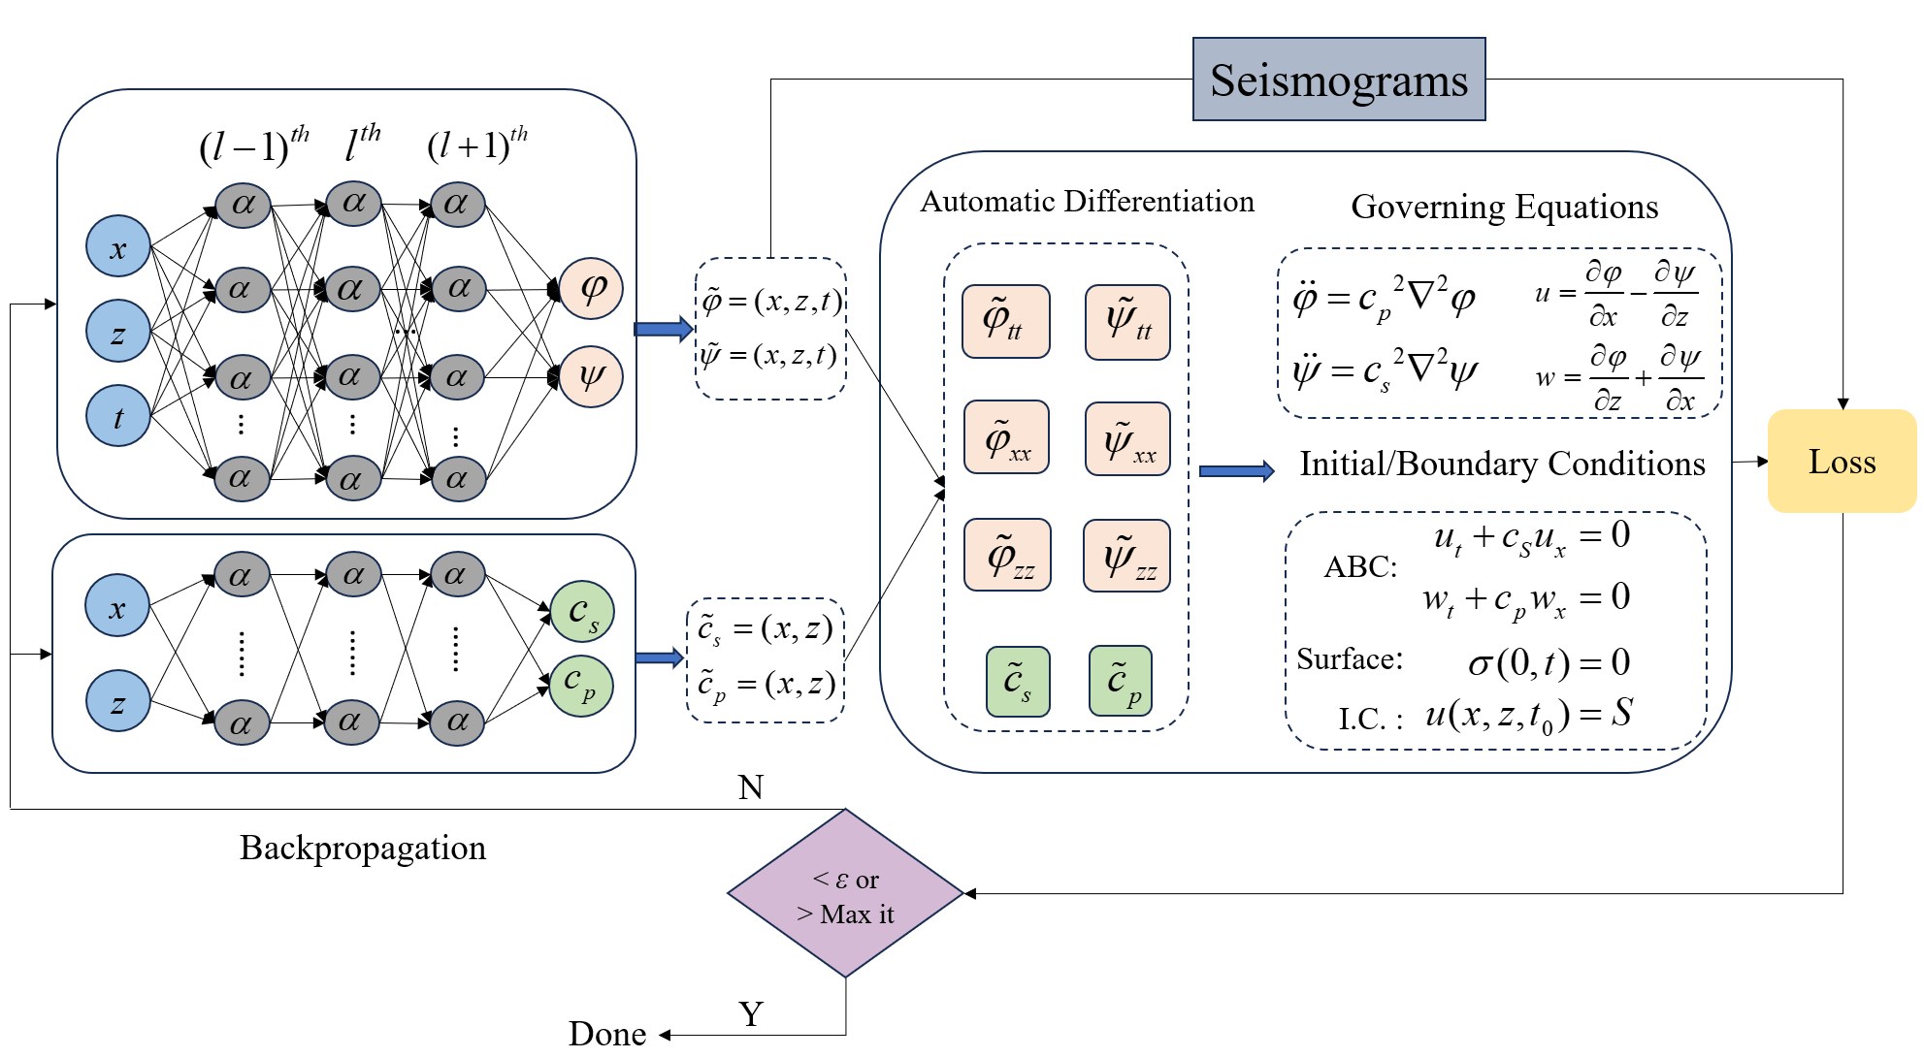

**Figure 1.** A schematic diagram of the proposed PINNs framework

## Relevance to Strategic Goals

Roadway subsidence presents a significant challenge to maintaining safe and structurally sound transportation infrastructure. Addressing this challenge effectively ensures the preservation of road usability and minimizes the risk of accidents. This underscores the importance of employing innovative engineering solutions tailored to mitigate the risks associated with subsurface anomalies. The proposed research presents a novel seismic inversion technique aimed at accurately detecting small-scale subsurface anomalies within transportation infrastructures at a reduced data acquisition cost. The early detection facilitated by this approach allows for the prompt implementation of corrective measures, thereby avoiding significant damage or the potential for disastrous roadway failures. These outcomes are aligned with USDOT’s strategic goals of *safety* and *preservation* of transportation systems.

## Educational Benefits

This project offers substantial educational benefits, particularly in training the next generation of researchers/practitioners and enhancing academic curricula. By involving a PhD student in this project, we provide a rich, hands-on learning experience that extends beyond traditional classroom education. The student will gain invaluable insights into cutting-edge seismic inversion techniques and their real-world applications for the maintenance and safety of transportation systems. Furthermore, the project's outcomes will serve as teaching material (working example) to enrich the existing graduate course of Signal Processing and Inverse Problems in Civil Engineering. Enhancing the current curriculum with this project's findings will broaden the exposure of students to the most recent technological innovations and current research directions in the field of seismic inversion.

## Outputs through Technology Transfer

For the technology transfer component of this project, we envision organizing a technical session at a national conference such as the American Geophysical Union (AGU), the Seismological Society of America (SSA), or the Transportation Research Board (TRB). Additionally, The research findings are planned to be published in high-impact journals relevant to our field, including the Geophysical Research Letters (GRL), the Bulletin of the Seismological Society of America (BSSA), and the Transportation Research Record (TRR). To ensure that our work reaches a broad audience of civil engineers specializing in natural hazard mitigation, we plan to share our data and findings on DesignSafe. DesignSafe is the cyberinfrastructure arm of the Natural Hazards Engineering Research Infrastructure (NHERI), designed specifically for facilitating the dissemination and collaboration of research outcomes within the natural hazards engineering community.

## Expected Outcomes and Impacts

The anticipated outcome of the proposed research is an inversion algorithm that integrates FWI with PINNs (objective 2), trained by synthetic seismic data for shallow embedded anomalies (objective 1), whose performance under real-world conditions is further examined by actual seismic data (objective 3). Figure 2 shows the preliminary results of the proposed FWI-PINNs algorithm that is designed and trained for *deep* anomalies/inclusions. The outcomes of this project have the potential to be expanded to utilize omnipresent urban noise and vibration, such as those from passing vehicles, as a source of excitation. This approach could significantly reduce operational costs and minimize disruptions to everyday urban activities. Finally, with the fast-growing advancements in GPU-based machine learning algorithms and their public availability and simplicity, we believe the proposed inversion method can turn into a fast, robust, and practical subsurface characterization tool for transportation systems.

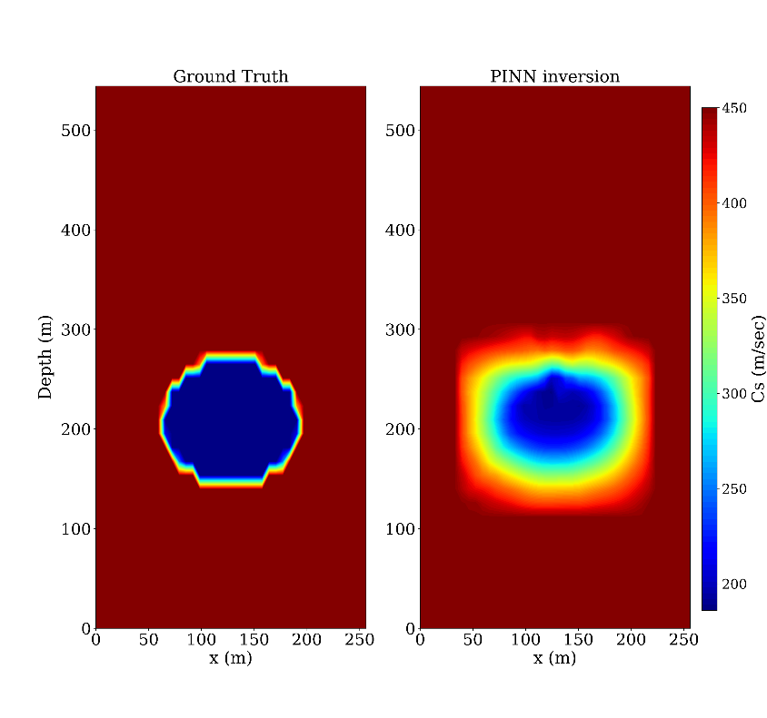

Ground truth

FWI-PINNs

**Figure 2.** Ground truth vs. FWI-PINNs inverted velocity for the case of circular anomaly

## Work Plan

The timeline of the proposed project is summarized in Table 1. We plan to perform the following major tasks over the period of 12 months:

1. Literature review (2 months)
2. Wave modeling to generate the synthetic seismic data (3 months)
3. Developing a PINNs-FWI framework to retrieve wave velocity profile (6 months)
4. Field data collection and processing (2 months)
5. Investigating the performance of the proposed framework under realistic conditions (2 months)
6. Final report (2 months)

**Table 1.** Project Timeline

|  |  |  |  |  |  |  |  |  |  |  |  |  |
| --- | --- | --- | --- | --- | --- | --- | --- | --- | --- | --- | --- | --- |
| Task/Month | 1 | 2 | 3 | 4 | 5 | 6 | 7 | 8 | 9 | 10 | 11 | 12 |
| **Task 1:** Literature Review | X | X |  |  |  |  |  |  |  |  |  |  |
| **Task 2:** Wave Modeling |  | X | X | X |  |  |  |  |  |  |  |  |
| **Task 3:** Developing PINNs-FWI |  |  | X | X | X | X | X | X |  |  |  |  |
| **Task 4:** Field Data Collection |  |  |  |  |  |  |  | X | X |  |  |  |
| **Task 5:** Validation w/ Field Data |  |  |  |  |  |  |  |  | X | X |  |  |
| **Task 6:** Final Report |  |  |  |  |  |  |  |  |  |  | X | X |

## Project Cost

Total Project Costs: $ 100,000

CTIPS Funds Requested: $ 50,000

Matching Funds: $ 50,000

Source of Matching Funds: University of Utah

## References

Adler, A., Araya-Polo, M., & Poggio, T. (2021). “Deep Learning for Seismic Inverse Problems: Toward the Acceleration of Geophysical Analysis Workflows.” *IEEE Signal Processing Magazine*, *38*(2):89-119.

Baydin, A. G., Pearlmutter, B. A., Radul, A. A., & Siskind, J. M. (2018). *Automatic Differentiation in Machine Learning: A Survey* (arXiv:1502.05767).

Bunks, C., Saleck, F. M., Zaleski, S., & Chavent, G. (1995). “Multiscale Seismic Waveform Inversion.” *Geophysics*, 60(5):1457-1473.

Cundall, P. (1976). “Explicit Finite-Difference Methods in Geomechanics.” *Proceedings of the International Conference on Numerical Methods in Geomechanics*, ASCE, New York, 132-150.

Karniadakis, G. E., Kevrekidis, I. G., Lu, L., Perdikaris, P., Wang, S., & Yang, L. (2021). “Physics-Informed Machine Learning.” *Nature Reviews Physics*, *3*:422-440.

Kingma, D. P., & Ba, J. (2017). *Adam: A Method for Stochastic Optimization* (arXiv:1412.6980).

Park, C. B., Miller, R. D., & Xia, J. (1999). “Multichannel Analysis of Surface Waves.” *Geophysics*, *64*(3):800-808.

Raissi, M., Perdikaris, P., & Karniadakis, G. E. (2019). “Physics-Informed Neural Networks: A Deep Learning Framework for Solving Forward and Inverse Problems Involving Nonlinear Partial Differential Equations.” *Journal of Computational Physics*, 378:686-707.

Stokoe, K. H., Wright, S. G., Bay, J. A., & Roesset, J. M. (1994). “Characterization of Geotechnical Sites by SASW Method.” *Geophysical Characterization of Sites* (pp. 15-25).

Sullivan, B., Tran, K. T., & Logston, B. (2016). Characterization of abandoned mine voids under roadway with land-streamer seismic waves. *Transportation Research Record*, *2580*(1):71-79.

Tarantola, A. (1984). Linearized Inversion of Seismic Reflection Data. *Geophysical Prospecting*, *32*(6):998-1015.

Tran, K. T., & Sperry, J. (2018). Application of 2D full-waveform tomography on land-streamer data for assessment of roadway subsidence. *Geophysics*, *83*(3).

Tran, K. T., Sperry, J., McVay, M., Wasman, S. J., & Horhota, D. (2017). Shear Wave Velocity Profiles of Roadway Substructures from Multichannel Analysis of Surface Waves and Waveform Tomography. *Transportation Research Record*, *2655*(1):36-44.

Virieux, J., Asnaashari, A., Brossier, R., Métivier, L., Ribodetti, A., & Zhou, W. (2014). 6. An introduction to full waveform inversion. In *Encyclopedia of Exploration Geophysics* (pp. R1-1-R1-40). Society of Exploration Geophysicists.

Yust, M. B., Cox, B. R., Vantassel, J. P., Hubbard, P. G., Boehm, C., & Krischer, L. (2023). Near-surface 2D imaging via FWI of DAS data: An examination on the impacts of FWI starting model. Geosciences, 13(3):63.