

# Optimizing Guardrail Placements along Highways in Utah to Enhance Road Safety and Mitigate Road Departure Crashes

*CTIPS-008*

*Approved 5/6/2024*

## University

University of Utah

## Principal Investigators

PI: Nikola Marković, Ph.D.

Assistant Professor

Dept. of Civil and Environmental Engineering

University of Utah

Phone: (801) 585-2877

Email: nikola.markovic@utah.edu

ORCID: 0000-0003-0883-2701

Co-PI: Abbas Rashidi, Ph.D.

Associate Professor

Dept. of Civil and Environmental Engineering

University of Utah

Phone: (801) 581-3155

Email: abbas.rashidi@utah.edu

ORCID: 0000-0002-4342-0588

## Research Needs

Road departure (RD) crashes stand as a principal cause of highway fatalities across the United States, underscoring the urgent need for a deeper understanding of the contributing factors, particularly the influence of roadside features. Notably, the Federal Highway Administration (FHWA) has reported that RD crashes account for over half of all highway fatalities, highlighting a significant area for intervention. Despite the volume of research directed at RD crashes, a substantial gap remains in the comprehensive evaluation of how roadside features, including safety barriers, affect the frequency and severity of these incidents.

Safety barriers, such as guardrails, are crucial for mitigating the impact of crashes by offering protection against various roadside hazards, including rigid obstacles, dangerous slopes, and difficult terrain. When a collision occurs with these barriers, they play a pivotal role in reducing the severity of the impact compared to collisions with rigid obstacles (Zou et al., 2014). In a comprehensive study conducted in Virginia, (Li et al., 2018) discovered that the presence of guardrails leads to a remarkable 45% to 50% reduction in fatal and serious injuries compared to incidents where guardrails are not deployed. Their effectiveness in reducing crash severity underscores the need for strategic placement and maintenance.

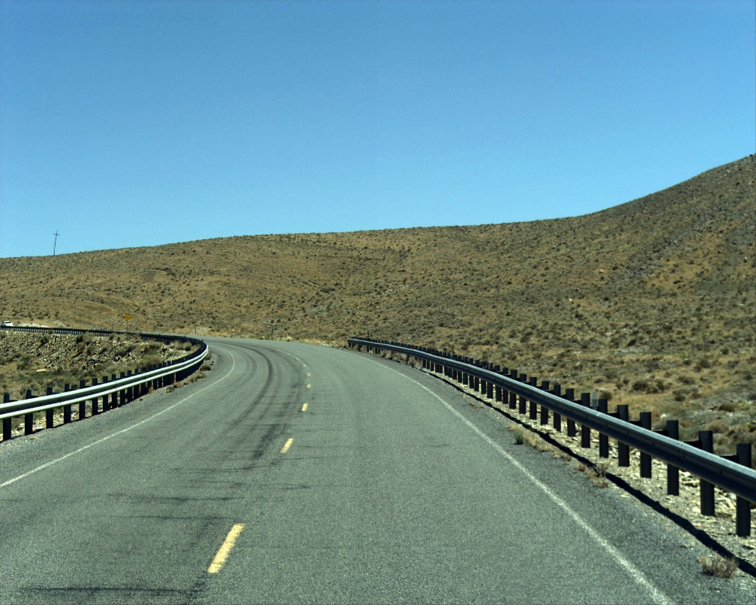

**Figure 1.** Guardrails on a road

The decision-making process for installing safety barriers, like guardrails, relies heavily on an in-depth analysis of roadside features and the associated risks. The installation of guardrails is particularly considered when the risk of collision with the barrier is deemed safer than the impact with stationary objects or the danger posed by steep slopes (Zhou et al., 2015). Thus, the availability of detailed information on roadside features, alongside data on crash severity, is vital for informed decision-making regarding guardrail placements. However, the primary obstacle in conducting a thorough analysis is the limited availability of comprehensive data on these critical roadside features.

In this context, computer vision emerges as a vital technological solution for enhancing the dataset on roadside features. The technique's capability to extract detailed information from images addresses the significant challenge of data scarcity, enabling more informed decisions to prevent road departure crashes. This approach is particularly beneficial for identifying the presence of guardrails, side slope conditions, clear zones, and rigid obstacles, thereby facilitating a better understanding of their relationship with road safety. Pathways, providing a repository of roadway images across Utah, serves as an essential resource for deploying computer vision models to analyze and extract roadside features.

Beyond the identification and analysis of roadside features, the challenge of guardrail placement extends to considerations of cost-effectiveness and the optimal allocation of resources. Given the substantial investment required for guardrail installation, leveraging an optimization technique becomes imperative for maximizing safety benefits within budgetary constraints. Here, the Mixed Integer Programming (MIP) model offers a sophisticated framework for optimizing guardrail placements. By integrating data on mile points, fatal crash incidents, and locations with hazardous roadside features, the MIP model facilitates strategic decision-making. This model not only helps in determining the most effective lengths and locations for guardrail installation but also ensures that such interventions are both economically viable and aligned with safety priorities.

This research aims to significantly enhance road safety by addressing the critical issue of road departure (RD) crashes through a dual approach. By leveraging computer vision, we intend to enrich the dataset on roadside features, specifically guardrails, to overcome existing data limitations and enable a deeper understanding of their impact on road safety. Simultaneously, the application of MIP techniques will optimize guardrail placements, ensuring they are both cost-effective and strategically located to mitigate crash severity and frequency. This integrated methodology promises to provide comprehensive insights and pragmatic solutions to reduce RD crashes, contributing to safer highways and preserving public welfare.

## Research Objectives

The objectives of this research project are as follows:

1. Extract the roadside features from pathway images for the five roads in Utah (SR6, SR10, SR12, SR40, and SR150).
2. Analyze the impact of roadside features on road departure crashes.
3. Optimizing the placement of guardrails for cost-effective and maximum safety impact.

## Research Methods

The primary goal of this research is to devise an optimization model that strategically recommends where to install guardrails, factoring in both risk considerations and resource constraints. This endeavor will incorporate data on roadside features across five roads in Utah (SR6, SR10, SR12, SR40, and SR150), correlating these with a comprehensive crash database from UDOT's previous project on Rural Roadway Departures (Burbidge et al., 2022). This database contains road departure crashes, detailing their severity, across Utah's rural roads over a span of 11 years.

To gather initial data on roadside attributes—such as clear zones, rigid obstacles, side slopes, and existing guardrails—a previously developed computer vision model from another UDOT project on Automated Safety Assessment of Rural Roadways Using Computer Vision (Mashhadi et al., 2023) will be utilized. This model, originally trained on the Mandli image dataset, will undergo retraining with manually labeled images from Pathways, a repository containing extensive photographic records of Utah's roadways, to refine its capability in identifying roadside features accurately.

Upon collecting roadside feature data, it will be integrated with the crash database through GPS coordinates, focusing analysis on selected routes. This integration aims to illuminate the interplay between roadside features and road departure crashes, identifying critical areas for guardrail implementation based on the condition of roadside features and the associated risk of severity they pose.

The analysis will proceed by filtering the dataset for the severity of crash outcomes and roadside conditions, prioritizing locations with histories of fatal injuries and hazardous roadside features. This filtered dataset, spotlighting milepoints along the roads with elevated risk profiles, readies the groundwork for optimizing guardrail placement.

Subsequently, a MIP model will be crafted to address the optimization task, structured around constraints such as the permissible number of guardrails and their cumulative length—parameters directly tied to the financial aspects of the installation. The model is designed to allocate guardrails within these constraints across the designated routes, targeting maximization of coverage over the most perilous locations.

In essence, this research will refine a computer vision model for roadside feature extraction, merging this data with crash severity insights to develop an MIP model for optimized guardrail placement. This comprehensive approach aims to furnish UDOT with a strategic framework for guardrail and safety barrier deployment, enhancing road safety within the constraints of available resources.

## Relevance to Strategic Goals

Primary strategic goal: Safety and Economic Strength

Nearly 40,000 lives are lost each year in the United States to traffic accidents, a significant portion of which, approximately 12,000 fatalities, are the result of road departure crashes—situations where vehicles leave their designated lanes and interact with dangerous roadside features. Understanding the specifics of these roadside features is vital for implementing effective safety measures against road departure incidents. In this context, the strategic placement of guardrails emerges as a pivotal action to reduce fatalities.

The UDOT plays a critical role in this scenario, as it is responsible for the judicious allocation of funds to ensure that investments are directed towards areas with the most significant potential for enhancing safety. To this end, the recommendation and prioritization of guardrail placement projects must be carefully evaluated within the confines of allocated budgets, with the aim of maximizing safety benefits and reducing road departure crashes and their severities.

The methodology proposed herein introduces a cost-effective strategy for identifying high-risk locations and prioritizing guardrail installation projects. This system is designed to maximize safety outcomes by targeting interventions at the most critical points, thereby ensuring efficient use of safety improvement project budgets. By leveraging data-driven analyses and prioritization techniques, this approach not only promises to significantly mitigate the risk of road departure crashes but also ensures that financial resources are utilized in the most impactful manner, aligning with the dual goals of enhancing public safety and maintaining economic efficiency.

## Educational Benefits

The PI of this project is currently teaching a relevant course on undergraduate-level classes called “CVEEN 3520: Transportation Engineering”. Similarly, the Co-PI of this project is currently teaching two relevant undergraduate and graduate-level classes called “CVEEN 6790: Advanced Computer-Aided Construction” and “CVEEN 5740: Horizontal Construction”. The developed optimization model, methods and case studies in this project are expected to be directly converted into new course materials for these courses. Additionally, the project will involve selected undergraduate and graduate students in various stages, including image labeling, model training, data engineering, and results validation, providing them with invaluable hands-on experience.

## Outputs through Technology Transfer

The technology transfer process for this project will take place through three major channels: 1) publishing (presenting) research results in scholarly journals (peer-reviewed journal articles or conference papers); 2) direct interactions with UDOT personnel through training sessions and workshops the potential end-users for the results of this study.

## Expected Outcomes and Impacts

The project aims to deliver three main outcomes: First, a computer vision model trained on Pathways images to identify roadside features like clear zones, obstacles, slopes, and guardrails. Second, a database with details on these features for five major Utah roads: SR6, SR10, SR12, SR40, and SR150. Third, we'll develop an optimization model MIP to figure out the best places to install guardrails.

It's also important to note that UDOT staff, who will benefit from this project, will discuss and assess the project's results.

## Work Plan

The project will include the following major tasks:

1. Literature review and initial evaluation of the existing computer vision techniques (expected completion date: end of 1st month)
2. Collecting crash data from the DOTs to enrich and update the existing crash database (expected completion date: end of 2nd month)
3. Manual labeling of the pathway images for classifying the roadside features (expected completion date: end of 4th month)
4. Data preprocessing of the pathway images and training the model on the new set of images (expected completion date: end of 6th month)
5. Merging the roadside features database created with the crash database and performing basic statistical analysis (expected completion date: end of 7th month)
6. Developing the MIP model for the optimization of guardrail placement (expected completion date: end of 9th month)
7. Preparing the final report (expected completion date: end of 10th month)

## Project Cost

Total Project Costs: $ 102,000

CTIPS Funds Requested: $ 50,000

Matching Funds: $ 52,000

Source of Matching Funds: Utah Department of Transportation

## References

Burbidge, S.K., Anderson, C., Welch, A., 2022. Investigation of Rural Roadway Departures. Technical Report, Utah Dept. of Transportation, Research Division.

Li, N., Park, B.B., Lambert, J.H., 2018. “Effect of Guardrail on Reducing Fatal and Severe Injuries on Freeways: Real-World Crash Data Analysis and Performance Assessment.” Journal of Transportation Safety and Security 10(5):455-470. https://doi.org/10.1080/19439962.2017.1297970

Mashhadi, A.H., Rashidi, A., Markovic, N., 2023. Automated Safety Assessment of Rural Roadways Using Computer Vision. Technical Report, Utah Dept. of Transportation, Research Division.

Zhou, H., Jalayer, M., Pour-Rouholamin, M., 2015. Preventing Vehicle Departures from Roadways Safety Performance of Pavement Marking Retroreflectivity in Alabama View project Impact-Based Decision Making Framework for Community-based Resiliency Planning under Extreme Storm Events. View project.

Zou, Y., Tarko, A.P., Chen, E., Romero, M.A., 2014. “Effectiveness of Cable Barriers, Guardrails, and Concrete Barrier Walls in Reducing the Risk of Injury.” Accident Analysis & Prevention, 72:55-65. https://doi.org/10.1016/j.aap.2014.06.013