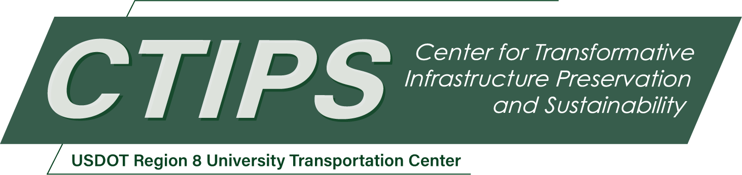

# Rapid and Low-Cost Bridge Scour Monitoring Using Unmanned Underwater Drones

*CTIPS-003*

*Approved 4/23/2024*

## University

Fort Lewis College

## Principal Investigators

Yiyan Li, Ph.D.

Associate Professor

Department of Physics and Engineering

Fort Lewis College

Phone: (970) 247-6574

Email: yli@fortlewis.edu

ORCID: 0000-0002-1682-1108

## Research Needs

Scour, a natural occurrence around a bridge’s piers and abutments, involves the creation of holes in the riverbed as water flows around the foundations [2]. The escalation of these holes near the bridge’s foundations increases the risk of a bridge collapse. Failure to address or monitor scour not only endangers the public but also incurs substantial financial and temporal costs for the state and taxpayers [3]. Given the estimated trillions of dollars required for bridge replacement and repairs, states, including Colorado, are exploring alternative solutions. In Colorado, among the 158 scour critical bridges identified by the Colorado Department of Transportation (CDOT), only a limited few have a remote monitoring system due to the high cost to acquire and maintain these monitors to each pier of all high-risk bridges.

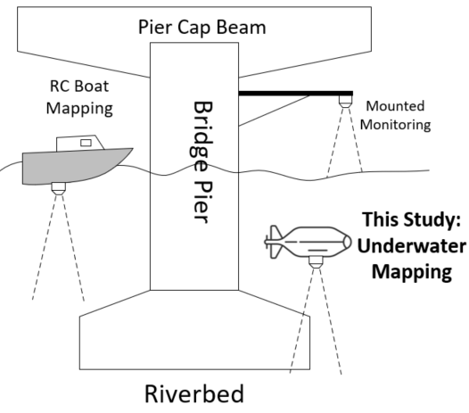

Figure 1. The submerged sonar system schematic for the Direct Measuring method.

***Preliminary results using a different technology.*** Scour has been measured using an RC boat or a mounted beam (Figure 1). The RC boat has a limited measuring depth [1], while the mounted beam is too expensive to install and maintain [4]. At Fort Lewis College, a team collaborated with the Colorado Department of Transportation to create an underwater sonar system. This system employs a single-beam sonar, which is powered by a solar setup (refer to Figure 1 and Figure 2). The team utilized a Renogy 100W monocrystalline solar panel connected to a 12V Dakota Lithium battery to supply power to the system. Two measuring methods were devised: the first involves a direct distance measurement approach using a Blue Robotics Ping Echosounder Sonar positioned at the pier's front, measuring scour by gauging the distance to the riverbed. The system's electronics were entirely customized in-house.

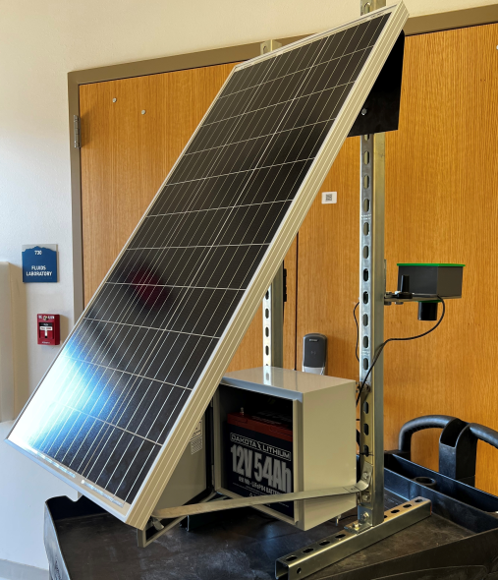

Figure 2. The solar panel, distance sensor, electrical housing, and battery for the submerged sonar system developed at Fort Lewis College.

The second measuring method that was explored was the indirect measuring which uses the Flowline LU28-02 distance sensor and the Decatur SI-3LSVR velocity sensor to calculate scour using the hydraulic modeling equations (HEC-18):

$$\frac{y_{s}}{y_{1}}=2K_{1}K_{2}K_{3}{(\frac{a}{y_{1}})}^{0.65}{Fr}^{43}$$

where:

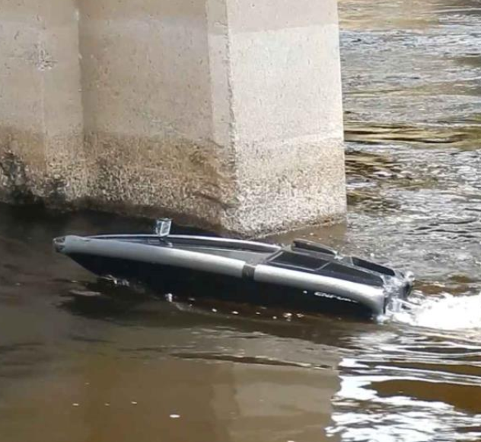

Figure 3. An Unmanned Surface Vessel (USV) was used for bridge scour evaluation. [1]

$$y_{s}=Pier scour depth$$

$$y_{1}=Flow depth directly upstrea of pier$$

$$K_{1}=Correction factor for pier nose shape$$

$$K_{2}=Correction factor for angle of attack$$

$$K_{3}=Correction factor for bed condition$$

$$a=Pier width$$

$$F_{r}=Froude number directly upstream of the pier$$

$$V_{1}=Mean velocity of flow directly upstream of the pier$$

$$g=Acceleration of gravity$$

$$Fr=\frac{V_{1}}{\sqrt{y_{1}g}}$$

While the system showed promising results in turbid environments, there were noted decreases in accuracy in turbulent water, prompting the need for additional testing. The devices are susceptible to damage or interference, resulting in increased maintenance requirements and associated costs. Additionally, the cost presents another challenge. For monitoring each pier of every at-risk bridge in Colorado, the one-time investment for acquiring each system per pier is $3,000. With a total cost exceeding $2 million for every at-risk bridge in Colorado, excluding maintenance and personnel expenses, deploying this solution on a large scale for long-term monitoring becomes less economically viable.

***Using water surface vehicles to map the riverbed***. Utilizing unmanned surface vessels (USV) for bridge scour evaluation offers enhanced safety, cost-effectiveness, and efficiency [5, 6]. These autonomous vehicles provide accurate data, operate continuously, and have a reduced environmental impact, making them a valuable and versatile tool for monitoring and assessing bridge infrastructure conditions. Because of its mobility, the expenses associated with acquiring, operating, installing, and maintaining it will be substantially lower than those of traditional fixed sensors.

Schroeder et al’s 2019 study in Michigan [1], utilizing a surface vessel and sonar to map bridge scour, served as a source of inspiration for our research. The team utilized the Blueview side scan sonar system, capable of generating 2D or 3D images that offer an elevated perspective of streambed banks or bridge piers. The 3D side scan proves effective in surveying deeper rivers, following the channel centerline as the boat drifts downstream. Figure 4 displays a raw 2D side scan image of a hydro facility, revealing features such as a timber cofferdam from the logging era, air bubbles, leaf litter, concrete piers, and the upstream face of steel tainted gates (Figure 4) [1].

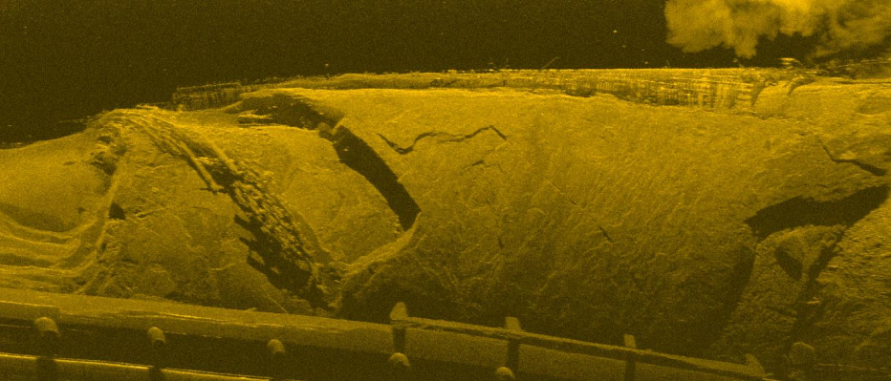

Figure 4. Raw 2D side scan image.

However, their approach presents certain limitations: the high cost of over $50,000 for both the surface vessel and the sensor/software bundle, a **detection limit of 30 feet**, and the reliance on remote operator control, introducing human errors and increased labor costs.

***Using unmanned underwater vehicles to map the riverbed.*** To address these challenges, our proposal introduces a cost-effective and autonomous unmanned underwater drone (UUD) for bridge scour monitoring. During the initial year, our strategy involves acquiring a $500 underwater drone, specifically the Chasing Dory. We intend to affix our side scan or single-beam sonar system to the drone and employ remote control for riverbed mapping. Subsequently, in the second year, we aim to enhance the system by incorporating additional autonomous driving features, enabling independent riverbed mapping. Finally, in the third year, our objective is to assess the system's performance by conducting tests on at-risk bridges. The initial three years of this project are dedicated to prototyping, building, and evaluating. Subsequently, over the next two years, our intention is to disseminate our research findings through published papers and make our complete system's electronics and software design publicly available on GitHub as open source.

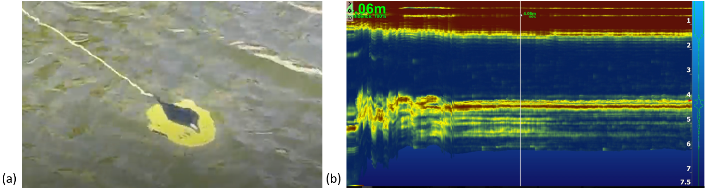

Figure 5. (a) The Chasing Dory UUD was tested in a lake in Durango, CO in 2024. (b) The recorded depth of a swimming pool using our BlueRobotics Ping 2 single beam sonar.

The PI Dr. Li and an undergraduate student at Fort Lewis College, Lucien Verrone, has started assembling the UUD and sonar system and already acquired some initial testing results (Figure 5) in Spring 2024.

## Research Objectives

The primary goal is to ***develop a low-cost and innovative UUD and sensing system*** for the rapid assessment of bridge scour. The envisioned UUD is designed to be more cost-effective than stationary mounted sonar systems, offering greater flexibility and accuracy compared to current surface vessel systems. Both the hardware and software components will be open source, fostering accessibility and collaboration. The knowledge gained from this project will be extensively shared on GitHub, with integration into our curriculum to educate engineering students on bridge scour monitoring, remote sensing, and data fusion. Furthermore, the novel circular maneuvering controller and its associated outcomes will be documented and published, encouraging others to replicate and benefit from this research. customizing it for our specific application. The enhancements involve integrating a side scan or single-beam sonar onto the underside of the UUD and incorporating a distance sensor to enable circular maneuvering around the pier. This circular motion initiates in close proximity to the pier and progressively extends outward, enabling the UUD to systematically generate a riverbed depth contour map encircling the pier. The incorporation of these enhancements ensures a 3D map is swiftly generated on-site, providing the operator with a real-time assessment of all bridge piers. This approach aims to overcome the cost, depth resolution, and operational issues associated with existing methods, offering a more efficient and accessible solution for scour mapping.

## Research Methods

**Objective 1: Mapping the riverbed using a customized low-cost UUD**

The modification of the UUD hardware will commence with the utilization of a $500 off-the-shelf underwater drone, specifically the Chasing Dory. Initially, the team will design an interface circuit incorporating the BlueRobotics Ping 2 sonar for riverbed mapping from the water's surface. The modification to the Dory necessitates a dedicated embedded system that interfaces with both the distance sensor and the sonar, with the sonar data temporarily stored on an SD card on the board. In the second quarter of the year, additional control software will be integrated into the Dory for underwater riverbed mapping. This involves identifying the ports of the original control system responsible for managing the UUD's navigation. Our supplementary control board will have the capability to directly read and write through these ports, ensuring full control over the UUD's maneuvering.

**Objective 2: Data processing and results evaluation**

This objective involves the creation of software to analyze the raw data gathered from both the sonar and the distance sensor. Anticipating the need for data refinement, we plan to employ digital low-pass filters to smooth out rapid changes resulting from water flow or motor-related errors in both the real-time depth data and the distance sensor's data. The collected sonar data will undergo processing and be visualized as 2D contours using Python, effectively representing the depth data around the pier. Areas exhibiting unusually greater depth levels will be flagged as potential scour concerns. Establishing benchmarks for these depth patterns and their corresponding assessments is crucial. To achieve this, we propose training an AI model using normal depth data, enabling the neural network to discern abnormal depth readings during on-site evaluations.

**Objective 3: Field testing**

We will implement the system on nearby bridges to assess its capabilities. Within La Plata County, 7 bridges urgently require repair, while 16 others are currently meeting the minimum tolerable limits. Our plan involves assessing the scour conditions of 5 out of these 23 bridges utilizing the system we aim to develop in the fourth quarter of the first year. We anticipate that engineering failures and potential issues will be identified during the testing phase, and we envisage extending this activity into the second year of the research. To ensure the alignment of our method with inspection standards, we will proactively engage with the CDOT bridge branch, seeking their guidance on bridge scour monitoring. This collaborative approach ensures that our methodology meets established inspection standards.

**Objective 4: Create educational modules on UUD Development for inclusion in undergraduate curricula**

We plan to develop educational modules for undergraduates on UUD development. In 2021, the CDOT assigned the task of developing a contactless sonar system mounted on piers to engineering students at FLC. The team employed satellite modules for user communication. Within the engineering department, faculty members and students have already conducted research in this field. Collaboration between computer engineering students and faculty, in conjunction with civil engineers, facilitated the development of hardware and software for data acquisition, communication, and analysis. The scour monitoring project served as a senior capstone project, seamlessly integrating into the curriculum. This project introduces an innovative approach, combining robotics, remote sensing, and artificial intelligence, aligning well with the department's existing expertise, infrastructure, and curricula. To enhance educational experiences, we plan to create educational modules as course projects for design courses (ENGR215, ENGR315, CE315, CE496, CE497, ENGR496, ENGR497), fostering engagement among a diverse team comprising students from various majors. This initiative aims to provide students with valuable real-world experiences.

## Relevance to Strategic Goals

The proposed project holds great relevance to the preservation and enhancement of existing transportation infrastructure, with a specific focus on bridges. Addressing the critical issue of scour, a natural threat to bridge foundations, the project is poised to contribute significantly to the long-term structural integrity of these essential components of transportation networks. By concentrating efforts on the 158 scour critical bridges identified by the Colorado Department of Transportation (CDOT), the project aids in identifying vulnerable structures, facilitating prioritized maintenance efforts, and efficient resource allocation. A key aspect of the proposal is the introduction of a cost-effective solution for scour assessment, leveraging an autonomous unmanned underwater vehicle (UUD). This innovative approach not only provides a scalable method for monitoring numerous bridges but also mitigates financial constraints associated with traditional monitoring systems. The UUD, equipped with sonar and distance sensors, enables real-time assessments of riverbed conditions around bridge piers. This capability ensures timely identification of potential scour concerns, allowing for prompt intervention and maintenance actions. The open-source nature of both hardware and software components fosters collaboration and knowledge sharing within the engineering community, facilitating the acceleration of effective scour monitoring technologies. Additionally, the documentation of research methods, outcomes, and educational modules serves as a valuable resource for transportation authorities, engineers, and researchers seeking best practices in infrastructure preservation.

Through field testing and collaboration with CDOT, the project aims to assist transportation authorities in efficient resource allocation by identifying specific bridges in need of urgent repair and assessing overall scour conditions. The development of an innovative UUD equipped with advanced sensors demonstrates a commitment to adopting cutting-edge technologies for infrastructure preservation.

## Educational Benefits

The proposed project presents significant educational benefits, aligning with various aspects of student learning and professional development. In the realm of real-world application, undergraduate students stand to gain valuable experience by tackling practical challenges related to engineering. The development of the UUD and sensing system serves as a tangible application of engineering principles, allowing students to bridge the gap between theoretical knowledge and hands-on problem-solving. Moreover, the project promotes interdisciplinary collaboration by bringing together students and faculty from civil engineering and computer engineering disciplines. This collaborative effort creates a learning environment, exposing students to diverse perspectives and skill sets within the engineering domain. The project design ensures that students acquire advanced technological skills through hands-on involvement in UUD design, hardware modification, and software development. By modifying an off-the-shelf underwater drone, integrating sensors, and developing control software, students are equipped with cutting-edge technological competencies.

This initiative supports the dissemination of knowledge within academic settings. Beyond the university setting, the project extends its reach to K-12 students through workshops and tours. This outreach effort aims to engage younger students in STEM education, fostering interest and inspiring the next generation of engineers. By proposing a cost-effective UUD solution, the project teaches students to consider budget constraints and explore innovative alternatives in engineering projects. This comprehensive approach ensures that students are well-prepared for the challenges and opportunities they may encounter in their future engineering careers.

## Outputs through Technology Transfer

The team will develop comprehensive research papers that detail methodologies, findings, and outcomes is the initial step, followed by publishing these papers in reputable journals to make them accessible to the global research community. Embracing open-source principles, project codes, algorithms, and software will be shared on platforms like GitHub, fostering collaboration and contributions from researchers and developers worldwide.

Collaborative research initiatives with institutions and universities will be pursued to leverage shared expertise and resources. Integration with educational curricula involves working with institutions to incorporate UUD development modules and offering training sessions for educators.

Establishing a framework for long-term support, updates, and maintenance guarantees continuous accessibility and relevance, aligning with the overarching goal of fostering widespread adoption and application of the UUD technology in bridge scour monitoring for enhanced infrastructure resilience and safety.

## Expected Outcomes and Impacts

In the first year, we will develop and assess the control system and the UUD capable of executing a spiral rotation around the pier. The methods and outcomes will be shared on GitHub, and the research particulars will be documented in a research article for publication. Moving into the second year, we will incorporate field testing and implement an updated system for a second publication. Each year, one undergraduate research assistants will be recruited to contribute to the project. Additionally, five engineering students will join a senior capstone team, integrating the project into their senior projects. We foresee training at least seven undergraduate researchers in UUD design, bridge maintenance, software development, and general engineering design skills, enabling them to actively participate in the research project. Furthermore, we anticipate the development of ten educational modules within the first two years of the project—five focusing on UUD development and related hardware and software design, and five concentrating on field testing and data processing. To engage K-12 students during field testing, at least two workshops or tours will be organized. The engineering department at FLC regularly welcomes local K-12 students for tours throughout the academic year and college-wide open houses. Additionally, the team will host a booth to showcase this technology twice a year during these events, disseminating knowledge to visitors.

Fort Lewis College, designated as a Native American serving institution, comprises approximately 35% Native American students. To enhance team diversity, we will engage with the Society of Women Engineers (SWE) and AISES (American Indian Science and Engineering Society) to actively recruit students from underrepresented populations.

## Work Plan

The work plan for the 1st year of this project consists of four major objectives, UUD modifications, software development, field testing, and educational module development. The methods and details about these four objectives can be found in the earlier sections. Here we present the timeline of these objective (Table 1).

Table 1. The timeline of the proposed work

|  |  |  |  |  |
| --- | --- | --- | --- | --- |
|  | 1st Quarter | 2nd Quarter | 3rd Quarter | 4th Quarter |
| Objective 1: UUD modification | X |  |  |  |
| Objective 2: Software and signal processing | X | X |  |  |
| Objective 3: Field testing |  |  | X | X |
| Objective 4: Educational module development |  |  |  | X |

At the very beginning, we will acquire the Chasing Dory underwater drone and design the interface circuit for the BlueRobotics Ping 2 sonar for the Dory drone. The Dory drone will then be customized into an UUD for riverbed mapping.

We anticipated that the hardware development will be completed by the end of the first quarter. The other team member will start testing the data acquisition software and the plotting software in the 1st quarter. The functioning software modules are expected to be completed by the end of the 2nd quarter.

Commencing in the 3rd quarter, field testing will initiate with the team establishing depth patterns and ratings benchmarks. An AI model will be trained on normal depth data for on-site evaluation. The system will then be implemented on five selected bridges within La Plata County for performance evaluation, identification of engineering issues, and method refinement. CDOT engagement will provide feedback on inspection standards alignment. Subsequently, field testing will expand to additional bridges, addressing engineering failures and optimizing the UUD system based on practical insights. Methods and results will be documented for publication and GitHub sharing. Simultaneously, educational modules for UUD development and hardware/software design will be developed. Integration into relevant design courses at FLC will follow, with feedback from students and faculty informing module refinement. Further expansion of educational modules will be based on field testing outcomes. These modules will be disseminated for broader adoption in engineering curricula.

The project aims to train at least seven undergraduate researchers in diverse engineering skills. Ten educational modules will engage students in real-world applications. Two publications will document methods, results, and lessons learned, with ongoing updates on GitHub for continuous knowledge sharing. Two workshops or tours during field testing will engage K-12 students, and regular technology dissemination events and open houses are planned.

It's essential to note that the work plan provides a general overview, and tasks and timelines may be adjusted based on ongoing feedback, project progress, and unforeseen challenges. Regular collaboration with CDOT and stakeholders remains integral for the project's success.

## Project Cost

Total Project Costs: $49,932

CTIPS Funds Requested: $24,966

Matching Funds: $24,966

Source of Matching Funds: Fort Lewis College

## References

[1] B. Schroeder, P. Haug, A. Alvarado, and S. Baribeau, “Unmanned Surface Vessels for Bridge Scour Monitoring,” Michigan Department of Transportation. Research Administration, 2019.

[2] A. Pizarro, S. Manfreda, and E. Tubaldi, “The Science behind Scour at Bridge Foundations: A Review,” *Water*, 12(2):374, 2020.

[3] A. Muhaimin, L. Zhang, S. Dhakal, X. Lv, N. Pradhananga, V. S. Kalasapudi*, et al.*, “Identification and Analysis of Factors Affecting the Future of Bridge Design, Construction, and Operation,” *Journal of Management in Engineering*, 37(5), p. 04021049, 2021.

[4] A. Kazemian, T. Yee, M. Oguzmert, M. Amirgholy, J. Yang, and D. Goff, “A Review of Bridge Scour Monitoring Techniques and Developments in Vibration Based Scour Monitoring for Bridge Foundations,” *Advances in Bridge Engineering*, vol. 4, p. 2, 2023.

[5] K. Von Ellenrieder and J. Wampler, “Unmanned Surface Vessel (USV) Systems for Bridge Inspection,” 2016.

[6] J. Hackl, B. T. Adey, M. Woźniak, and O. Schümperlin, “Use of Unmanned Aerial Vehicle Photogrammetry to Obtain Topographical Information to Improve Bridge Risk Assessment,” *Journal of Infrastructure Systems*, 24(1), p. 04017041, 2018.