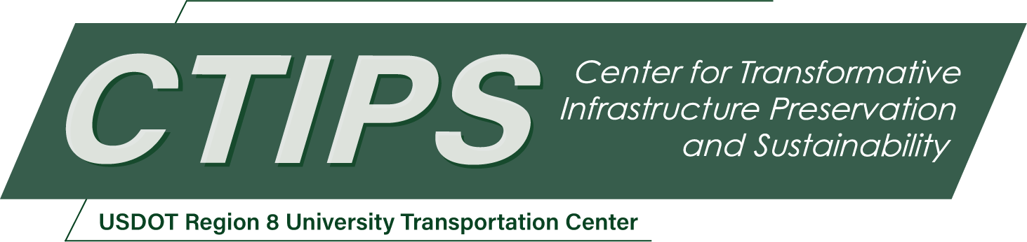

# Advanced Air Mobility to Enhance Freight Logistics and Preserve Road Condition

*CTIPS-001*

*Approved 3/25/2024*

## University

North Dakota State University

## Principal Investigators

Raj Bridgelall, Ph.D.

Associate Professor

Upper Great Plains Transportation Institute

North Dakota State University

Phone: (408) 607-3214

Email: raj.bridgelall@ndsu.edu

ORCID: 0000-0003-3743-6652

## Research Needs

The advent of Advanced Air Mobility (AAM) heralds significant advancements in transportation, promising to alleviate congestion, enhance accessibility, and foster sustainability. Yet, the integration of AAM with existing transportation modalities and the maximization of its benefits demand a refined understanding of the complex interplay between AAM infrastructure like vertiports and autonomous drone corridors, autonomous surface transportation, and conventional transportation systems. This integration is further complicated by the rapid evolution of complementary technologies like AI-driven logistics, high-velocity data analytics, and generative AI that poses both challenges and opportunities for comprehensive transportation planning.

## Research Objectives

To devise a pragmatic guide for AAM integration within North Dakota's multimodal transportation and evolving data systems, serving both public and private stakeholders.

To contribute to workforce and educational development through the engagement of a graduate research assistant in the project.

## Research Methods

The research will adopt a multidisciplinary approach, encompassing the following four methods:

*Technology Assessment*: Conduct both a thorough *literature review* and *patent analysis* to gauge current and future AAM technological capabilities, identify innovation trends, and develop AI models to predict electric vertical takeoff and landing (eVTOL) aircraft performance metrics. This will inform future work in infrastructure planning and public acceptance strategies.

*Market Analysis*: Utilize GIS to assess potential AAM networks by identifying gaps in existing infrastructure and highlighting economic opportunities, especially in remote and underserved areas, to support efficient cargo transport. This will inform future work incorporating collaborative AI for multimodal (rail, road, air) logistics optimization.

*Regulatory Review*: Analyze AAM-related policies and regulations to identify adoption barriers and opportunities for regulatory alignment across different levels of government and sectors. This will inform future work to develop a regulatory framework without stifling innovation, community engagement to understand concerns and garner support, and public-private partnerships to foster innovation, share risks, and accelerate deployments.

*Infrastructure Evaluation*: Investigate how existing transportation facilities can support AAM operations, identifying technical requirements and potential for multimodal integration and preserving highways. This will inform investments to develop vertiports and charging stations to support seamless integration.

## Relevance to Strategic Goals

This research aligns with the U.S. DOT's goals of economic strength and global competitiveness by supporting the efficient evolution of transportation systems to accommodate AAM innovations. This research will lead to enhanced service life of existing infrastructures by transferring ground traffic to air, promoting environmental sustainability.

## Educational Benefits

The project will include at least one graduate student who is working towards a Ph.D. The student will incorporate some of the methodologies and findings of the project into a dissertation. The PI will advise the student in both an academic and professional development capacity. The project will help the student hone research, presentation, and writing skills needed for advancements in the professional world. The broader educational benefits will be knowledge products and tools that feed into curricula development and laboratories studying multimodal transportation systems. The PIs intend to incorporate knowledge and models from this research into curricula focused on intelligent transportation solutions, spatial analysis, and cybersecurity.

## Outputs through Technology Transfer

The PI will utilize the project findings and models to produce publications and outreach to guide real world adoption. Insights from the project will inform AAM use cases, business development, and further studies for practical deployments, tailored to unique needs of the state. Students will gain expertise in technology development to enhance business practices and logistical operations. The team will utilize traditional methods such as journal papers, conference presentations, project reports, web page postings, and other marketing or outreach materials. In addition, the team will engage stakeholders throughout the project to review intermediate findings and to suggest future research directions. The PIs will submit reports to the SAPR (Semi-Annual Progress Report), highlighting publications and technology transfer activities generated from this project.

## Expected Outcomes and Impacts

The research will yield an initial foundational guide for AAM adoption, outlining the technological, economic, and regulatory landscapes. This guide will inform an actionable deployment roadmap, support educational initiatives, and support technology transfer towards AAM integration into North Dakota's multimodal transportation ecosystem.

## Work Plan

***Year 1****:*

1. Systematic *literature* review of eVTOL development challenges and solutions (ends month 4)
2. Systematic *patent* review of eVTOL innovation trends (ends month 8)
3. eVTOL freight capacity forecasting using machine learning and AI techniques (ends month 12)

***Year 2****:*

1. Assessments of *regulatory* landscape and FAA *certification* progress (ends month 4)
2. Case studies of eVTOL performance *forecasting* (ends month 8)
3. Forecasting AAM freight *market* opportunities and commodity types (ends month 12)
4. Final report (ends month 12)

## Project Cost

Total Project Costs: $336,688

CTIPS Funds Requested: $168,344

Matching Funds: $168,344

Source of Matching Funds: North Dakota LTAP – $83,344

Transportation Learning Network – $60,000

Northern TTAP – $25,000